Software Requirements Specification

for

Rapid Rail Sdn Bhd Train Management System
Version 1.0

Prepared by
Group Name: Thomas and Friends
Ng Jing Yong | 23WMD05078 | jyng-wm23@student.tarc.edu.my
Lim Wai Kit | 23WMD10460 | limwk-wm23@student.tarc.edu.my
Tan Eason | 23WMD04871 | tane-wm23@student.tarc.edu.my
Shannell Wong Si Yuan | 23WMD04621 | shannellwsy-wm23@student.tarc.edu.my
Chai Jing Yi | 23WMD05142 | chaijy-wm23@student.tarc.edu.my

Instructor: | Mr. DHAYALAN A/L GOBI
Course: | AMCS2003 Software Requirement And Design
Lab Section: | 12.00pm - 1.00pm
Date: | 25/9/2024
Contents
1 Introduction 1
1.1 Document Purpose 1
1.2 Product Scope 1
1.3 Intended Audience and Document Overview 2
1.4 Definitions, Acronyms and Abbreviations 4
1.5 References and Acknowledgments 6
2 Overall Description 8
2.1 Product Overview 8
2.2 Product Functionality 9
2.2.1 Problem 9
2.2.2 Solution 11
2.2.3 Structure chart 13
2.2.4 Object oriented approach (what is oop, benefits, class diagram simple) 14
2.3 Design and Implementation Constraints 17
2.4 Assumptions and Dependencies 18
3 Specific Requirements 19
3.1 User Interface Explanation 19
3.1.1 Facilities and Service Module 20
3.1.1.1 Brief Description on User Interface For Facilities and Service Module 23
3.1.2 Marketing Module 26
3.1.2.1 Brief Description on User Interface For Marketing Module 28
3.1.3 Customer Service Module 31
3.1.3.1 Brief Description on User Interface For Customer Service Module 33
3.1.4 IT Module 39
3.1.4.1 Brief Description on User Interface For IT Module 42
3.1.5 HR Module 47
3.1.5.1 Brief Description on User Interface For HR Module 51
3.2 Quality Attributes User Interface 54
3.3 Functional Requirements 55
3.3.1 Facilities and Service Module 56
3.3.2 Marketing Module 57
3.3.3 Customer Service Module 58
3.3.4 IT Module 59
3.3.5 HR Department Module 60
3.4 Use Case Model 61
3.5 Detailed Use Case 63
3.5.1 Facilities and Service Module 63
3.5.1.1 Use Case Description For Facilities and Service Module 64
3.5.2 Marketing Module 65
3.5.2.1 Use Case Description For Marketing Module 66
3.5.3 Customer Service Module 67
3.5.3.1 Use Case Description For Customer Service Module 68
3.5.4 IT Module 69
3.5.4.1 Use Case Description For IT Module 70
3.5.5 HR Module 72
3.5.5.1 Use Case Description For HR Module 73
4 Other Non-functional Requirements 74
4.1 Performance Requirements 74
4.2 Safety and Security Requirements 75
4.3 Non-functional Requirements 78
4.3.1 Facilities and Service Module 78
4.3.2 Marketing Module 79
4.3.3 Customer Service Module 80
4.3.4 IT Module 81
4.3.5 HR Module 82
4.4 Overall System Quality Attributes 84
5 Other Requirements 85
5.1 Hardware and Software Requirements 86
5.1.1 Hardware Requirements 86
5.1.2 Software Requirements 88
5.2 Requirement Management 92
5.2.1 Problem analysis and change specification 92
5.2.2 Change analysis and costing 93
5.2.3 Change implementation 93
5.3 Architecture Requirement 95
5.4 State Diagram 99
5.4.1 Facilities and Service Module 99
5.4.2 Marketing Module 100
5.4.3 Customer Service Module 101
5.4.4 IT Module 102
5.4.5 HR Module 103
5.5 Sequence Diagram 104
5.5.1 Facilities and Service Module 104
5.5.2 Marketing Module 106
5.5.3 Customer Service Module 108
5.5.4 IT Module 110
5.5.5 HR Module 111
5.6 Communication Diagram 112
5.7 Activity Diagram 113
Appendix 114
Background Studies 114
Interview 114
Interview Questions 115
Facilities and Service Department 115
Marketing Department 116
Customer Service Department 116
IT Department 117
HR Department 118
Stakeholder analysis 119

Revisions
Version | Primary Author(s) | Description of Version | Date Completed
1.0 | Ng Jing Yong  Lim Wai Kit  Tan Eason  Shannell Wong Si Yuan  Chai Jing Yi | Initial version, including all functional and non-functional requirements, design constraints, assumptions, and dependencies. | 30/08/24

1 Introduction
This section provides a comprehensive overview of the software requirements for the Train Management System (TMS). It outlines the purpose, scope, and audience of the document, along with key definitions, references, and acknowledgments.

1.1 Document Purpose
This document outlines the Software Requirements Specification (SRS) for the Train Management System (TMS) designed for Rapid Rail Sdn Bhd. It provides a detailed description of the software requirements, version 1.0, for this product. The purpose of this document is to define the functional and non-functional requirements, as well as the design constraints, necessary for the development and implementation of the TMS. This SRS covers the entire system, which includes multiple modules such as facilities and service, marketing, customer service, IT and HR. It is intended to ensure that all stakeholders have a clear understanding of the system’s capabilities and its intended behavior.

The scope of this SRS includes outlining the TMS's interactions with existing systems and its integration into the broader railway infrastructure. This document aims to provide a foundation for the development team to design and build the system while ensuring that all user and regulatory requirements are met.

1.2 Product Scope
The Train Management System (TMS) is a comprehensive platform developed to streamline and enhance the operations of Rapid Rail Sdn Bhd. Its primary purpose is to integrate multiple critical functions related to train operations, maintenance, customer service, and marketing into a single, unified system. The system addresses the limitations of current fragmented systems, ensuring better coordination, data accuracy, and real-time management of train services.

The TMS consists of several key modules, each serving a specific function. These include modules for Facilities and Service, Marketing, Customer Service Management, IT System Monitoring and HR. Each module is designed to ensure seamless operations across different departments, improving overall efficiency and safety.

The main benefits of the TMS include the reduction of manual errors through real-time data entry and automated processes, enhanced decision-making via comprehensive reporting and analytics, and improved response times to maintenance and operational issues. It also helps in maintaining regulatory compliance by ensuring that all safety protocols and procedures are adhered to. The system is capable of monitoring train performance, scheduling maintenance during off-peak hours, handling passenger feedback, managing promotions, and providing IT support across the organization. Overall, the TMS optimizes day-to-day train operations and ensures a higher level of service for passengers.

1.3 Intended Audience and Document Overview
Intended Audience:

This Software Requirements Specification (SRS) document is intended for a variety of stakeholders involved in the development, implementation, and use of the Train Management System (TMS). The primary audience includes developers, who will use this document to understand the system’s functional and non-functional requirements to build the software. Project managers will refer to it to ensure that the development process stays within scope and meets the outlined goals. Testers will use this document to create test cases and validate that the system meets all the necessary specifications. Additionally, end users, such as train operators, maintenance staff, customer service teams, and marketing personnel, will find information on how the system is expected to function in their daily operations. Lastly, documentation writers will use this SRS as a basis for creating user manuals and training materials, while the client and professors involved in the project can review the requirements to ensure they meet expectations.

Document Overview:

Chapter 1: Introduction

This chapter provides an overview of the Train Management System (TMS), explaining the purpose of the document, the scope of the product, and the intended audience. It sets the foundation for understanding the context and objectives of the system. The chapter also includes definitions, acronyms, and references that will help readers interpret the document correctly. It outlines the product's key goals and the audience who will benefit from this document, such as developers, project managers, testers, and end users.

Chapter 2: Overall Description

This chapter describes the overall architecture and background of the TMS. It explains why the system is needed, the problems with the current system, and how the TMS addresses these challenges. It provides a high-level view of the system’s major components, such as modules for train control, maintenance scheduling, and customer service, along with assumptions and dependencies related to its integration with existing systems. This section helps readers understand the system’s context, its core functionality, and how it fits within the broader railway infrastructure.

Chapter 3: Specific Requirements

This is the most detailed section of the document and outlines the functional requirements of the TMS. Each requirement specifies what the system must do, including use cases, workflows, and interactions between users and the system. The chapter breaks down these requirements by modules, such as train control, customer service, and maintenance. It also covers non-functional requirements like performance, security, and usability standards. This section ensures that developers and testers have a clear and comprehensive guide to the system's expected behaviors and outputs.

Chapter 4: Non-Functional Requirements

This chapter focuses on the performance, security, scalability, and reliability of the TMS. It provides specific metrics and criteria that the system must meet, such as response times, uptime percentages, and safety standards. This section is critical for ensuring that the system not only functions correctly but also performs efficiently under various conditions. It ensures that the TMS will be reliable, secure, and scalable for future needs.

Chapter 5: Other Requirements

This chapter captures additional technical and operational requirements that may not fall under the functional or non-functional categories. These could include hardware and software specifications, compliance with industry standards, legal or regulatory considerations, and any specific client needs. It may also outline the deployment environment, third-party tools, or additional operational constraints that the system must adhere to.

Appendix

The appendix includes supplementary materials such as background studies, interview questions, stakeholder analysis, etc.

1.4 Definitions, Acronyms and Abbreviations

Abbreviation | Parameter | Definition
API | Application Programming Interface | A set of tools and protocols that allows different software applications to communicate with each other.
COMET | COMET Methodology | A methodology for object-oriented software design that emphasizes component-based design.
DB | Database | A structured collection of data that can be easily accessed, managed, and updated.
GDPR | General Data Protection Regulation | A legal framework that sets guidelines for the collection and processing of personal information in the EU.
HR | Human Resources | The department responsible for managing employee records, recruitment, and payroll.
IT | Information Technology | The use of systems (computers, networks, etc.) for storing, retrieving, and sending information.
KPI | Key Performance Indicator | A measurable value that indicates how effectively a company or system is achieving key business objectives.
LRT | Light Rail Transit | A type of rail-based public transportation system, typically for urban areas.
MRT | Mass Rapid Transit | A high-capacity public transportation system, often operating in metropolitan areas.
OOP | Object-Oriented Programming | A programming paradigm based on the concept of objects, which contain data and methods.
SRS | Software Requirements Specification | A document that outlines the functional and nonfunctional requirements for a software product.
SSL | Secure Sockets Layer | A standard security technology that establishes an encrypted link between a server and a client.
TMS | Train Management System | The system is being developed to manage train operations, maintenance, customer service, and other functions.
UI | User Interface | The visual elements and controls with which users interact in a software system.
UML | Unified Modeling Language | A standardized modeling language used to specify, visualize, and document the structure of software systems.
UX | User Experience | The overall experience users have when interacting with the system, focusing on ease of use and satisfaction.

1.5 References and Acknowledgments
References:
- Brunner, Jens O., et al. “Flexible Shift Scheduling of Physicians.” Health Care Management Science, vol. 12, no. 3, 20 Jan. 2009, pp. 285–305, https://doi.org/10.1007/s10729-008-9095-2. Accessed 28 Sept. 2022.
- Keneley, Monica, et al. “Digitizing Archival Records: Benefits and Challenges for a Large Professional Accounting Association.” Archivaria, vol. 81, no. 1, 2016, pp. 75–100, muse.jhu.edu/pub/302/article/687707/summary. Accessed 7 Sept. 2024.
- Levine, Alex B, et al. “Search and Rescue in California: The Need for a Centralized Reporting System.” Wilderness & Environmental Medicine, vol. 34, no. 2, 1 June 2023, pp. 164–171, https://doi.org/10.1016/j.wem.2023.01.011. Accessed 18 Apr. 2024.
- Mandelbaum, Avi, and Sergey Zeltyn. “The Impact of Customers? Patience on Delay and Abandonment: Some Empirically-Driven Experiments with the M/M/ N + G Queue.” OR Spectrum, vol. 26, no. 3, 1 July 2004, pp. 377–411, https://doi.org/10.1007/s00291-004-0164-8. Accessed 21 Sept. 2022.
- Osman, Rasha, and William J. Knottenbelt. “Database System Performance Evaluation Models: A Survey.” Performance Evaluation, vol. 69, no. 10, Oct. 2012, pp. 471–493, https://doi.org/10.1016/j.peva.2012.05.006
- Rao, Ashwin. “AttenFace: A Real Time Attendance System Using Face Recognition.” IEEE Xplore, 1 Nov. 2022, ieeexplore.ieee.org/document/9998001/references#references. Accessed 20 Feb. 2023.
- Rolfsen, Christian Nordahl, and Ann Karina Lassen. “On-Site Inspections: The Shift from Forms to Digital Capture.” Organization, Technology and Management in Construction: An International Journal, vol. 12, no. 1, 25 Mar. 2020, pp. 2064–2071, https://doi.org/10.2478/otmcj-2020-0003. Accessed 22 Sept. 2020.
- Sexton, Thurston, et al. “Categorization Errors for Data Entry in Maintenance Work-Orders.” Annual Conference of the PHM Society, vol. 11, no. 1, 22 Sept. 2019, pdfs.semanticscholar.org/a36d/9185218392bcec3c8621cadcd83092a82bf8.pdf, https://doi.org/10.36001/phmconf.2019.v11i1.790.

Acknowledgments:

We would like to express our sincere gratitude to Mr. DHAYALAN A/L GOBI, whose guidance and support were invaluable throughout the development of this Software Requirements Specification (SRS) for the Train Management System (TMS). His insights and feedback were essential in shaping this document and ensuring it met the highest standards.

We also wish to thank the development team members: Ng Jing Yong, Lim Wai Kit, Tan Eason, Shannell Wong Si Yuan, and Chai Jing Yi for their dedication and hard work in contributing to the creation of this document. Their collaboration and commitment were crucial in thoroughly analyzing the system requirements and ensuring that all necessary components were addressed.

Lastly, we would like to acknowledge the contributions of Rapid Rail Sdn Bhd for providing the necessary information and context that helped guide the development of the Train Management System.

2 Overall Description
This section provides a comprehensive overview of the Train Management System (TMS), offering context for its development, functionality, and use. It covers the background and origin of the product, its key functions, design constraints, assumptions, and dependencies.

2.1 Product Overview
The Train Management System (TMS) is a comprehensive solution developed for Rapid Rail Sdn Bhd, which manages a vast network of LRT and MRT lines in Kuala Lumpur and the Klang Valley. This new system is designed to address the limitations of the existing fragmented systems currently in use. The old system has caused significant operational inefficiencies, as various departments operate on separate platforms that don’t communicate well with each other. This has led to delays in data entry, errors in train monitoring and maintenance, and ineffective communication between departments such as maintenance, customer service, and train operators. Additionally, the current system struggles with scalability and performance issues, making it difficult to add new features or handle large data volumes. These problems also arise from the rigid embedding of business logic directly into databases, which complicates updates and system modifications.

The TMS integrates multiple functions into a unified platform, including train control and performance monitoring, signaling, communication, maintenance, customer service, and marketing. This integration ensures seamless coordination between all departments, allowing real-time data sharing and operational management, which reduces human error and improves efficiency. The new system will support over 500 users from various departments, including train operators, maintenance personnel, customer service staff, marketing teams, and IT personnel. It is designed to scale to accommodate future expansion, ensuring that as Rapid Rail grows its network or user base, the system can handle increased demand.

From a technical perspective, the TMS will be deployed on a modern cloud-based infrastructure using high-performance servers. This setup ensures high availability with 99.9% uptime, real-time data processing, and the ability to scale as needed. The system will utilize modern programming languages like Python and Java, and the architecture will follow a microservices approach, ensuring modularity and flexibility. For data storage, secure and scalable databases like MySQL or PostgreSQL will be used. To ensure accessibility, both web and mobile applications will be available, allowing users to access the system from control rooms or in the field. Additionally, the system design will be modeled using UML, with development following the COMET method to guarantee a robust and consistent architecture.

In summary, the new TMS will greatly enhance operational efficiency, reduce delays, improve passenger safety, and provide a more flexible platform for future growth, addressing the key shortcomings of the current system.

2.2 Product Functionality

2.2.1 Problem
The Facilities and Service Department faces significant challenges due to system complexity and performance bottlenecks. The root cause is that the current system embeds business logic directly into the database, which complicates updating and maintaining processes. For example, when the department needs to make business process adjustments, they must coordinate with the database administrator to modify stored procedures or triggers. This not only increases the complexity but also risks errors or omissions. Maintenance personnel are forced to deal with scattered business logic within the database, making it difficult to track and resolve issues efficiently. Furthermore, embedded stored procedures may perform poorly when processing large amounts of data, resulting in longer query response times, especially under high loads. These issues contribute to overall performance bottlenecks and degrade the user experience. The tight coupling between the application and the database limits flexibility, increases maintenance costs, and makes the system less scalable, leading to higher development costs and difficulty in adding new features.

The Marketing Department struggles with ineffective promotions due to a poor user interface in their current system. This poor design makes it difficult for users to understand and navigate the system, which directly impacts their ability to discuss or share promotions effectively. The interface is confusing, leading to frequent mistakes when applying promotions to the correct routes, dates, or customer segments. Moreover, the analytics and reporting functions are unclear and difficult to access, preventing the marketing team from effectively analyzing promotion results. These issues result in inefficient adjustments and updates, as the cumbersome interface causes delays in responding to market changes. Additionally, the marketing team faces challenges in monitoring promotion performance and may struggle to configure promotions correctly, leading to incomplete or erroneous campaigns that fail to meet marketing objectives.

The Customer Service Department faces delays in responding to customer issues, primarily due to a reliance on paper-based processes. When customer inquiries are received, staff record the problems and solutions on paper, store them in cabinets, and later manually input the information into the system. This method leads to long search times when attempting to retrieve records from several years ago, slowing response times. Additionally, staff may forget to key in some of the inquiries or even lose the papers, leading to incomplete records. This process causes an increase in customer complaints, as delays in responding to issues lead to a backlog of unresolved cases, wasting resources and causing further escalation.

The IT Department experiences inefficiencies in maintenance processes, leading to extended resolution times and higher operational costs. When other departments encounter system issues, they must contact the IT department or submit a form, disrupting their work. IT staff are then required to repeatedly update departments on the status of their issues, which is inefficient. This process becomes even more burdensome as IT personnel must document all the problems and resolutions for future reference, taking up additional time. These inefficiencies result in extended system downtimes, which disrupt train operations, scheduling, and communication. Longer maintenance periods increase operational costs without improving system performance or reliability. Furthermore, prolonged maintenance delays system upgrades and the implementation of new features that could enhance operational efficiency and safety.

Finally, the HR Department deals with shift coverage issues, primarily due to inadequate attendance management and the potential for falsified attendance records. Colleagues can easily mark each other as present, allowing trains to operate without the necessary staff on board, posing significant safety risks. Moreover, the lack of detailed leave records makes it difficult to analyze absenteeism and plan staff schedules effectively. The system does not automatically notify managers of attendance issues, causing delays in responding to absences and leaving shifts uncovered. As a result, staff are often required to work overtime to compensate for absent colleagues, which can lead to operational disruptions and a decrease in service efficiency. Frequent absences and poor management of shift coverage can also cause stress among remaining staff, leading to lower morale and job dissatisfaction. Additionally, HR personnel may neglect other important tasks as they scramble to find last-minute replacements.

2.2.2 Solution
Another improvement for the Facilities and Service Department involves refactoring the system architecture. Shifting business logic from stored procedures, triggers, and other database objects to the application layer and creating clear interfaces between the application layer and the database provides numerous benefits. By separating business logic from the database, the system gains flexibility, allowing changes to business rules or processes within the application code without altering the database schema or stored procedures. This decoupling makes it easier to adapt to changing business requirements, as updates can be managed within the application codebase, which is typically easier to modify and deploy. Centralizing the logic in the application layer makes it easier to manage, debug, and update the system, and developers can perform more complex data manipulations and optimizations within the application, potentially improving performance. Additionally, version control is simplified, as application code is easier to track and manage compared to database scripts, and the modular development of application code makes adding new features or functionality easier without significantly altering the database.

In the Marketing Department, a user interface redesign is essential to enhance the usability and effectiveness of the system. The current system’s interface can be improved by making it more intuitive and user-friendly. The redesign process begins with gathering user feedback and collaborating with UI/UX designers to create and review prototypes. Key components such as navigation, dashboards, and workflows are streamlined to ensure simplicity and efficiency. After development and testing, the new interface is rolled out along with comprehensive training and documentation for the marketing team. A support system is established to address any initial issues, and continuous feedback is gathered for iterative improvements. The advantages of a redesigned interface include improved usability, reduced confusion and errors, and more efficient work processes for the marketing team. Streamlined workflows save time and increase productivity, while the inclusion of clear and visual performance data enhances the marketing team’s ability to evaluate the success of promotions. Overall, the redesign leads to higher user satisfaction and morale among the marketing team, fostering a more positive working environment.

For the Customer Service Department, digitizing existing records offers a significant improvement in managing customer inquiries. Scanning paper records and storing them digitally in the system, possibly using OCR (Optical Character Recognition) technology to convert scanned documents into searchable and editable text, simplifies the process of retrieving specific information. A digital system allows customer service representatives to quickly search and retrieve historical inquiries using keywords or specific criteria, drastically reducing the time spent searching through physical files. This system can also track customer inquiries and solutions in real-time, providing immediate updates on the status of each issue and reducing the time spent on follow-up communications. By eliminating the need to manually search through paper records, staff can focus on promptly resolving customer issues, ultimately improving customer service response times.

In the IT Department, implementing a centralized issue reporting system is key to improving efficiency. This system would allow issues to be reported, tracked, and updated in real-time, eliminating the need for manual form submissions and phone calls. Automated notifications can be sent to respective departments regarding the status of reported issues, reducing the need for follow-up calls or emails. Each issue and its resolution process is automatically documented by the system, reducing the time spent on manual documentation and ensuring consistent record-keeping. This new approach streamlines issue reporting and handling, saving time and reducing workload. Real-time tracking and notifications ensure that issues are addressed promptly, which reduces downtime and boosts productivity. Additionally, departments are kept informed of the progress of their reported issues, fostering transparency and trust in the IT department's efficiency.

Finally, in the HR Department, the introduction of real-time attendance tracking can greatly improve staff management. By allowing staff to check in and out using mobile devices in real-time, the system ensures accurate and immediate attendance data. The system tracks attendance through location services or IP addresses, enabling immediate identification of absent staff members, which allows managers to quickly find replacements. The system also sends automatic notifications to department managers when staff are absent or late, enabling them to adjust staff assignments and ensure adequate coverage for scheduled train services. This real-time attendance tracking provides faster response times during emergencies, minimizes operational disruptions, and helps maintain service continuity.

2.2.3 Structure chart
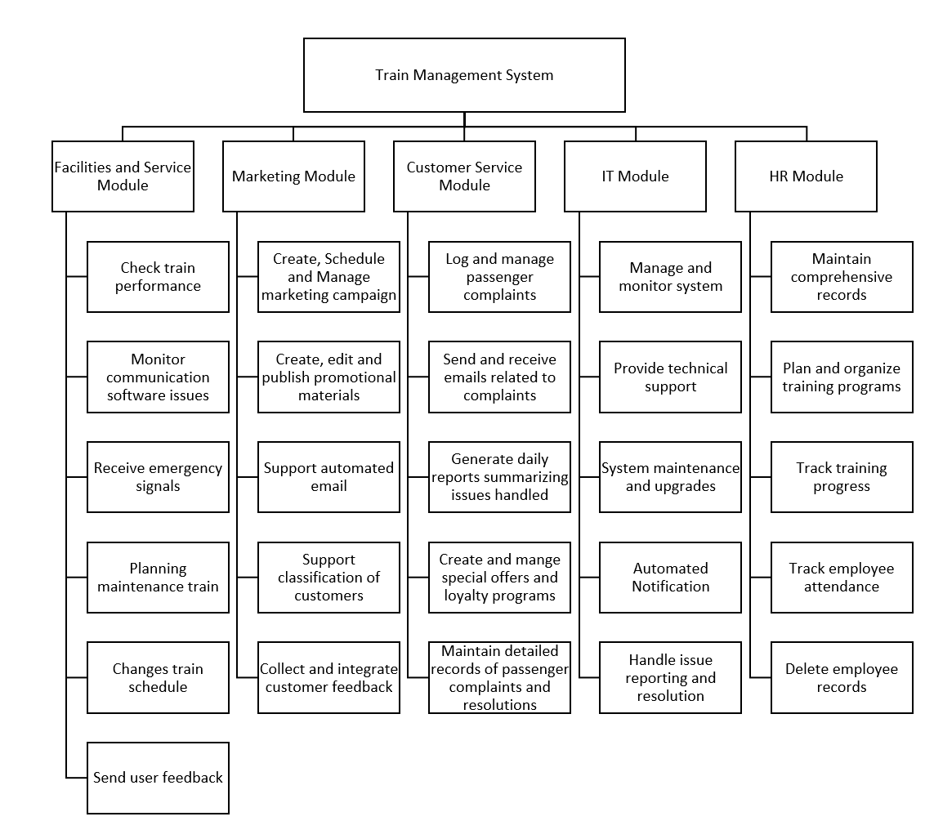
Diagram 2.2.3.1 (Train Management System Structure Chart)

2.2.4 Object oriented approach (what is oop, benefits, class diagram simple)

Object-Oriented Programming (OOP) is a programming paradigm that organizes software design around objects, rather than functions or logic. An object is a self-contained entity that holds both data (attributes) and methods (functions) that manipulate the data. OOP is built around four key principles: encapsulation, inheritance, polymorphism, and abstraction.

Encapsulation involves bundling data and methods within a class, hiding the internal implementation from the outside world. This ensures that the data inside an object can only be modified through its methods, improving security and preventing accidental changes. Inheritance allows one class to inherit properties and behaviors from another, enabling code reuse and creating a hierarchical relationship between classes. For example, a "Train" class could serve as a parent class from which a "High-Speed Train" class inherits attributes like speed and capacity while adding specific features. Polymorphism enables objects to be treated as instances of their parent class, allowing different classes to implement methods in a way that's specific to their needs. This means that a method can perform different functions depending on which object calls it. Lastly, abstraction simplifies complex systems by exposing only the necessary parts, allowing programmers to work on different layers without getting bogged down by underlying complexity.

The benefits of OOP are numerous. One of the key advantages is modularity and code reusability. By dividing a system into self-contained objects, developers can reuse and repurpose code across different applications. This modularity makes it easy to update or expand specific components without affecting the entire system. Maintainability is another benefit, as changes to a class don't disrupt other parts of the program, ensuring that each object manages its own data and behaviors. This separation of concerns makes debugging and code management much simpler.

OOP also enhances scalability, making it easier to build large, complex systems. As new features or functionalities are required, developers can add new objects or extend existing ones without rewriting the entire codebase. This promotes growth without disruption. Additionally, data security is improved through encapsulation, as objects can restrict access to their data, controlling what information is exposed and ensuring that sensitive data remains protected.

Lastly, OOP provides a natural way to map software to real-world entities. Objects in OOP are modeled after real-world items, making it easier for developers to conceptualize and design systems that closely resemble actual processes or items, such as a "Train" object with its properties and behaviors.
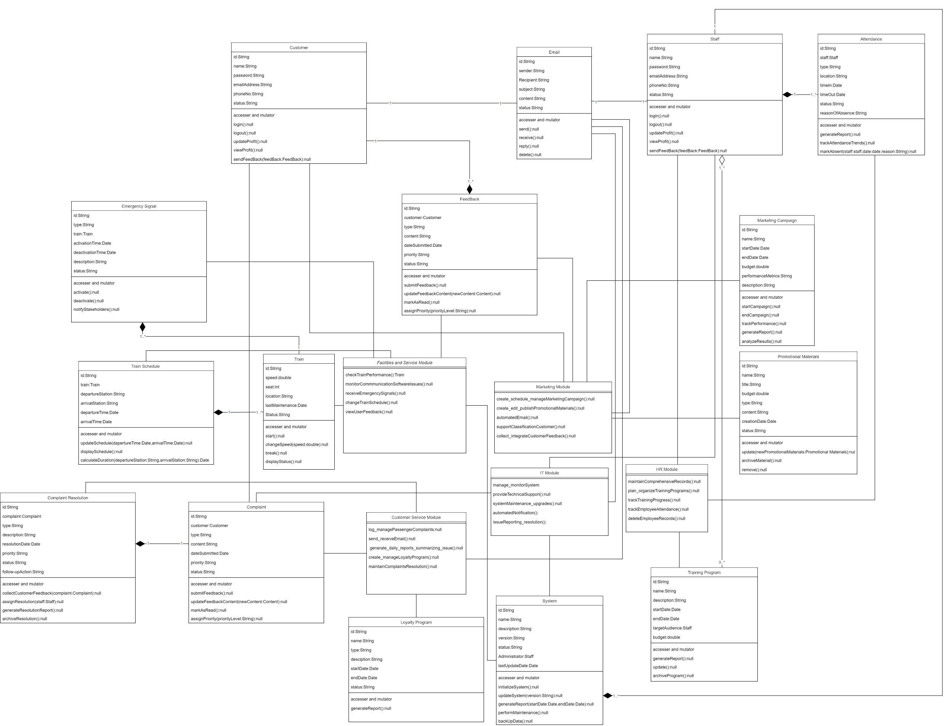
source:https://app.diagrams.net/#G1WJleSfyhQ6O22g9eu738iOPplpjz3N4j#%7B%22pageId%22%3A%22C5RBs43oDa-KdzZeNtuy%22%7D

2.3 Design and Implementation Constraints
The Train Management System (TMS) must be compatible with existing railway infrastructure, which may involve older hardware systems with limited memory and processing power, presenting certain hardware limitations. Additionally, the system must seamlessly interface with other applications, integrating smoothly with existing control centers, signaling systems, and mobile applications used by train operators. In terms of the technology stack, development should follow the COMET method for software design and utilize UML for modeling, ensuring consistent architecture and thorough documentation. Security considerations are critical, requiring the implementation of robust security measures such as encryption and access controls to prevent unauthorized access and protect data. The TMS must also support real-time communication between trains, control centers, and maintenance teams by using reliable, low-latency communication protocols for smooth operations.

The design must take into account specific hardware limitations that may arise from legacy equipment still in use. This includes ensuring that the TMS does not exceed the processing capabilities of existing systems or require excessive memory. The system must be scalable, allowing for potential upgrades as railway infrastructure modernizes over time.

Regulatory constraints also play a significant role in the design of the TMS. The system must comply with international and local railway safety standards, such as the International Railway Industry Standard (IRIS) and ISO 9001, which impose strict guidelines on system reliability, safety, and performance. In addition, data privacy laws, such as the General Data Protection Regulation (GDPR) or local data protection laws, must be observed, especially in handling personal data from passengers and employees.

Firewall settings and network security protocols are essential design constraints, as the TMS must operate within secure network environments. It must adhere to established security frameworks like ISO/IEC 27001 for information security management, ensuring protection against potential cyberattacks. The system must support VPN and secure remote access for maintenance staff, and it should integrate with existing cybersecurity infrastructure.

Furthermore, the design should consider constraints related to disaster recovery and system redundancy. The TMS must have backup and failover mechanisms in place to ensure high availability, even in the case of hardware or network failures. This includes real-time data replication and automatic switchover capabilities to minimize service disruptions. Lastly, the system should be designed to meet stringent performance requirements, including high throughput and low latency, especially during peak hours and emergencies.

2.4 Assumptions and Dependencies
The integration with existing systems assumes that current railway systems, including signaling and communication infrastructure, will be compatible with the new Train Management System (TMS), requiring minimal modifications. Additionally, the TMS will rely on stable and well-supported third-party components, such as databases and communication protocols, throughout its lifecycle to ensure consistent performance. The operating environment is expected to be a well-supported IT setup with sufficient server capacity and network infrastructure. Furthermore, the TMS must comply with all relevant railway safety and security regulations, which are assumed to remain stable during the development process, ensuring regulatory compliance throughout its implementation.

It is assumed that the users of the system, including train operators, maintenance personnel, and administrative staff, will undergo sufficient training to effectively utilize the TMS. Additionally, the system assumes that users have access to modern devices capable of running the TMS software efficiently, including desktops, tablets, or mobile devices. Compatibility with legacy systems may pose limitations, and any required updates or upgrades to these systems are the responsibility of the railway operator. Regular maintenance and support from third-party vendors, such as software updates and hardware replacements, will be crucial for the system’s optimal performance over time.

Moreover, the system's performance will depend on the availability of a stable internet connection, especially for remote monitoring and real-time communication between trains, control centers, and field personnel. Any network interruptions or connectivity issues could affect the real-time functionality of the system. Lastly, it is assumed that all necessary legal clearances and regulatory approvals for operating the TMS, particularly concerning data privacy, passenger safety, and communication protocols, are already in place or will be secured before deployment.

3 Specific Requirements
This section will outline the detailed functional requirements that the Train Management System must meet to fulfill the needs of its users and stakeholders. These requirements will specify the exact behaviors, functions, and operations that the system must perform across different departments with different use case diagrams and user interfaces.

3.1 User Interface Explanation

3.1.1 Facilities and Service Module

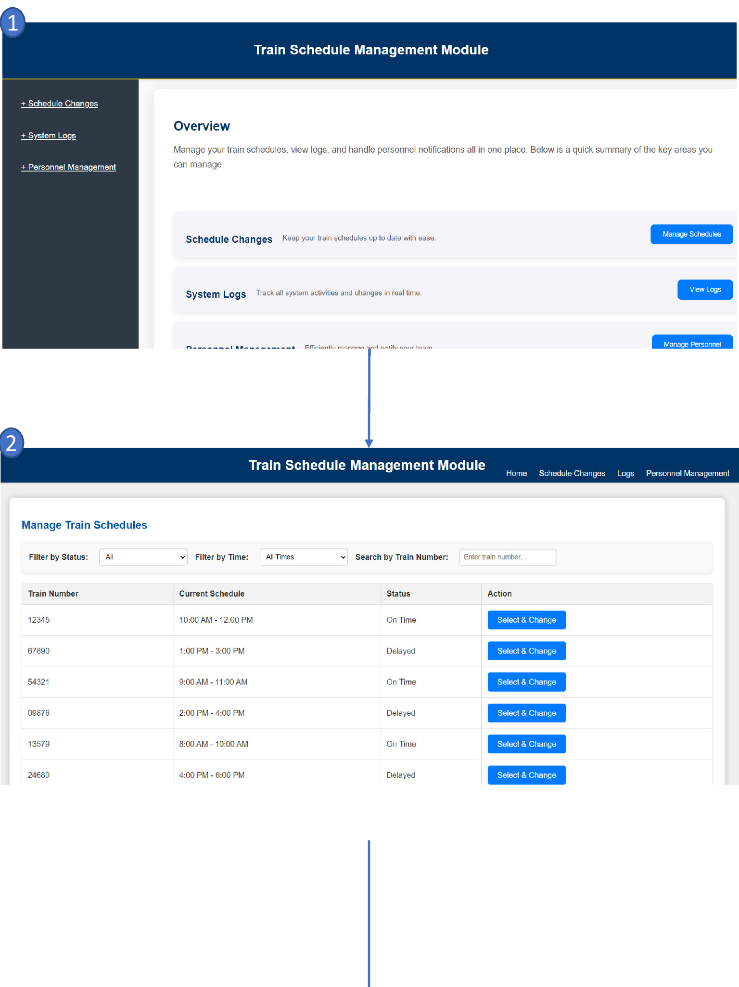
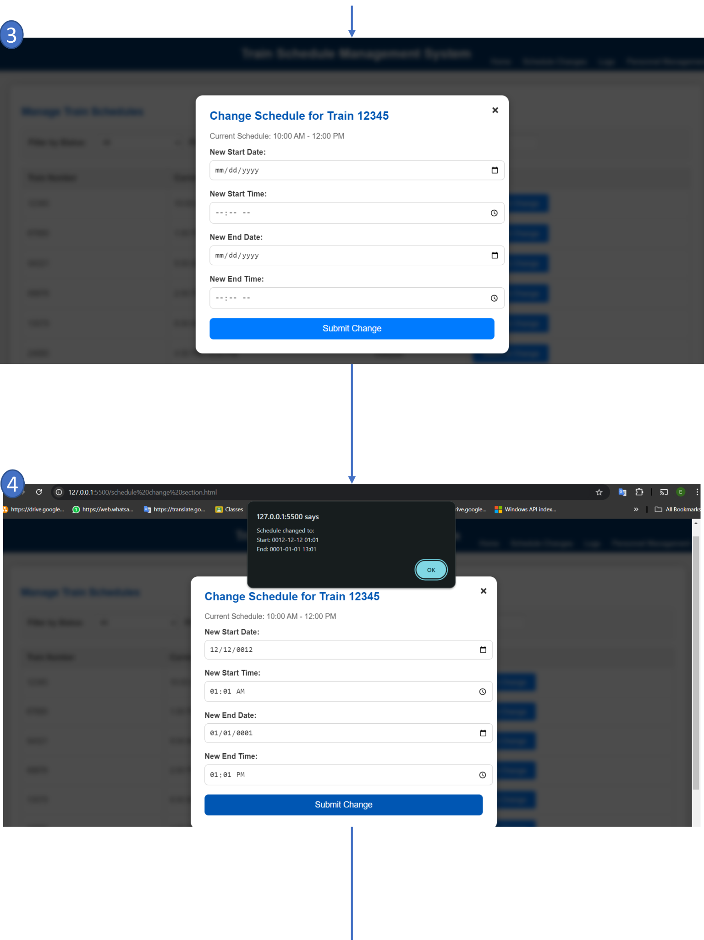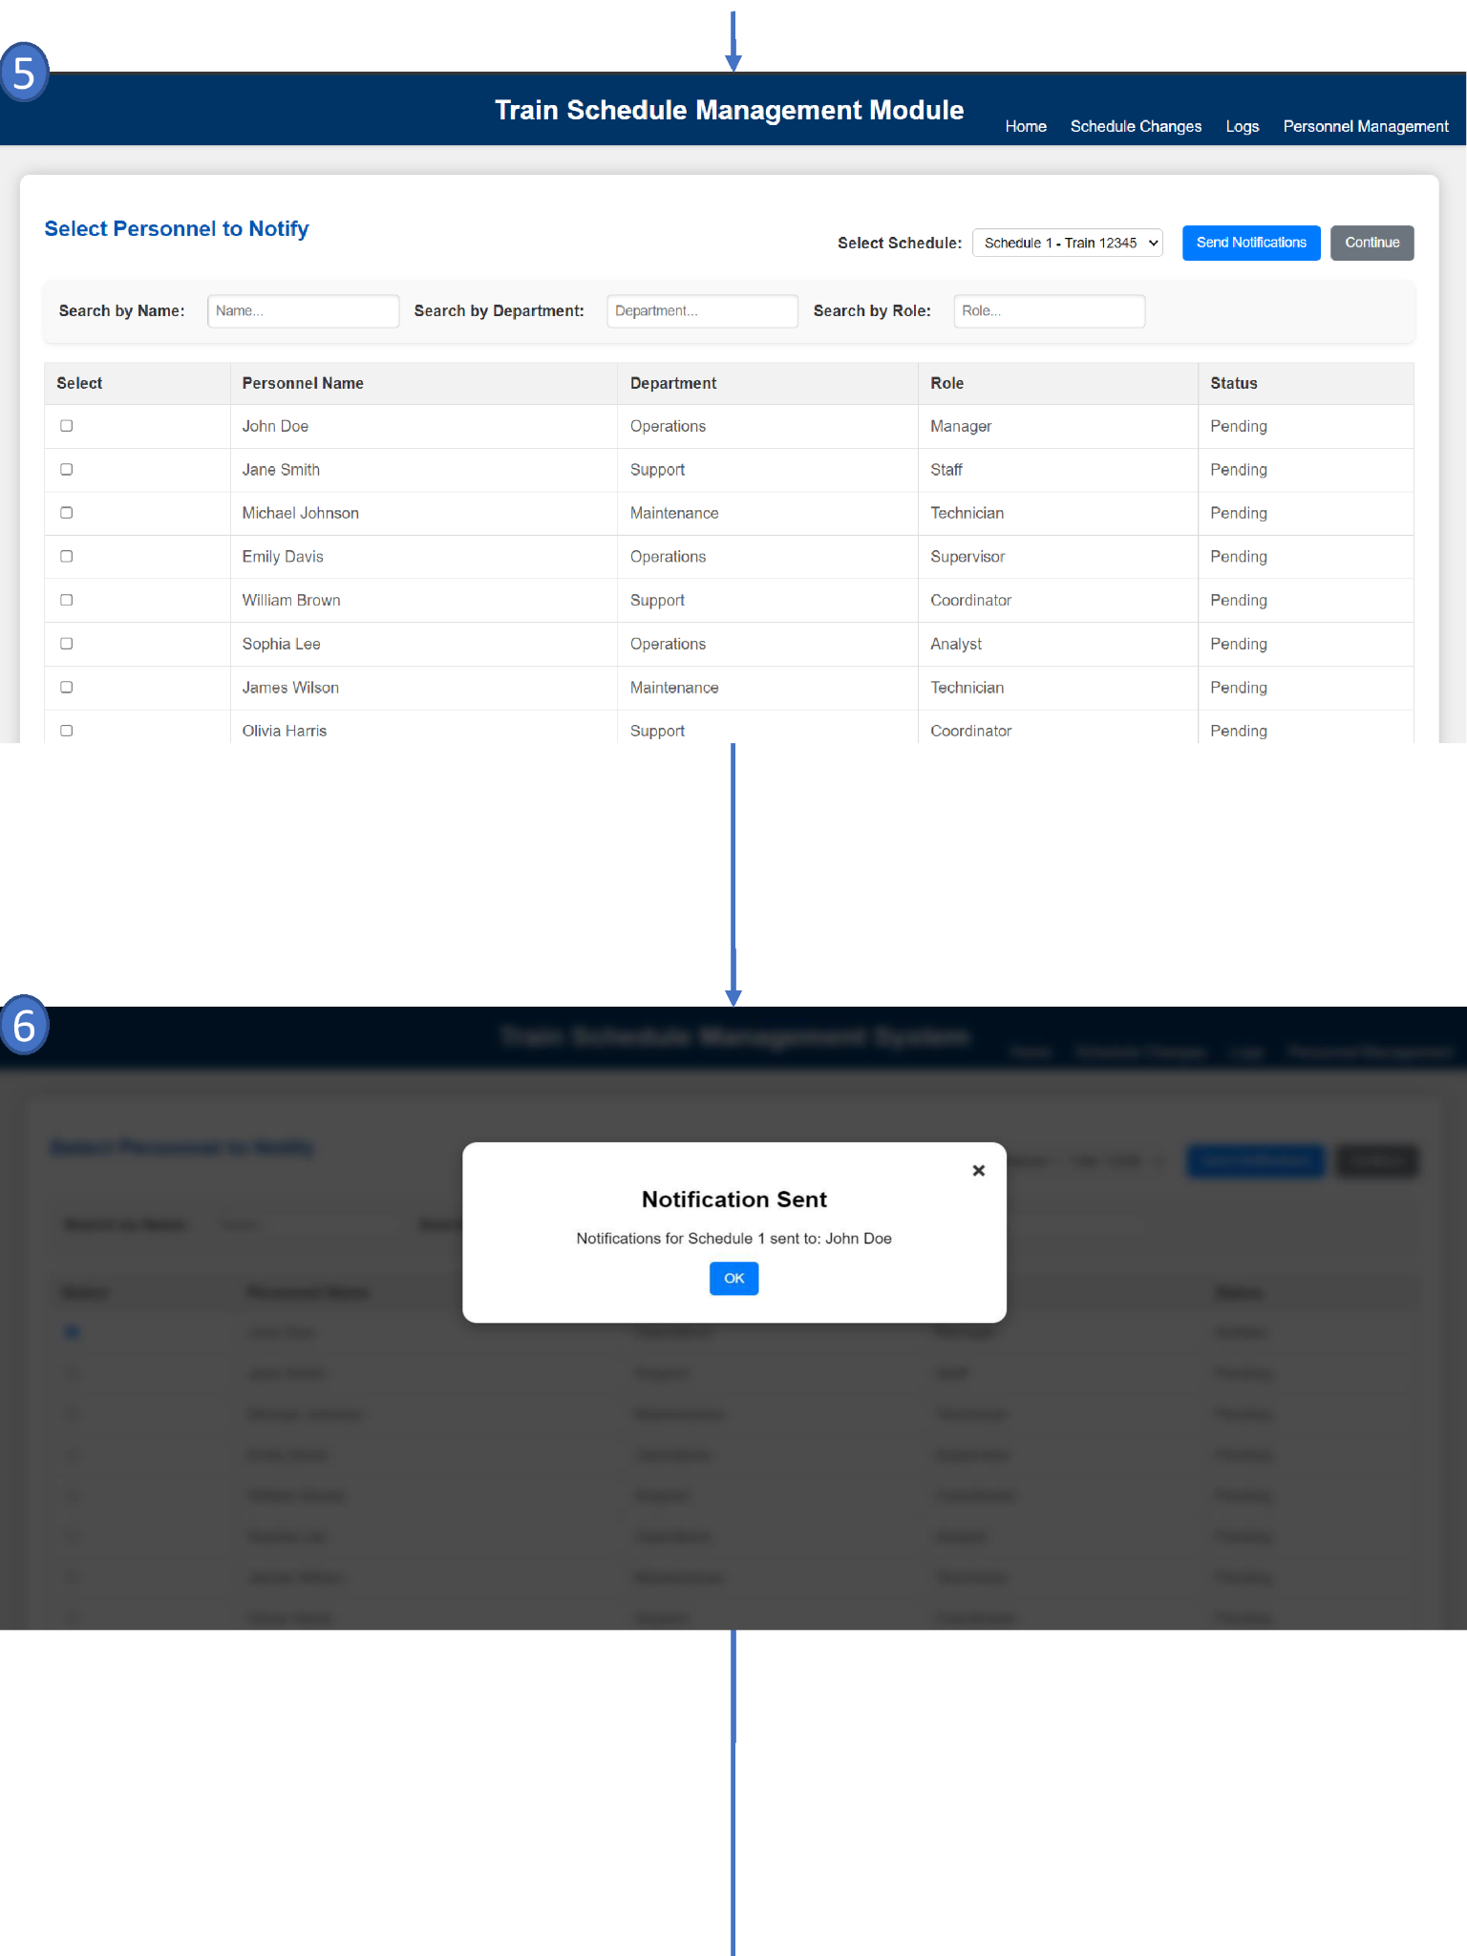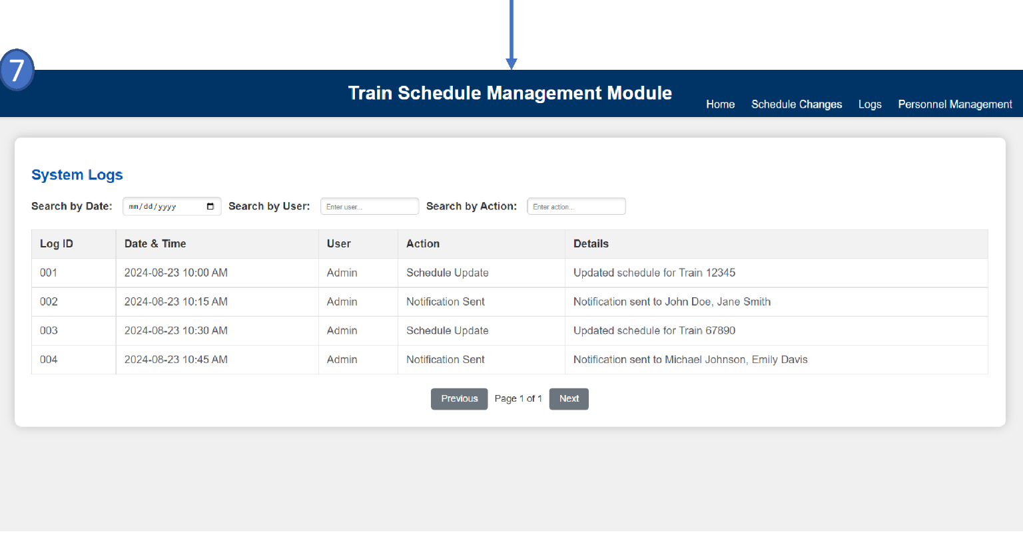
Diagram 3.1.2.1 (Facilities and Service Module User Interface Design)

3.1.1.1 Brief Description on User Interface For Facilities and Service Module
- Home Page Overview: The user starts at the homepage of the Train Schedule Management System. This page provides three main options: Schedule Changes, System Logs, and Personnel Management. Each option is accessible via clearly labeled buttons, allowing the user to navigate to different sections of the system.

- Manage Train Schedules: After selecting the "Manage Schedule" option, the user is directed to the "Manage Train Schedules" page. Here, the user can view the current train schedules, filter them by status or time, and search by train number. For each train schedule, there is an option to "Select & Change."

- Change Train Schedule: The user selects a specific train schedule to modify, which opens a form titled "Change Schedule for Train [Train Number]." This form displays the current schedule and allows the user to input new dates and times for the start and end of the schedule. The user can then submit the changes by clicking the "Submit Changes" button.

- Change Notification Pop-up: Upon submission, a notification pop-up appears, indicating the successful submission of the schedule change. This pop-up may provide additional information, such as the new times or other relevant details.If the user input is incomplete or missing, another notification pop-up will appear, alerting the user that required information is missing. The user will have the opportunity to provide the necessary details before attempting to resubmit.
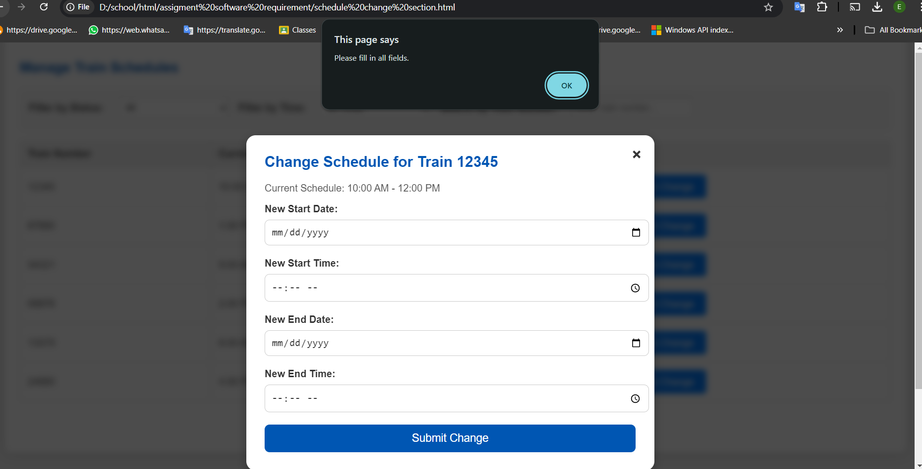

- Notify Personnel: The system allows the user to notify relevant personnel about the schedule changes. The user is directed to a page where they can select personnel based on various criteria like name, department, or role. Once the appropriate personnel are selected, the user can click the "Send Notification" button to inform them about the schedule update.

- Notification Confirmation: After sending the notification, the system confirms that the notification has been successfully sent to the selected personnel. A pop-up message displays the confirmation.If no personnel have been selected, a different pop-up message will appear, alerting the user that no recipients were chosen. This message will instruct the user to select at least one person before attempting to send the notification again.
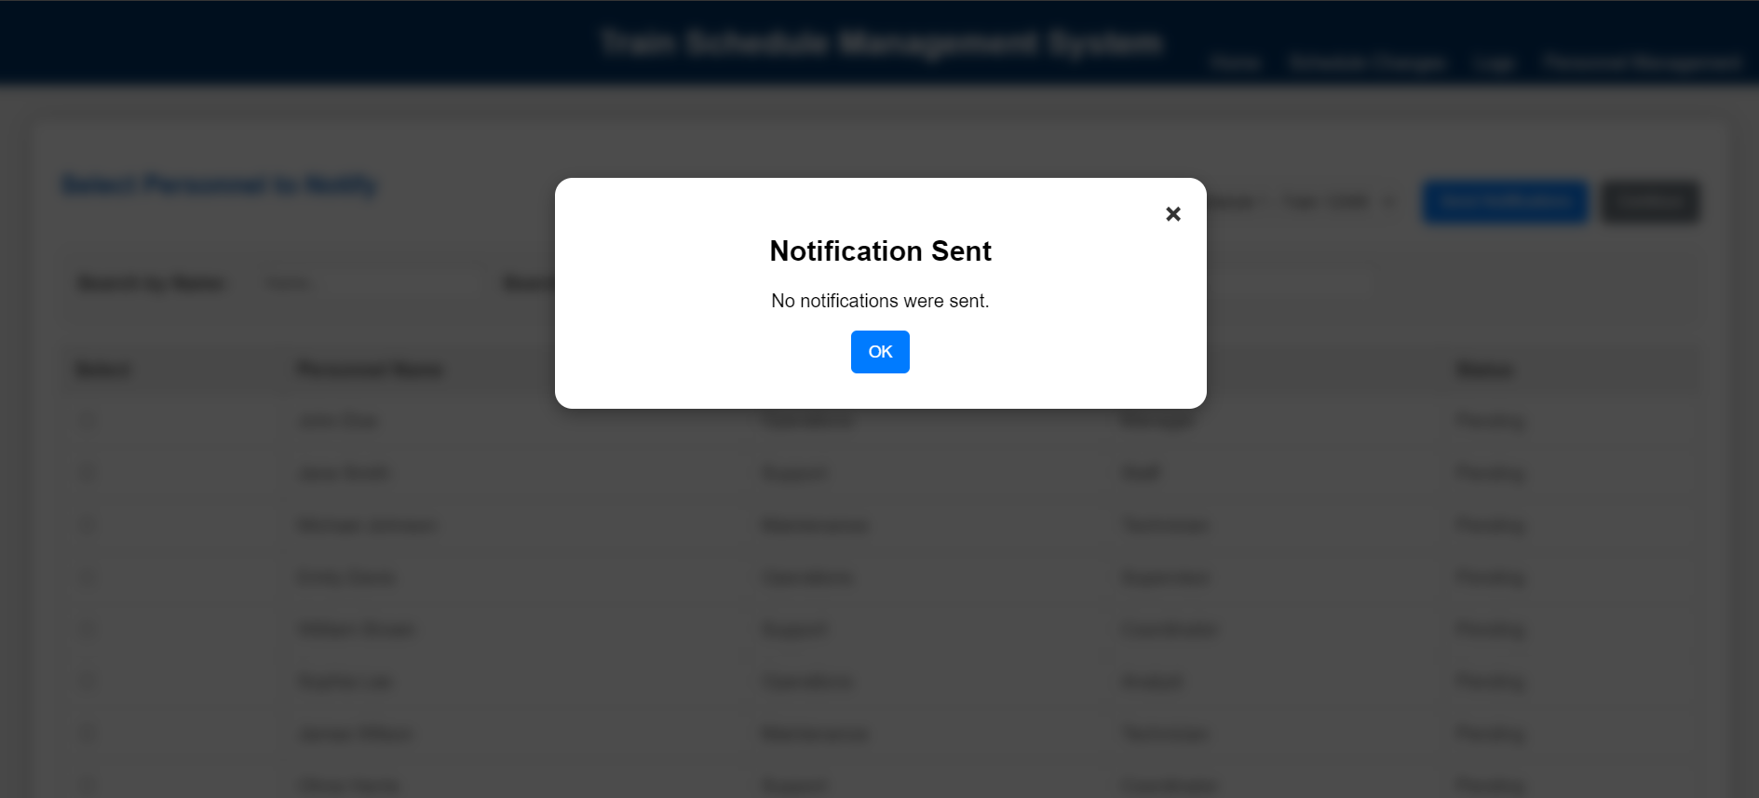

- System Logs: Finally, the user can view the system logs, where all actions, including schedule updates and notifications, are recorded. The logs provide a detailed record of the actions taken, including who performed them and when they occurred.

3.1.2 Marketing Module
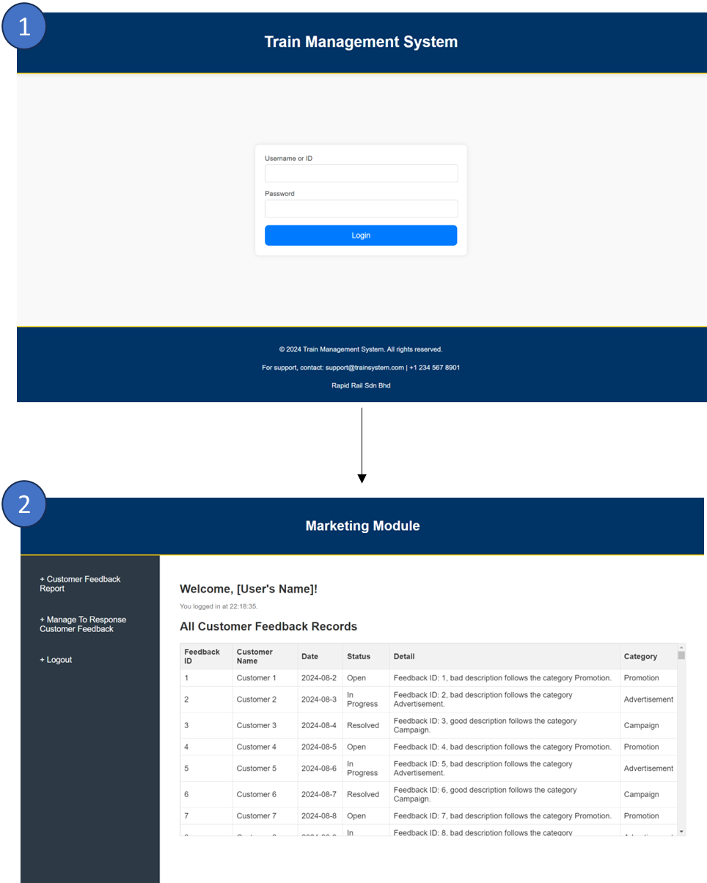
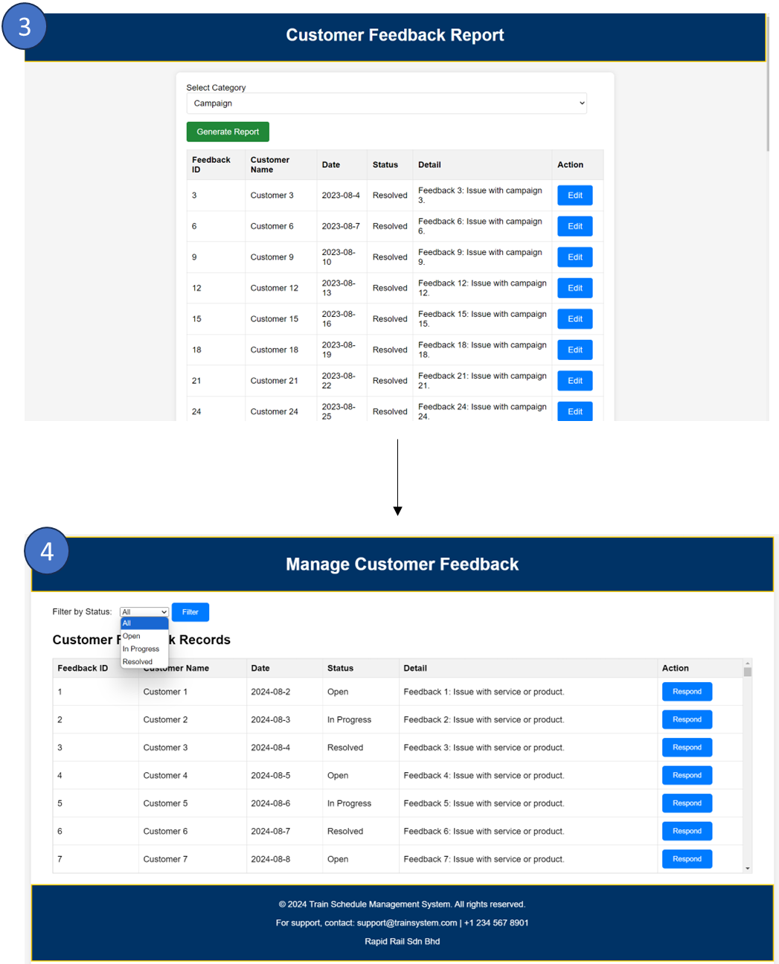
Diagram 3.1.2.1 (Marketing Module User Interface Design)

3.1.2.1 Brief Description on User Interface For Marketing Module
1. Login section. Users have to enter the correct ID and password to proceed to the next section. When users enter the wrong ID or password, an error message will be displayed.
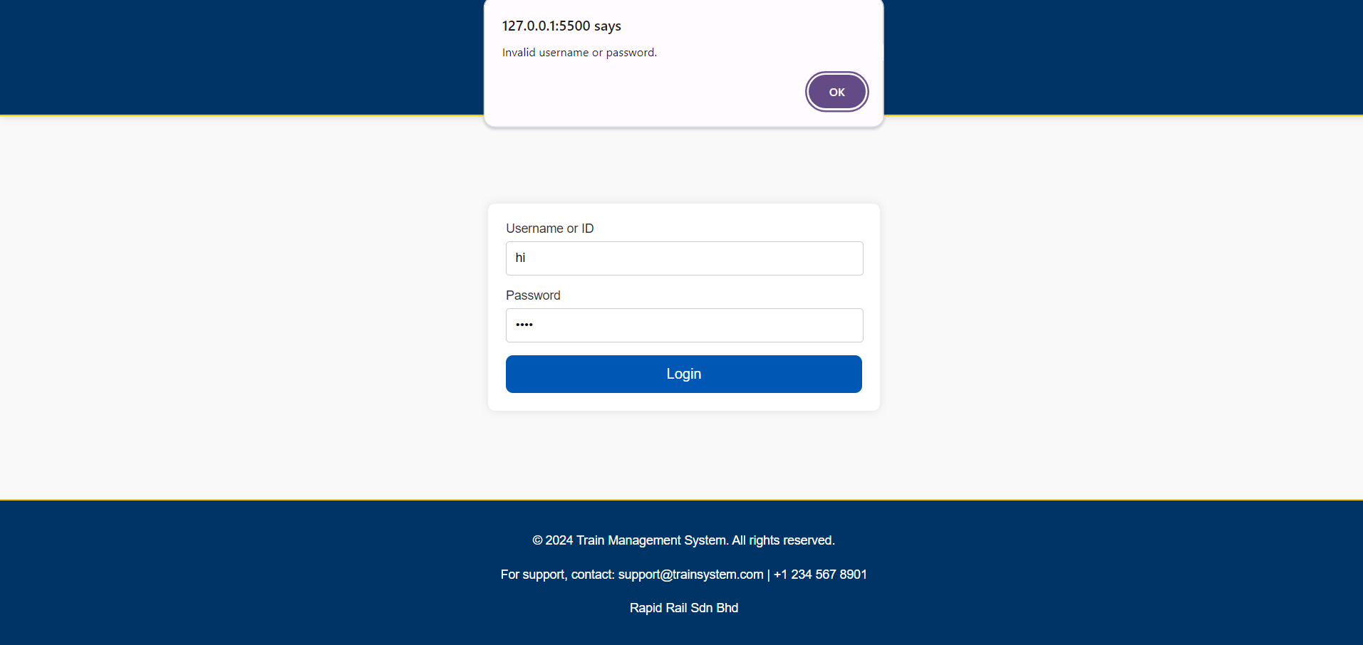 When users didn’t fill in the required fields, a message will be prompted that asks the user to fill in the required fields.
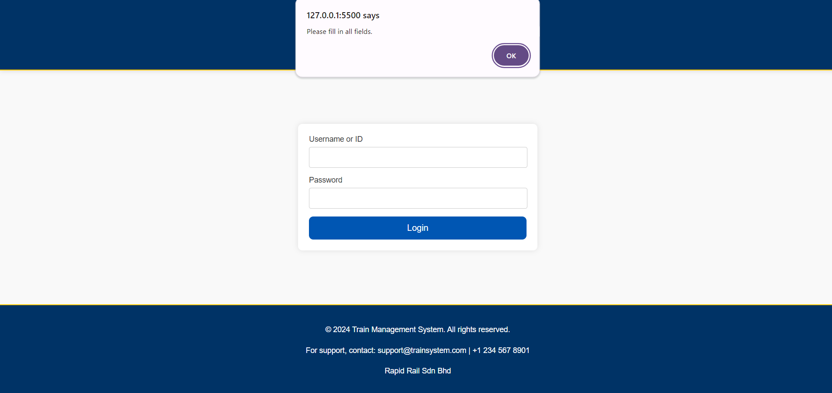After users enter the correct ID and password, users click the blue login button to submit the credentials and access the system and proceed to the next section.
2. Menu Page: After logged in, it will come to the menu page which shows all Customer Feedback Records and with a sidebar on the left which can go through customer feedback report page, manage to respond to customer feedback page and log out.

3. Customer Feedback Report Page: It allows users to select the category such as campaign, promotion and advertisement. After selecting one of them, click the button to generate a report, it will show the report of all the records under the specific category. If none of the categories are selected and click for generate a report the error message will be shown.
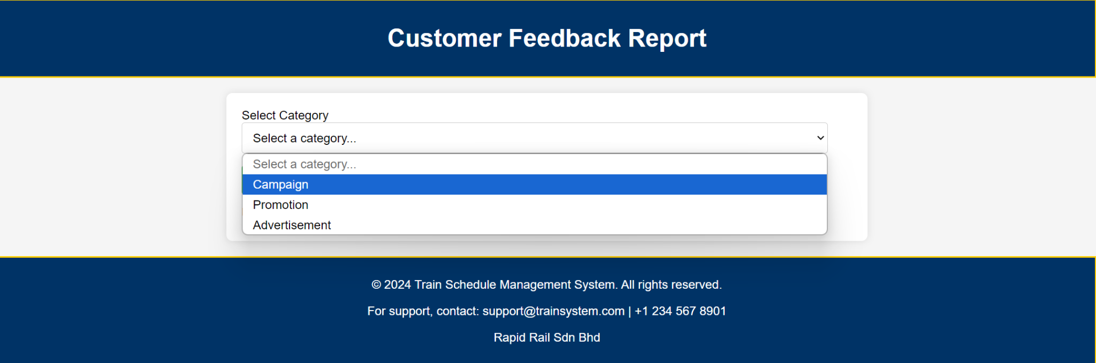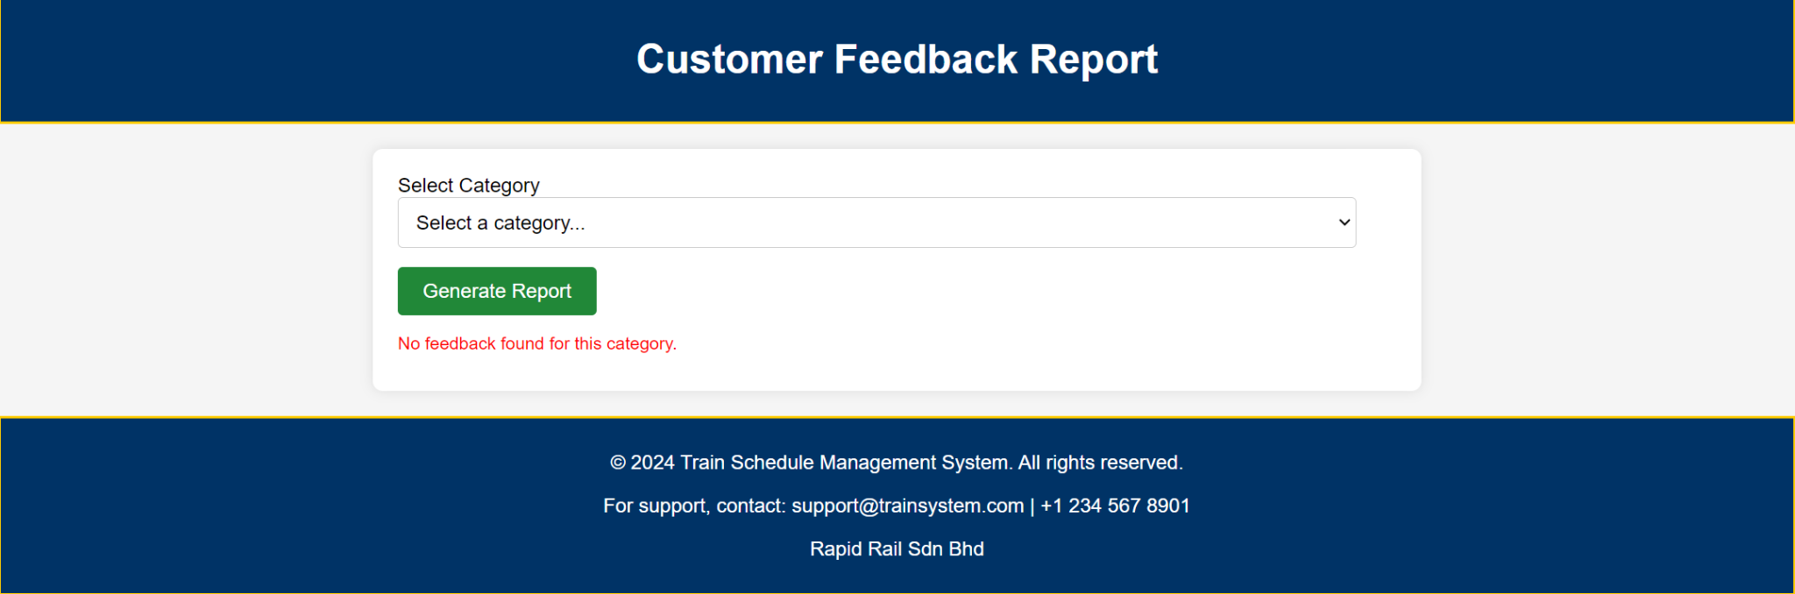
4. Respond Customer Feedback Page: It allows users to select the status such as all, open, in progress and resolved. After selecting one of its clicks for filter, the specific status records will display out. Users can click for the response action for the specific record. After clicking the button, the user is allowed to insert the text for feedback to the customer. After confirming the text to be responded then click for save response or either cancel button if you do not like to respond to the feedback. If the feedback successfully saved the successful message will be shown, else if failed to save like an empty response, the error message will be shown.
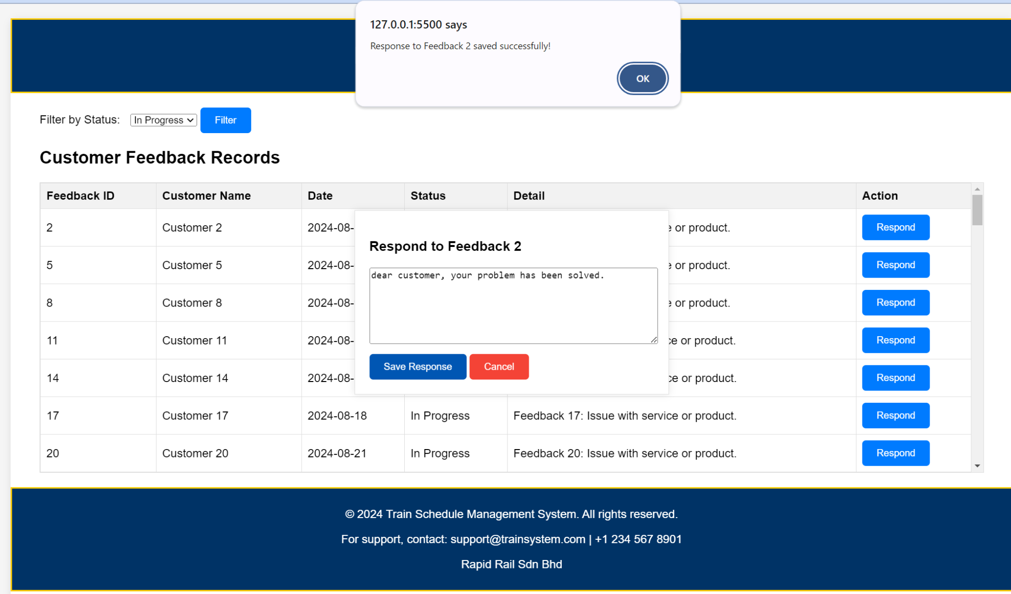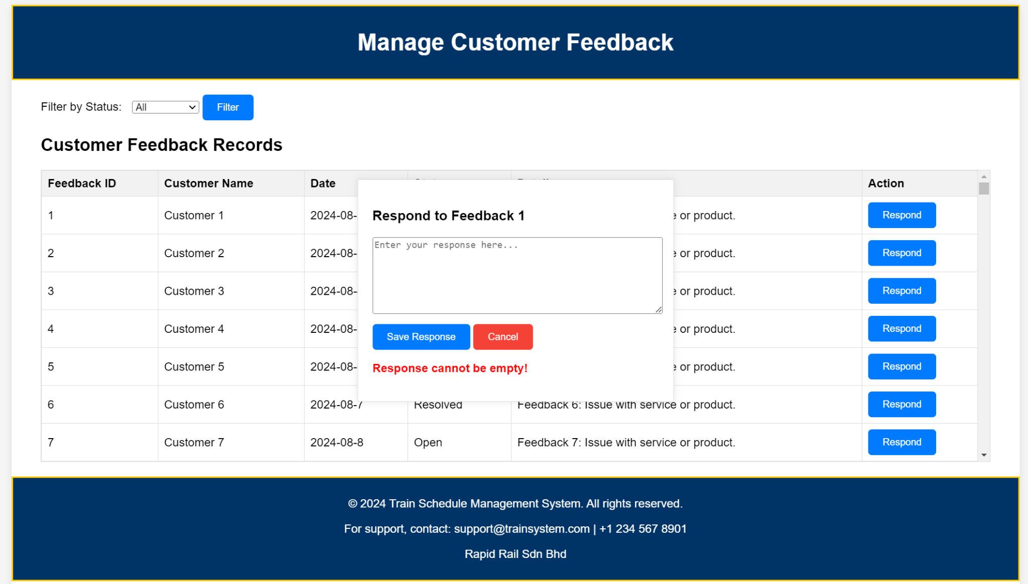

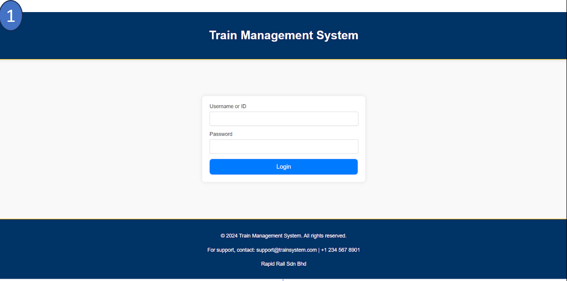
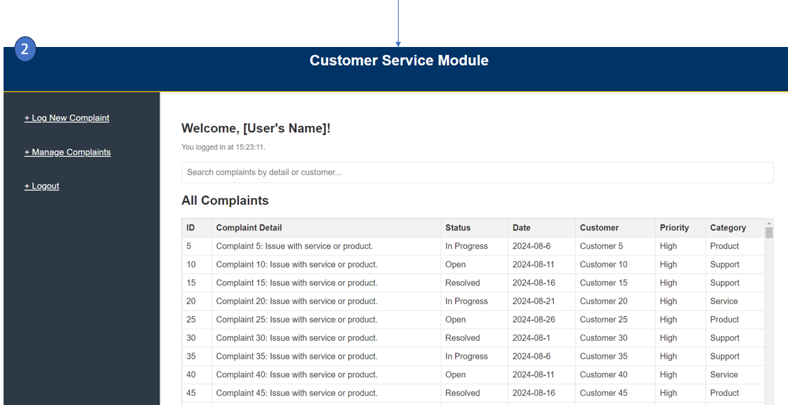
3.1.3 Customer Service Module
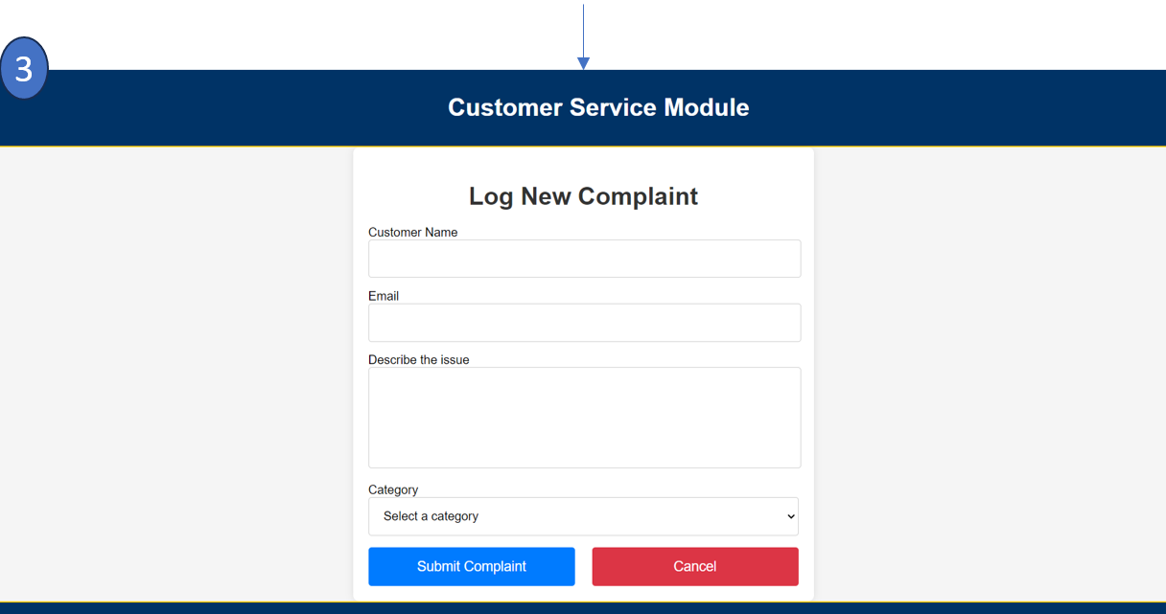
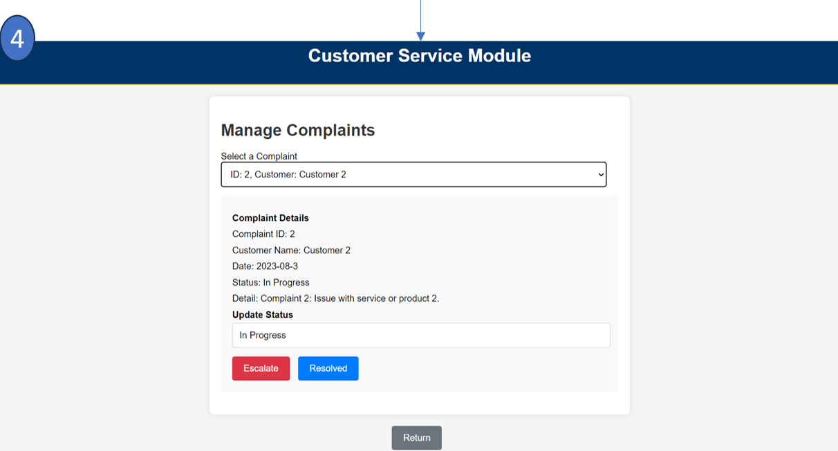
Diagram 3.1.3.1 (Customer Service Module User Interface Design)

3.1.3.1 Brief Description on User Interface For Customer Service Module
- Login section. Users have to enter the correct ID and password to proceed to the next section. When users enter the wrong ID or password, an error message will be displayed.
When users didn’t fill in the required fields, a message will be prompted that asks the user to fill in the required fields.
After users enter the correct ID and password, users click the blue login button to submit the credentials and access the system and proceed to the next section.

- Complaint Homepage. There is a navigation panel on the left hand side that consists of three buttons: log new complaint, manage complaint and logout. Log New Complaint: A link/button to navigate to the page where a new complaint can be logged. Manage Complaints: A link/button to manage existing complaints. Logout: A link/button to log out of the system and return to the login section. There is a welcome message on the top, including a personalized greeting, "Welcome, [User's Name]!" and displays the login time: "You logged in at [Time].". There is a complaints table that displays a list of all complaints with several columns (ID, Complaint Detail, Status, Date, Customer, Priority and Category). A search bar is provided to let users search the complaint by details or customer name.

- Log New Complaint section. There are 4 form fields to be filled in. Customer Name: A text input field to enter the name of the customer lodging the complaint. Email: A text input field to enter the email of the customer. When the format of the email is wrong, an error message saying the format is wrong will be displayed.
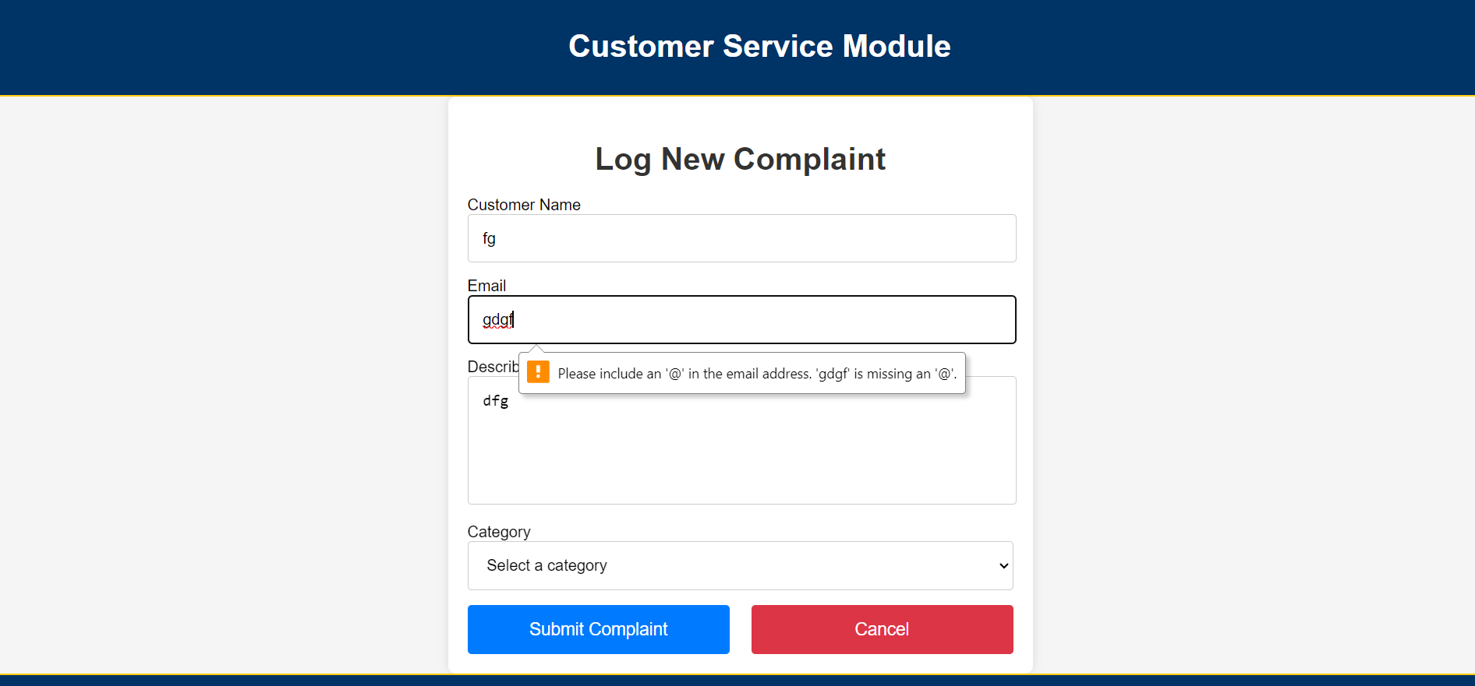
Describe the Issue: A text area where the user describes the complaint or issue. Category: A dropdown list to categorize the complaint.
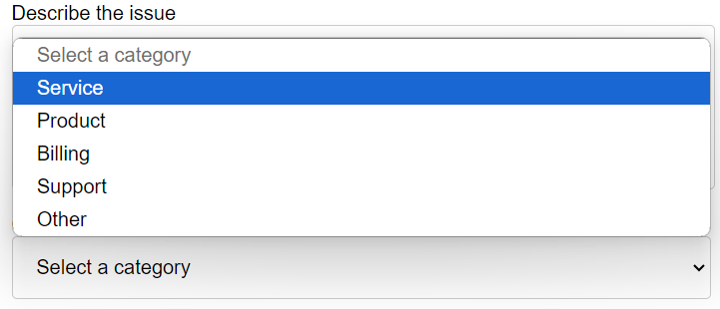After filling all the fields, users click the Submit Complaint Button, which is a large blue button labeled "Submit Complaint" to log the new complaint into the system. Before the complaint is successfully logged, validation checks will be carried out to ensure all the fields have been filled. If not filled, an error message will be displayed that asks users to fill in all the fields.
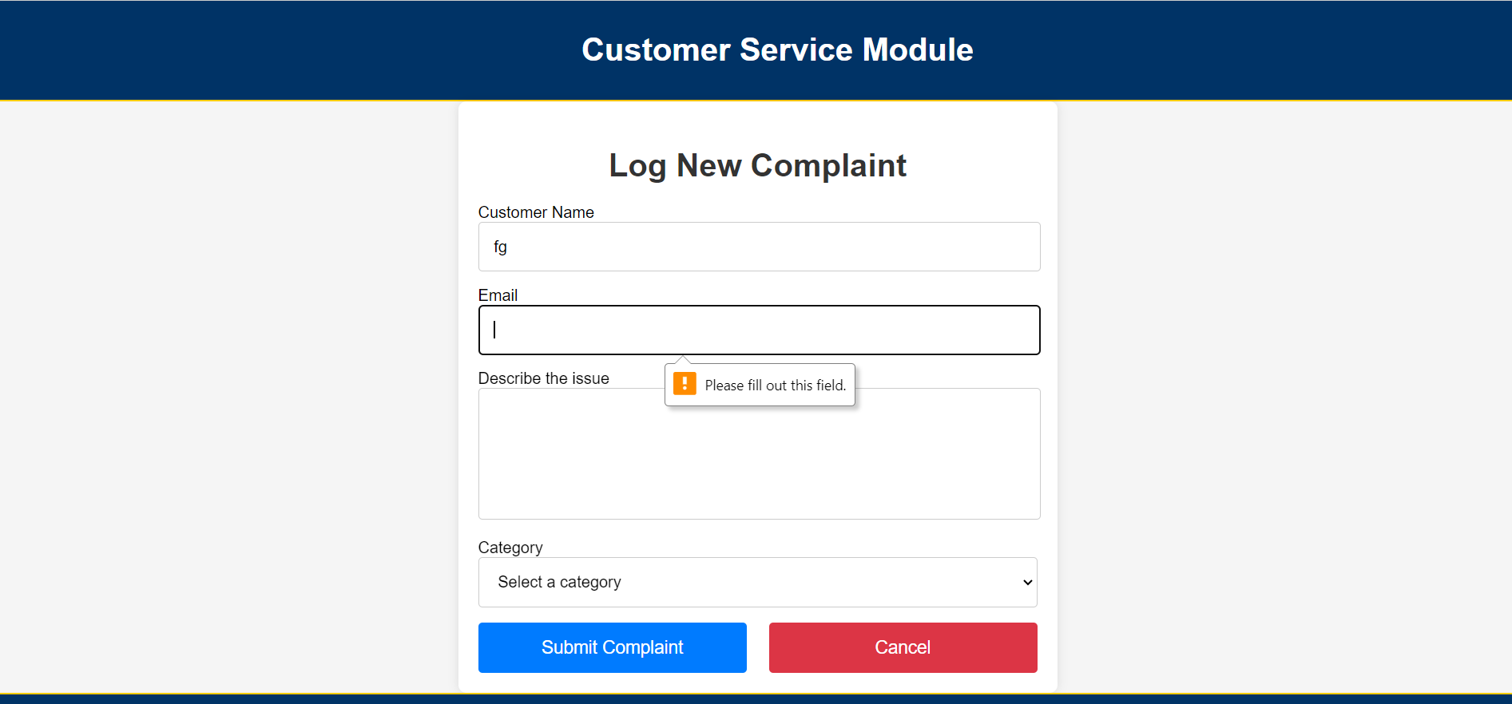
If users want to cancel to log a new complaint or return to the complaint homepage, users click the Cancel Button, which is a large red button labeled "Cancel" to return.

4. Manage Complaint section. This section consists of a dropdown menu labeled as “Select a Complaint” that allows the user to choose a specific complaint by ID and customer name.
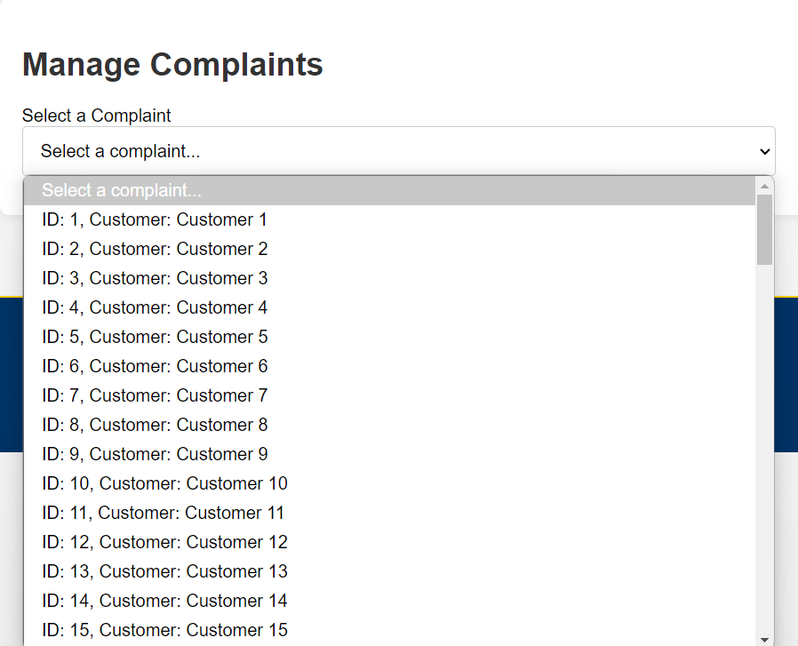 After selecting the complaint, complaint details will be displayed. Then, there is a Update Status Section, which includes a text box to update the status of the complaint.". Finally, there are two buttons with different functionalities. Escalate Button: Red button labeled "Escalate," likely used to escalate the complaint to higher authorities. Resolved Button: Blue button labeled "Resolved," used to mark the complaint as resolved.

After clicking the button, status in the database will be updated and a notification will be automatically sent to the customer and a successful message will be prompted and returned to the Complaint Homepage
. 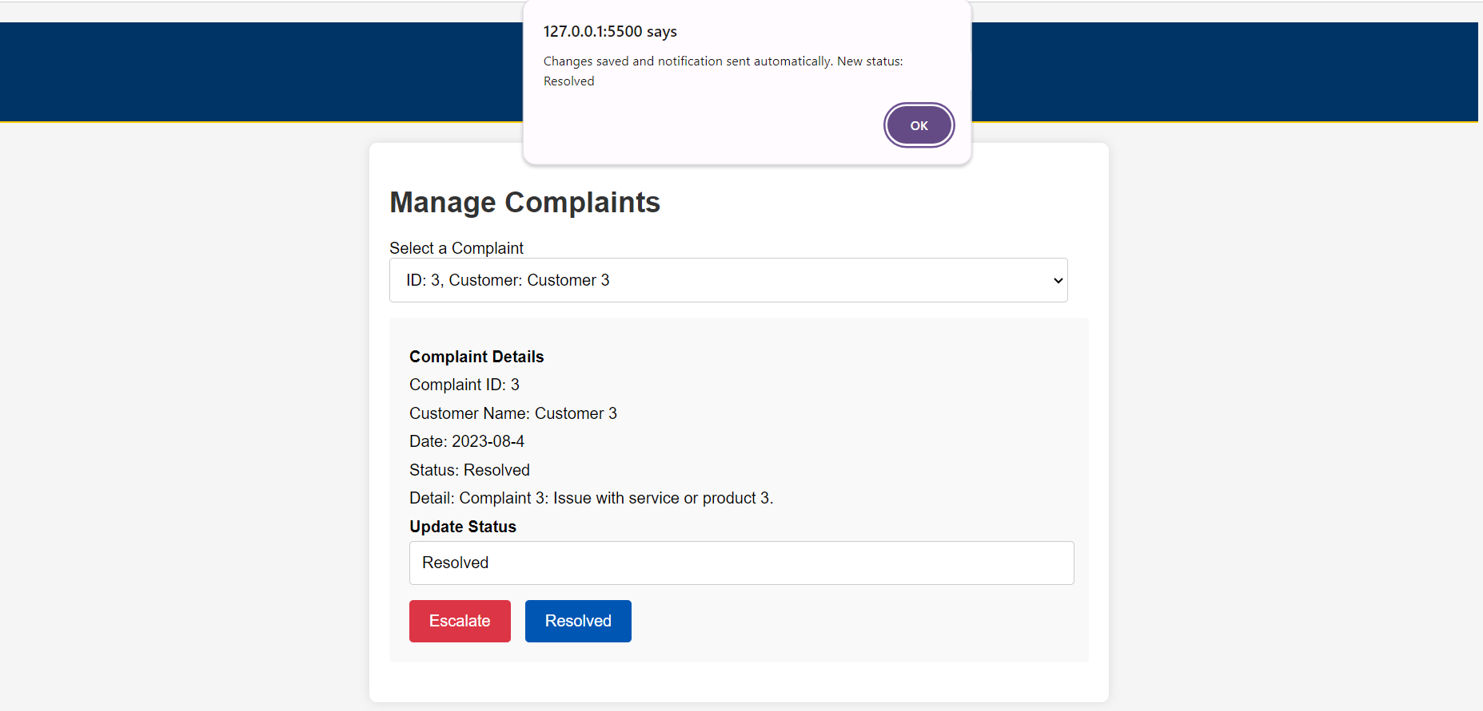

3.1.4 IT Module

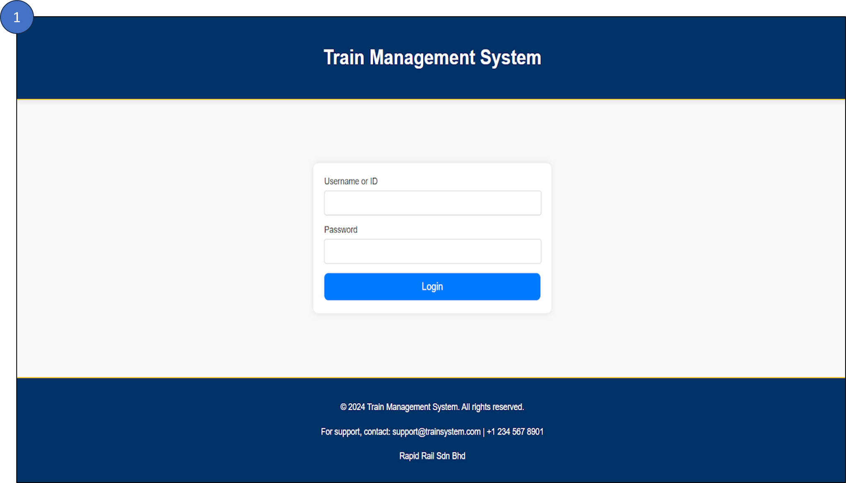

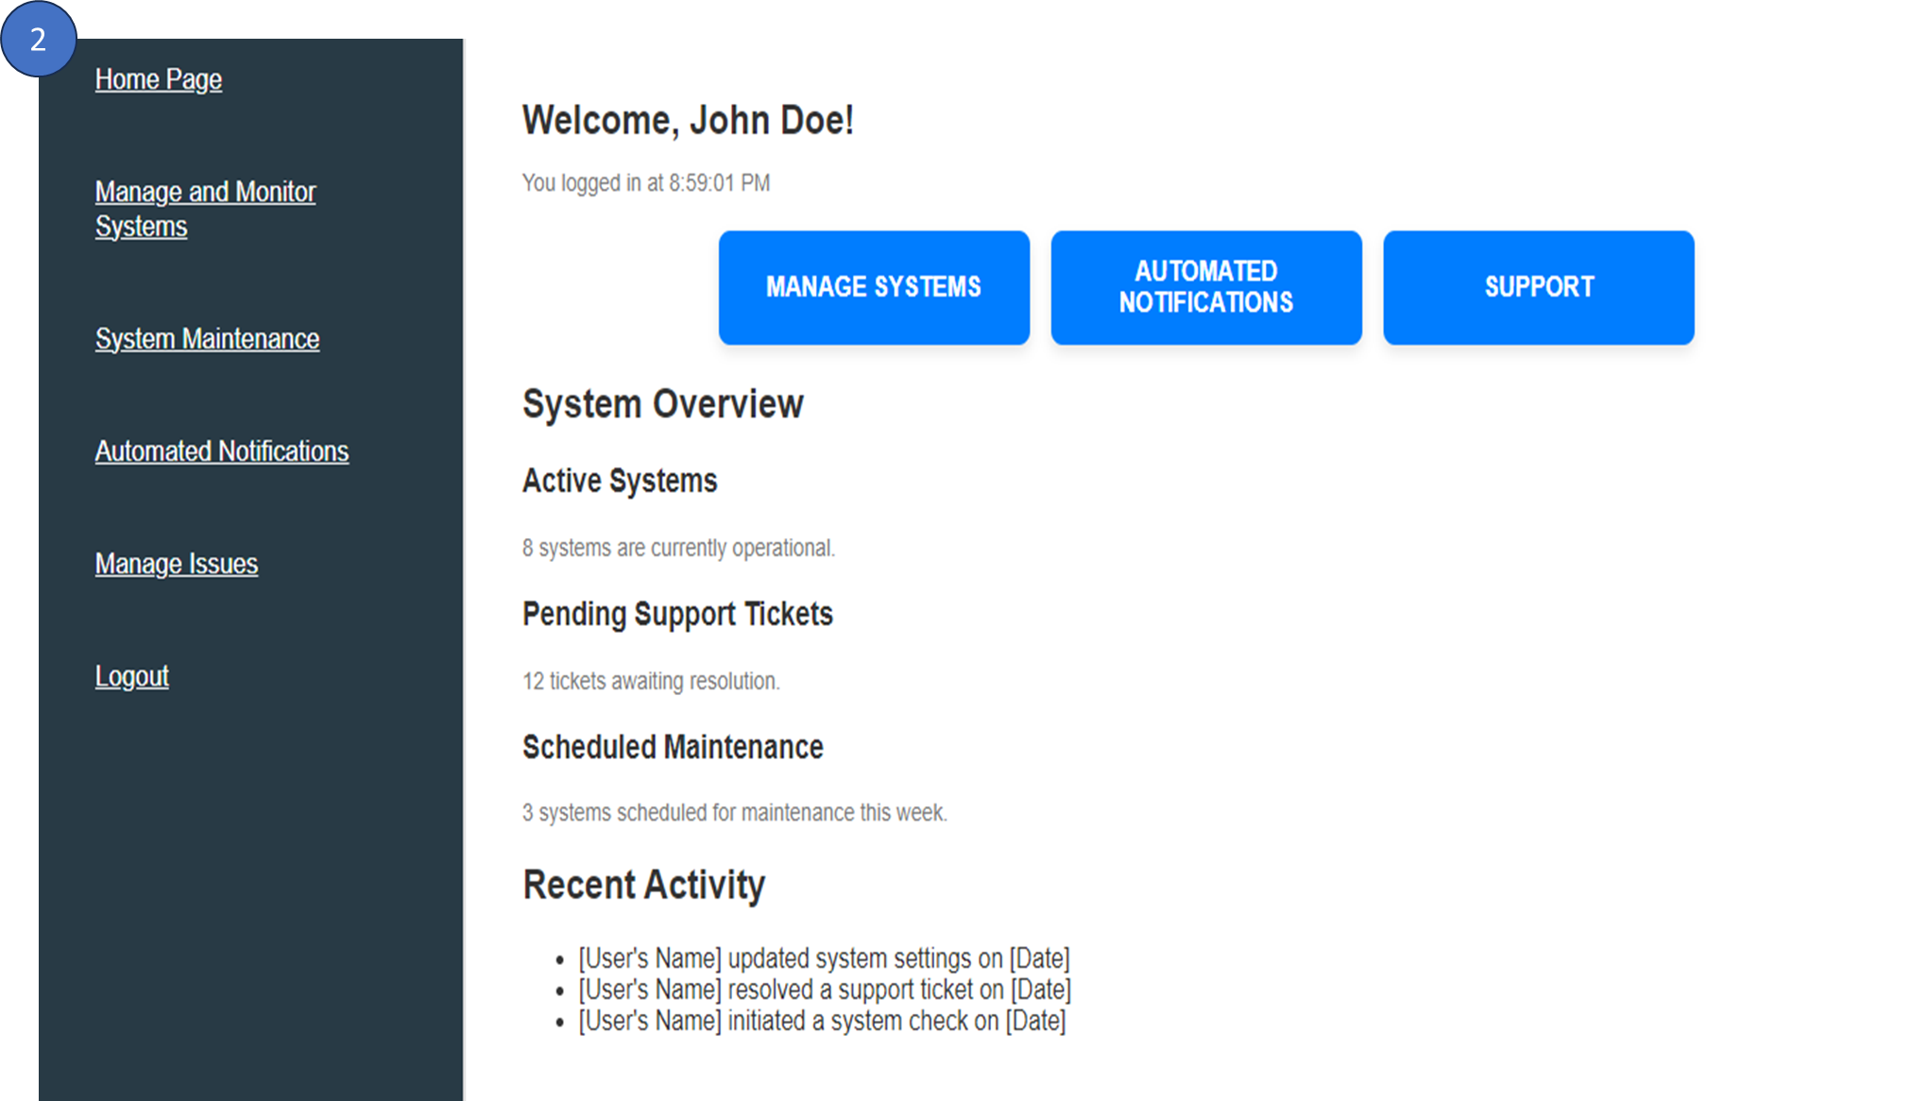

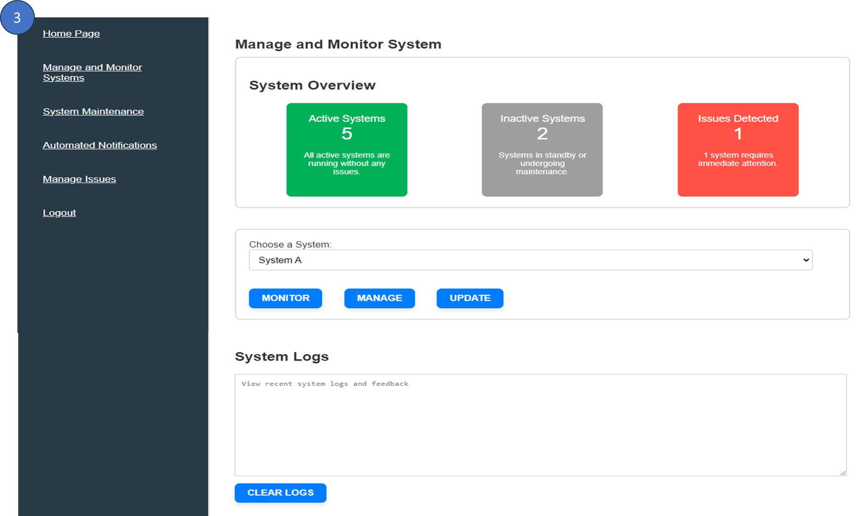

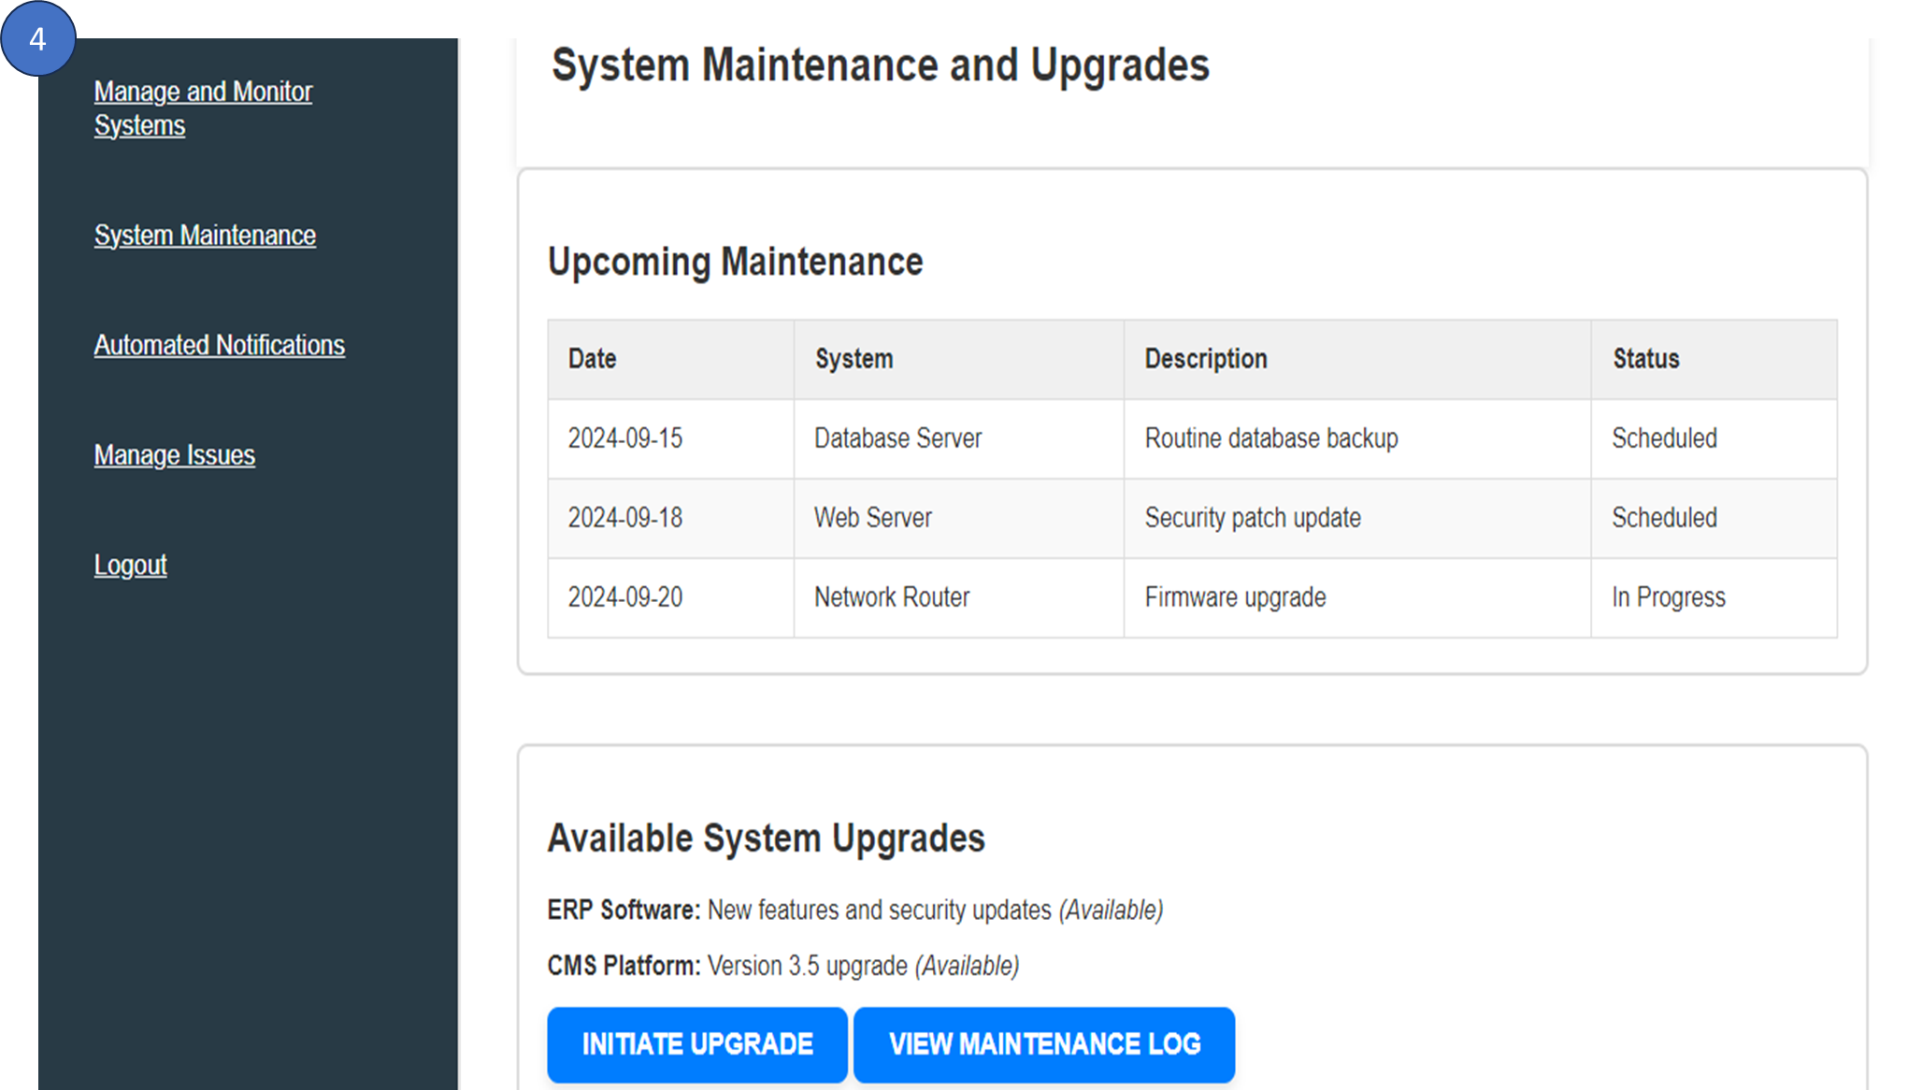

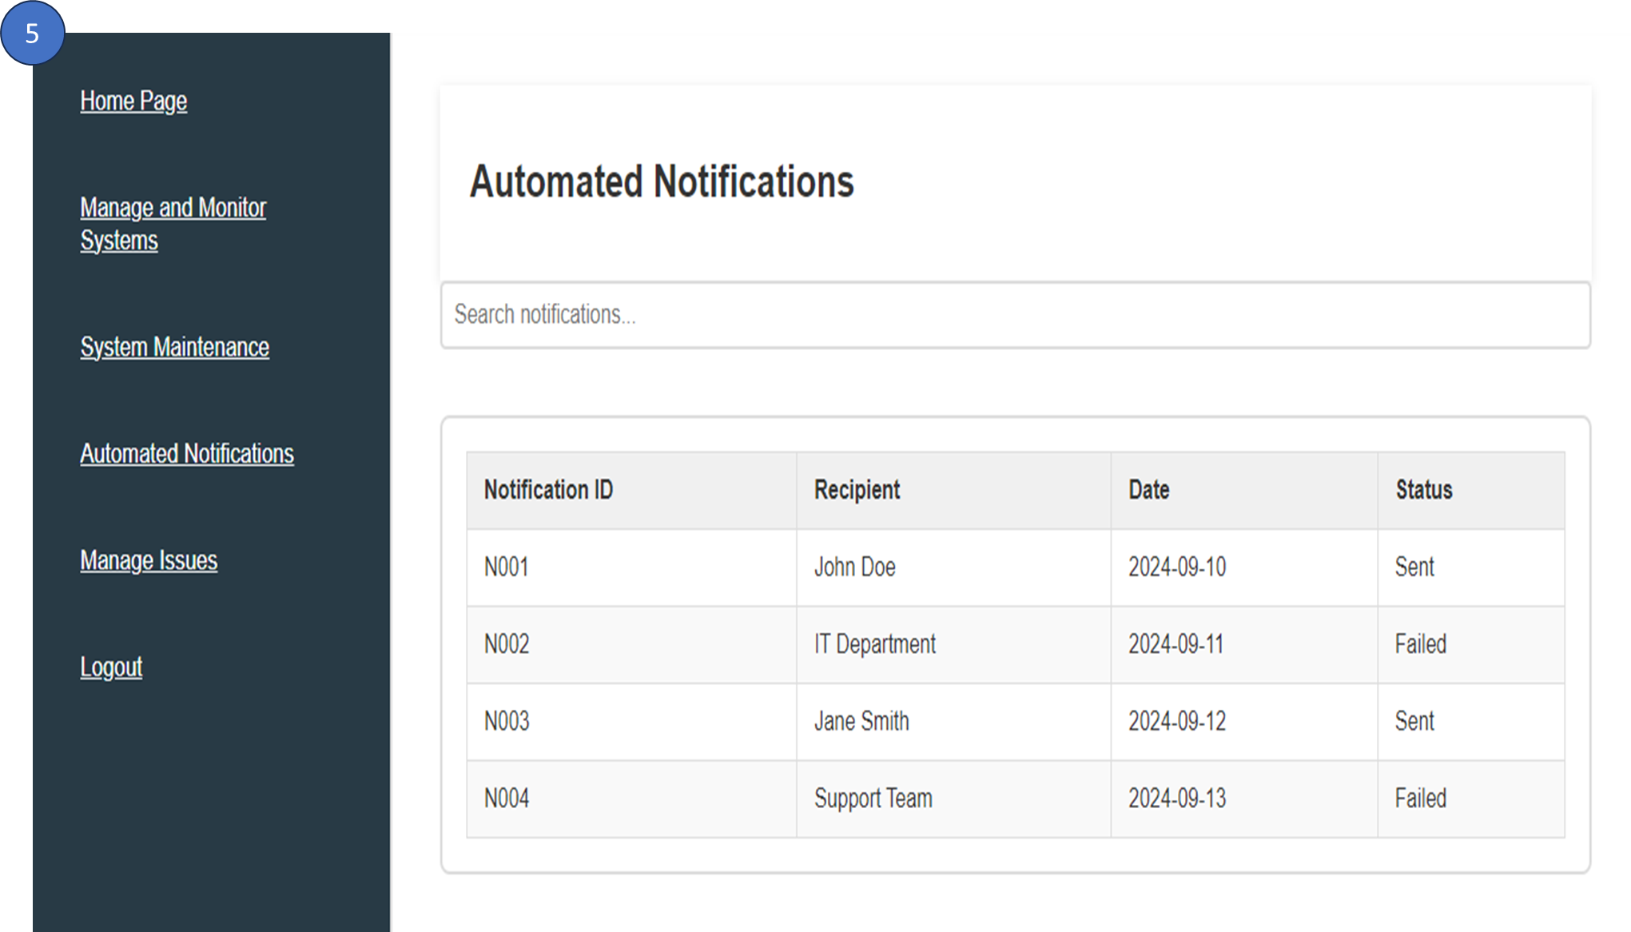

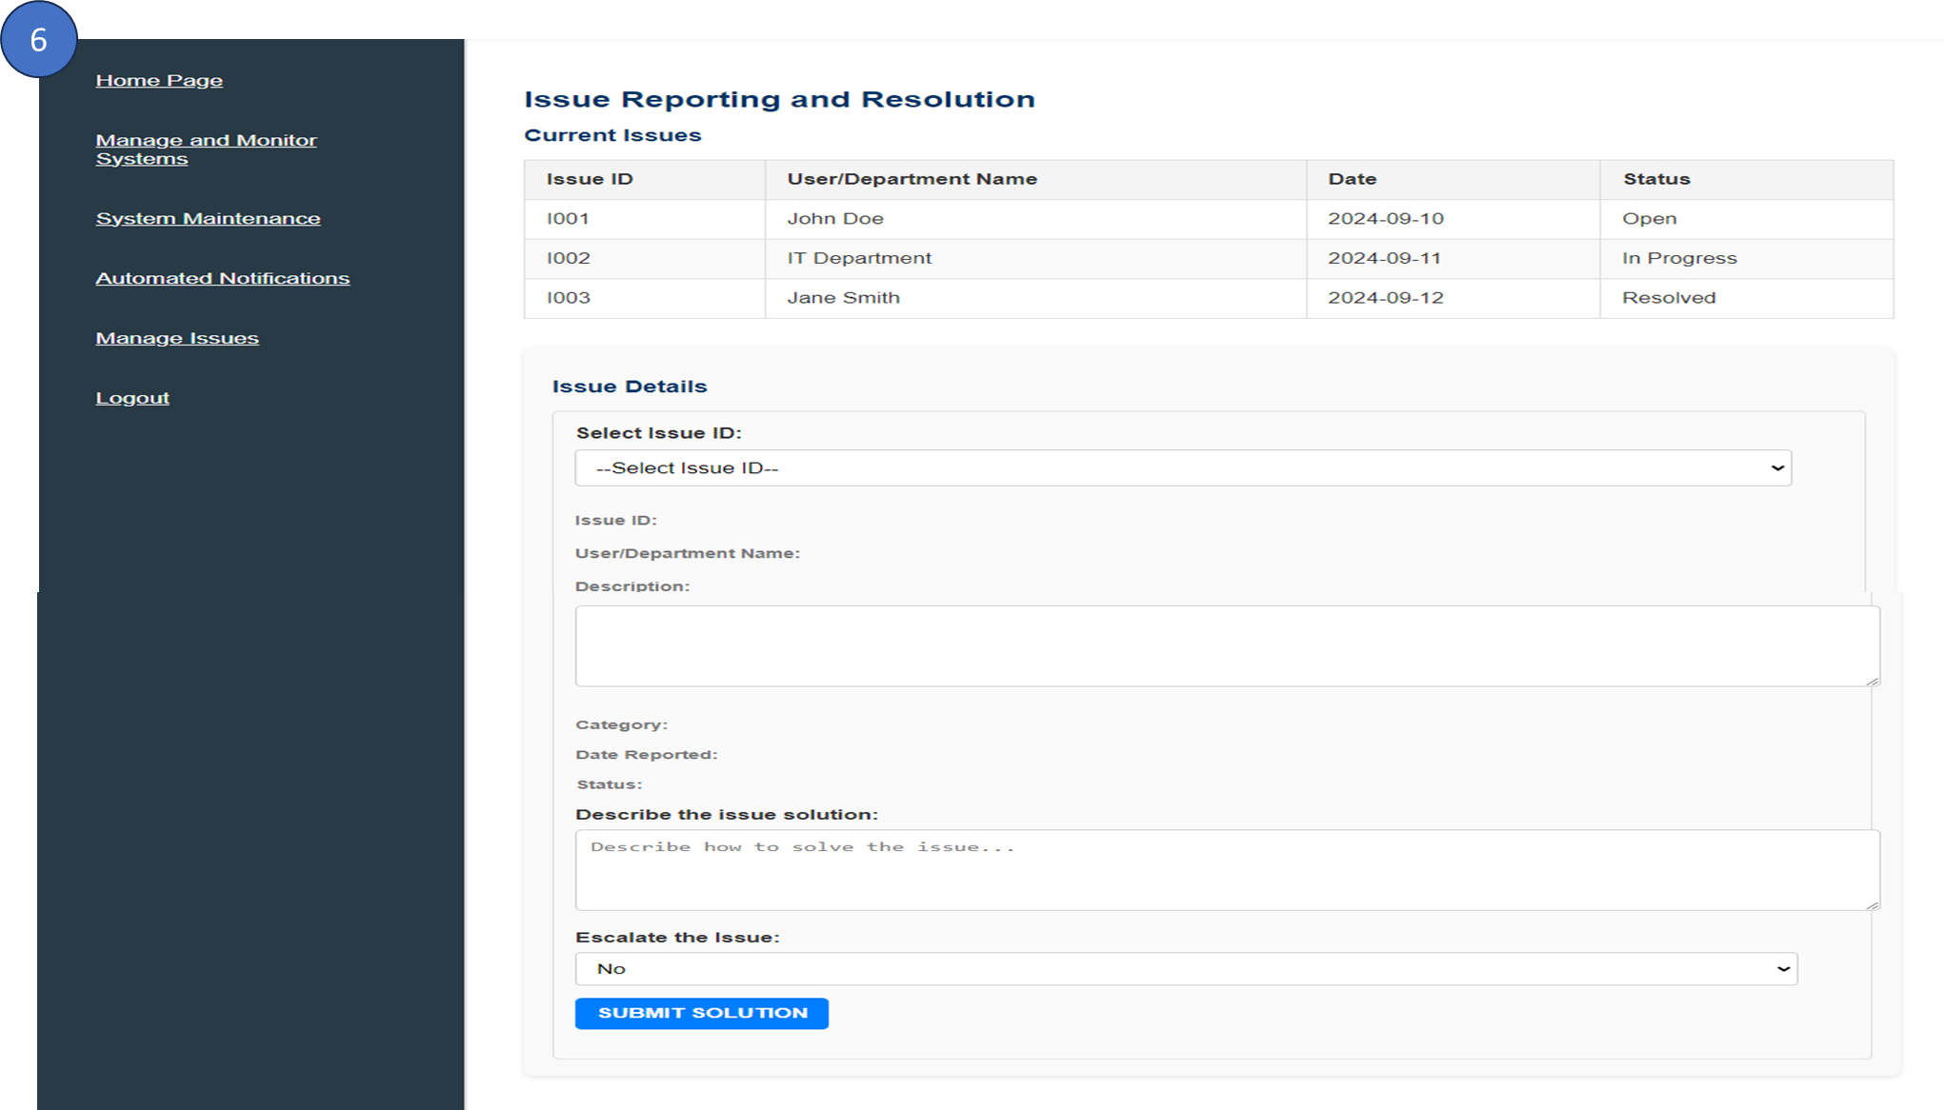

Diagram 3.1.4.1 (IT Module User Interface Design)

3.1.4.1 Brief Description on User Interface For IT Module
2. Home Page Session. The Manage Systems button leads to the Manage and Monitor Systems page, where users can oversee system operations and performance metrics. The Automated Notifications button directs users to the Automated Notifications page, allowing them to manage and configure system alerts. Lastly, the Support button takes users to the Issue Reporting and Resolution page, where they can report technical problems and track their progress toward resolution.

3. Manage and Monitor System Session. There is a list of available systems to choose from for monitoring, management, or updates.
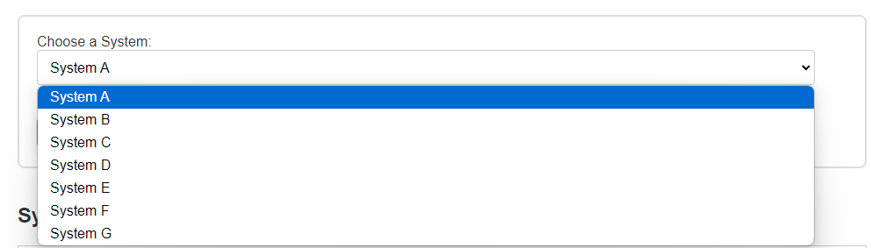

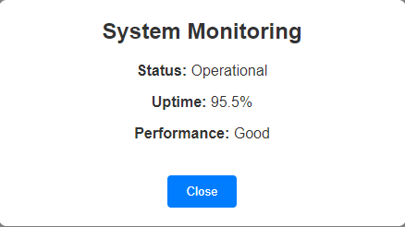
The Monitor button allows users to track the status, uptime, and performance of the selected system in real-time.

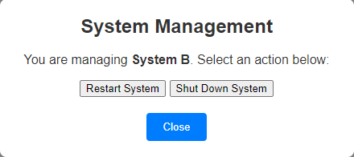
The Manage System button gives users control to decide whether to restart or shut down the system.

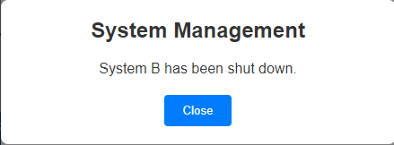
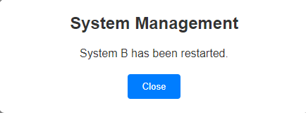

(After choosing the restart button) (After choosing the shutdown button)

With the Update button, users can apply system updates as needed.
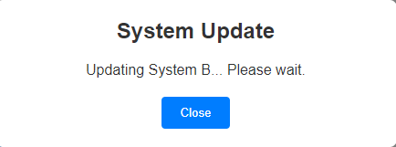
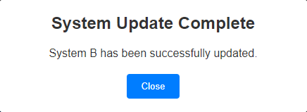

All user actions are recorded in the system logs, and there is a Clear Logs button available for users to easily clear the log history when necessary.
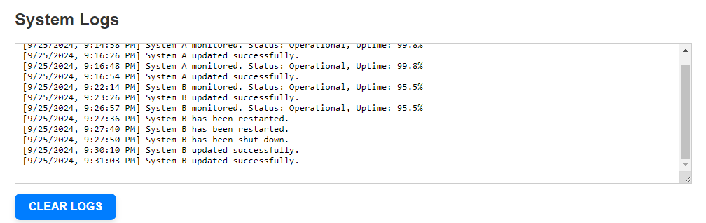
(Before clear logs)
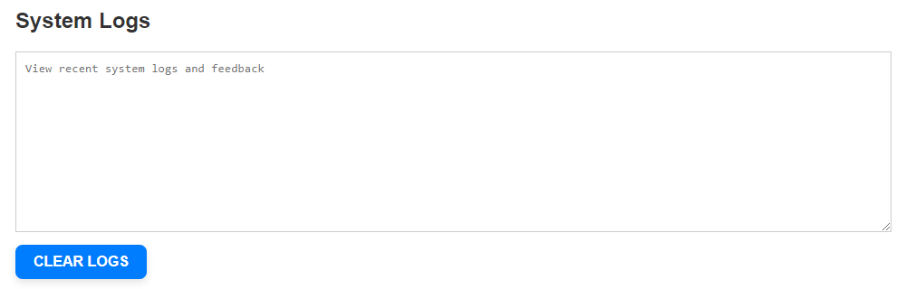
(After clear logs)

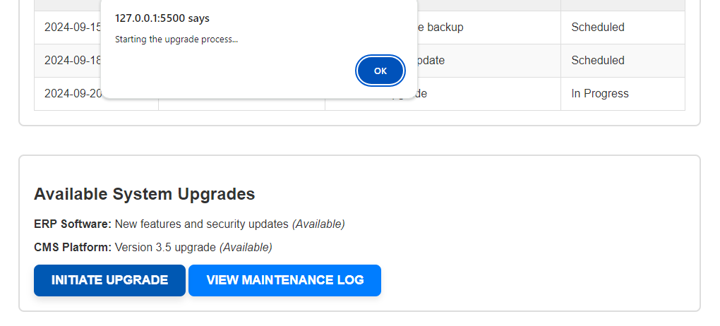
4. System Maintenance and Upgrades Session. Staff have the option to either initiate system upgrades or review the maintenance log. When choosing to initiate an upgrade, staff can follow a streamlined process to ensure that the latest features and improvements are implemented efficiently.

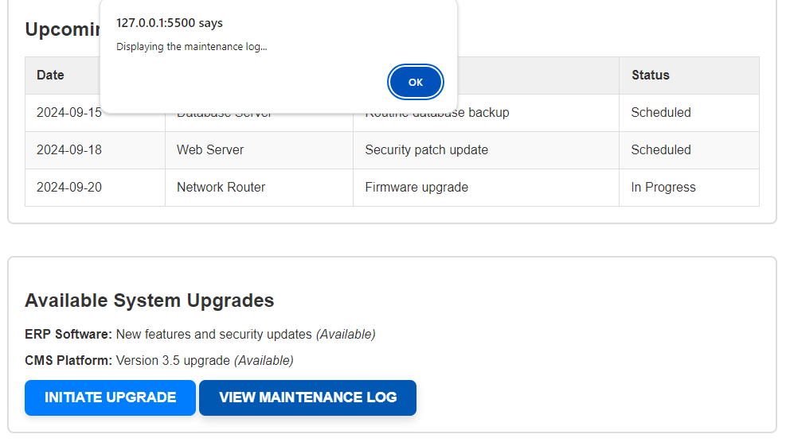
Alternatively, staff can view the maintenance log, which provides a comprehensive record of past maintenance activities, upgrades, and any issues that have been addressed.

5. Automated Notification Session. Staff benefit from a streamlined notification system that automatically sends updates regarding important events and system changes. While notifications are generated and delivered without manual intervention, staff retain the ability to search for specific notifications to view their history.
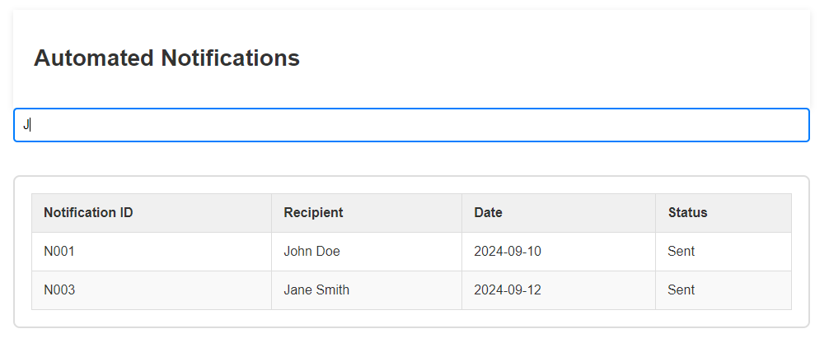
7. Manage Issues Session. There is a list of issues that allows users to select an issue by its ID to begin resolving it.
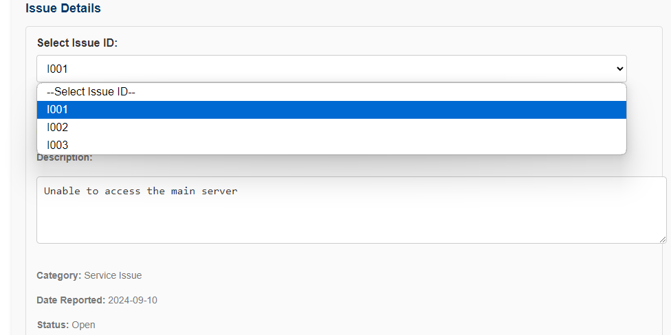
Once an issue is solved, users are required to provide a description of the solution.
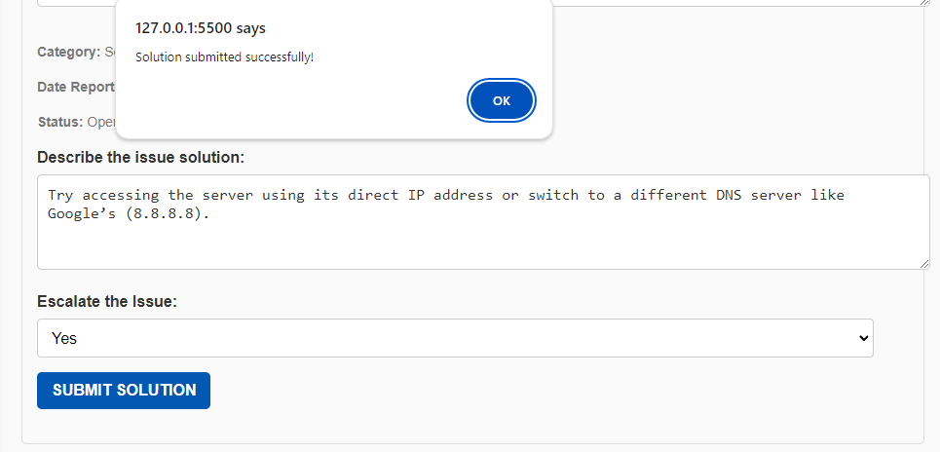
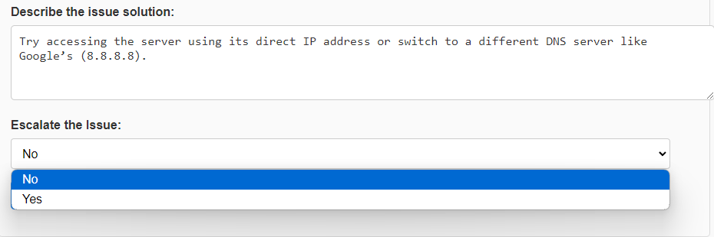 If the issue cannot be resolved, there is an option to escalate it for further assistance.

3.1.5 HR Module
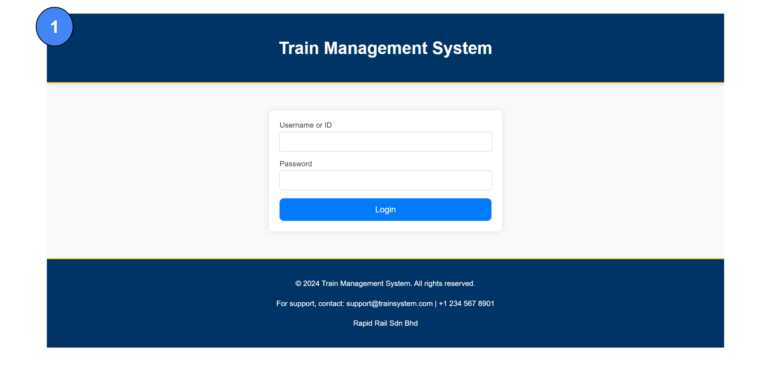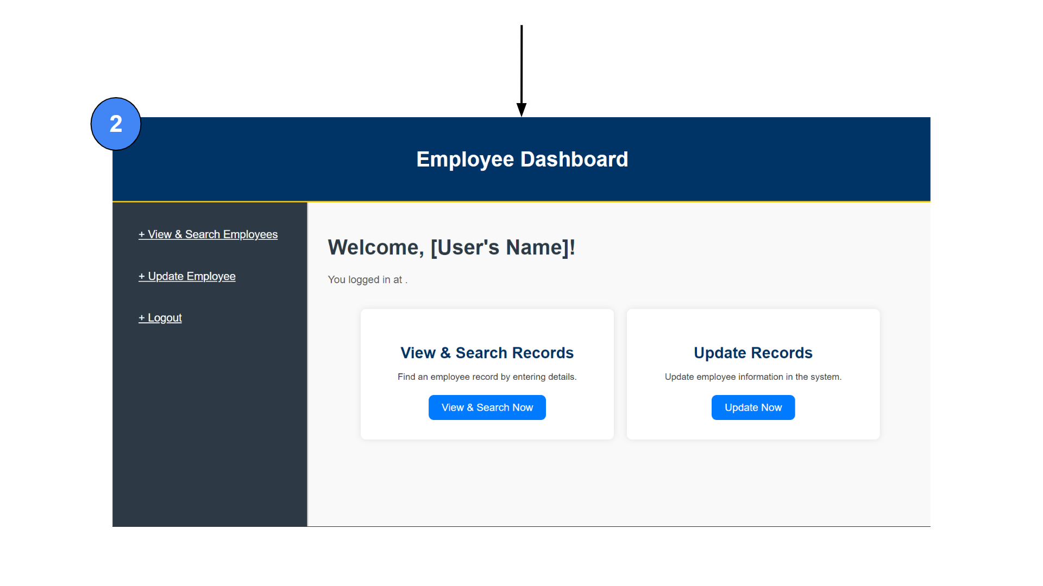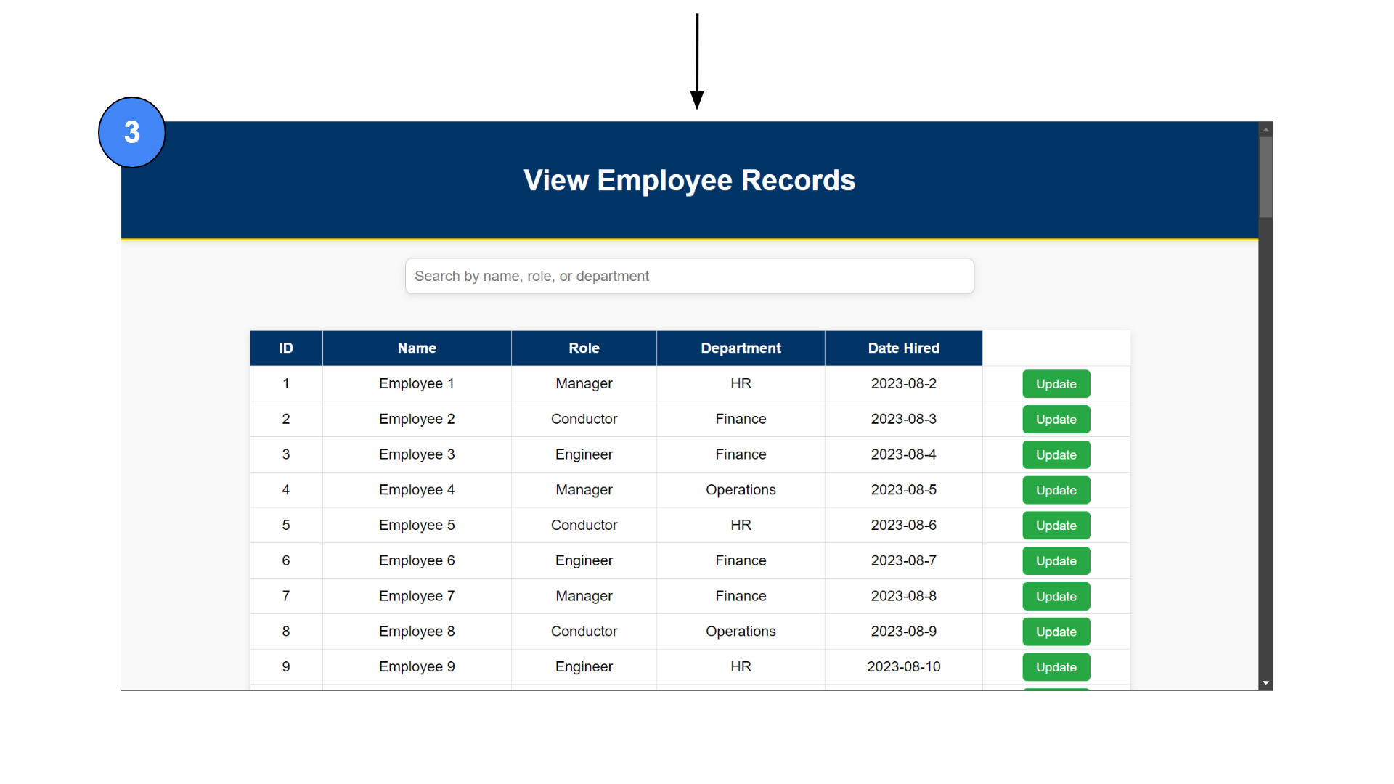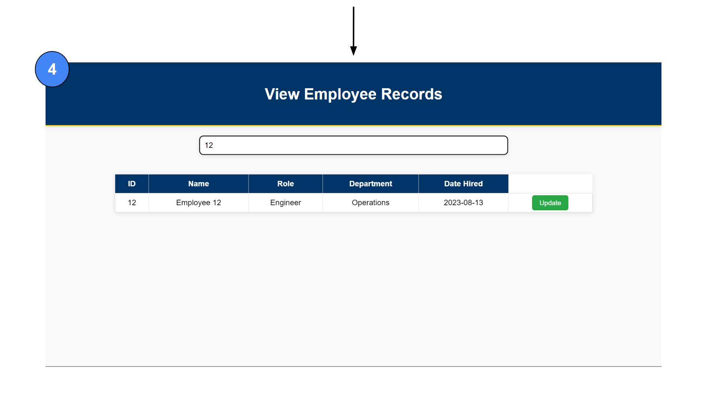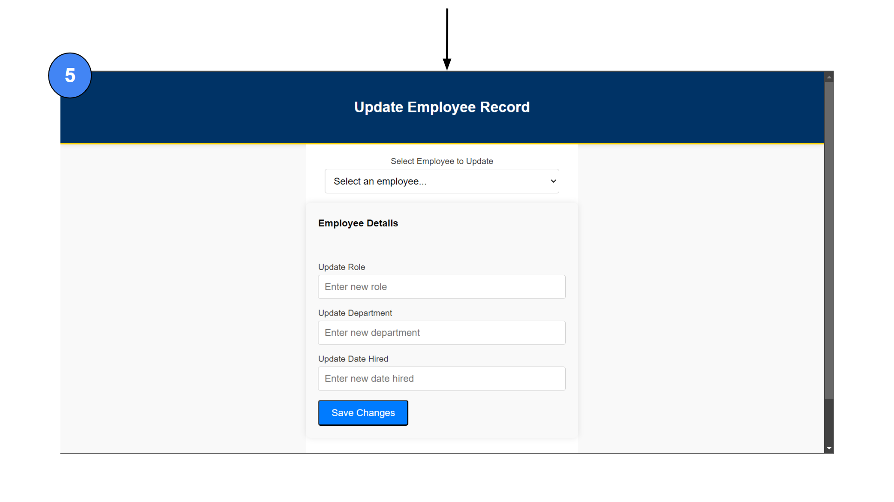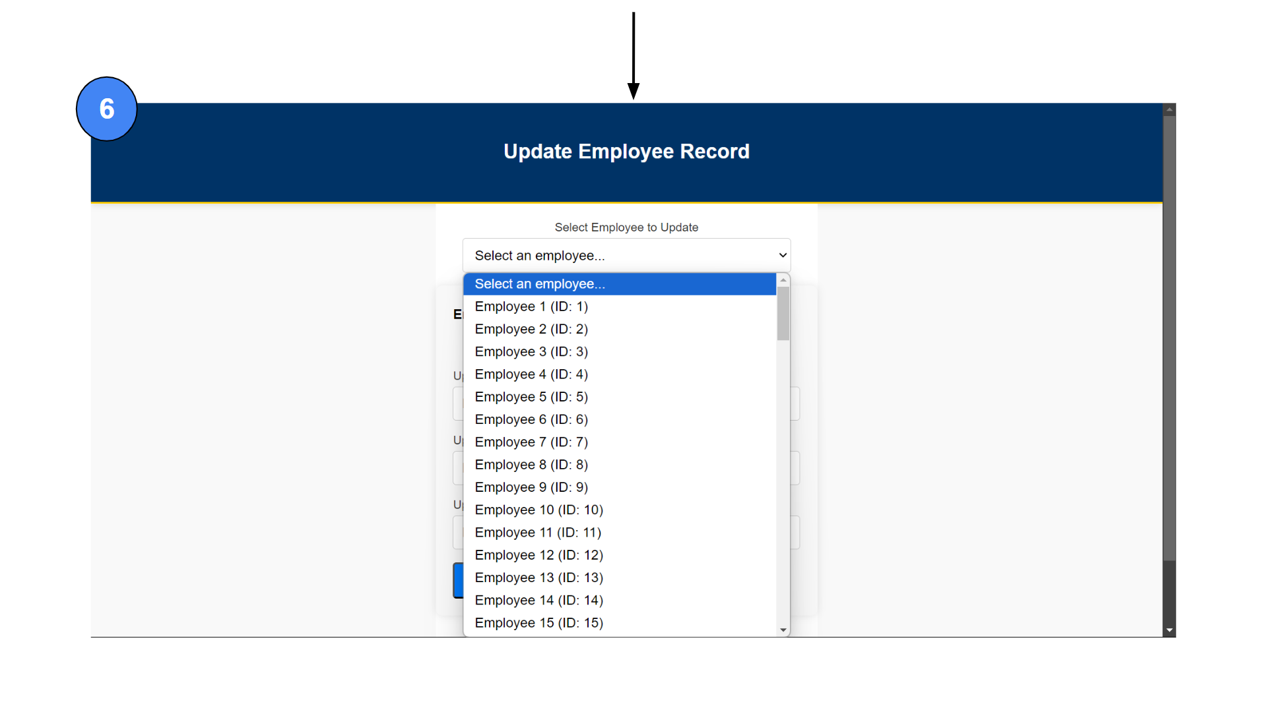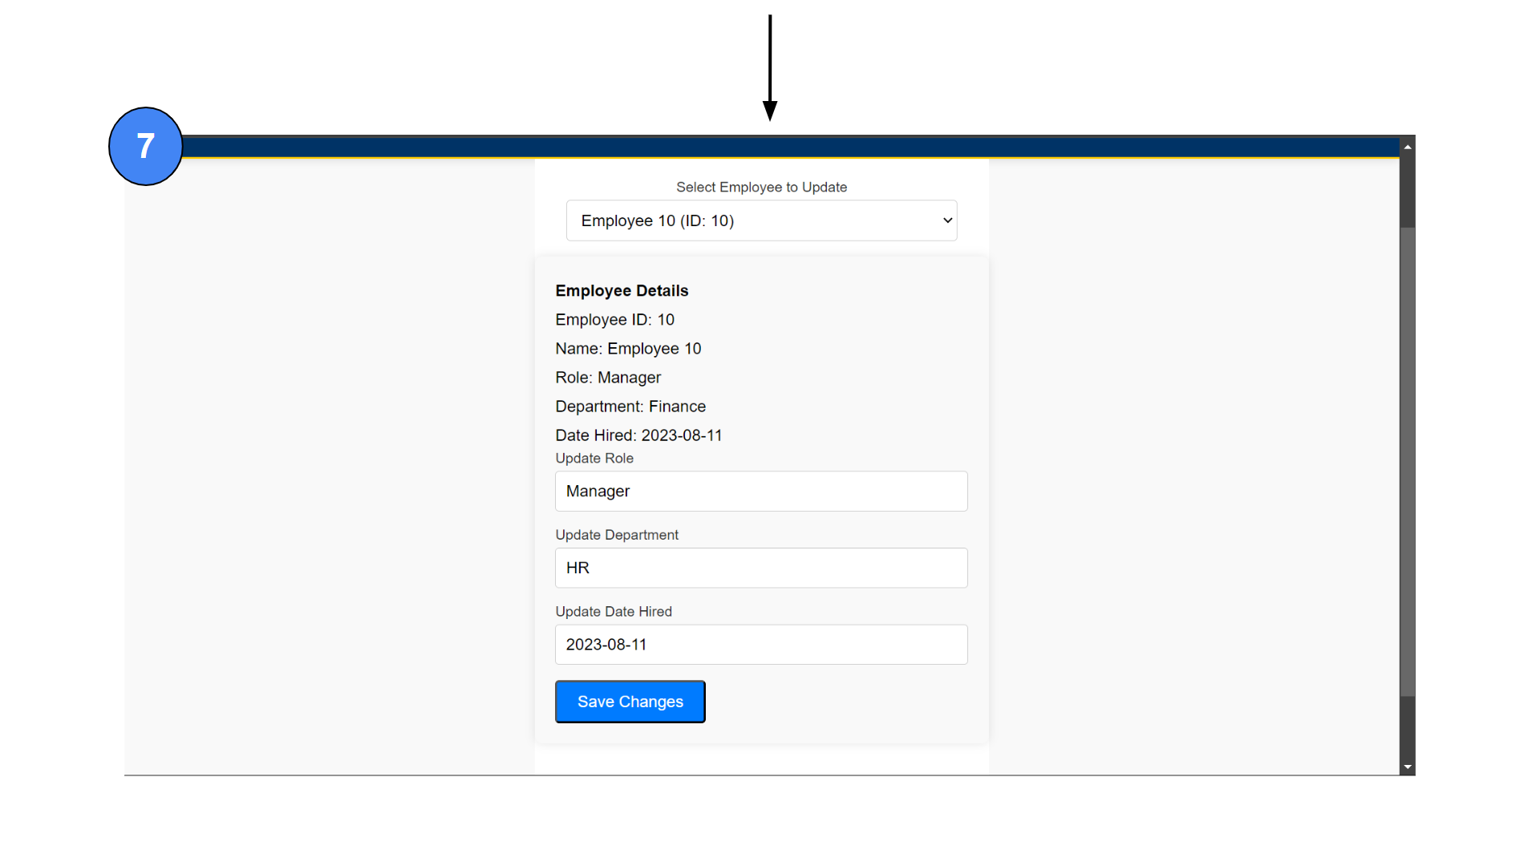
Diagram 3.1.5.1 (HR Module User Interface Design)

3.1.5.1 Brief Description on User Interface For HR Module
- Login section : Users have to enter the ID and password to proceed to the next section. If the ID is incorrect, an error message will be displayed, prompting users to correct their input.
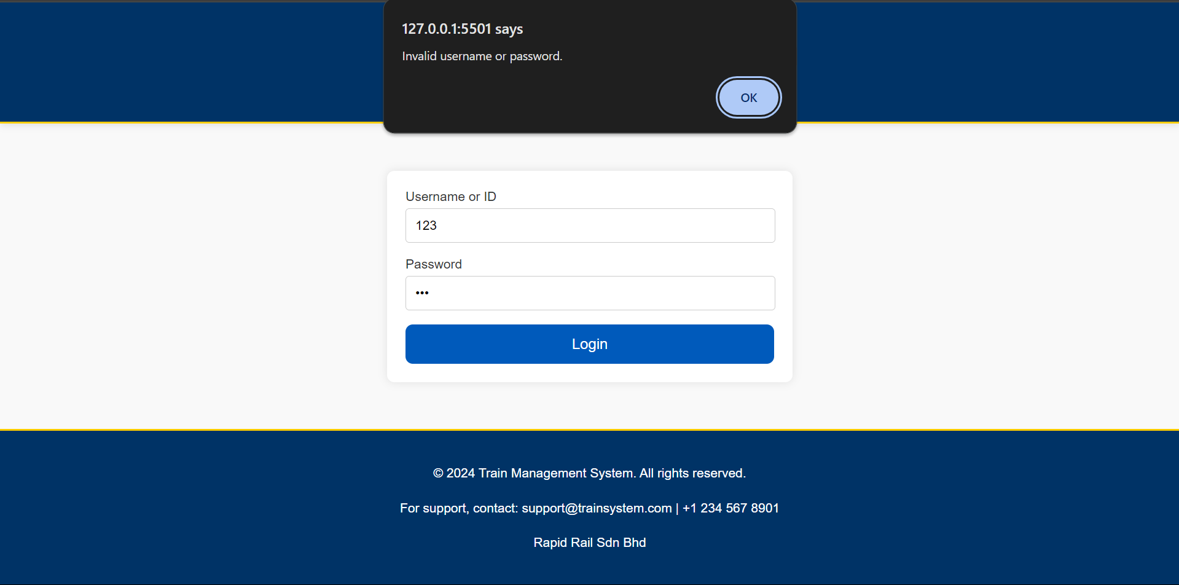
If any required fields are left blank, an error message will be displayed, prompting users to fill in the required fields.
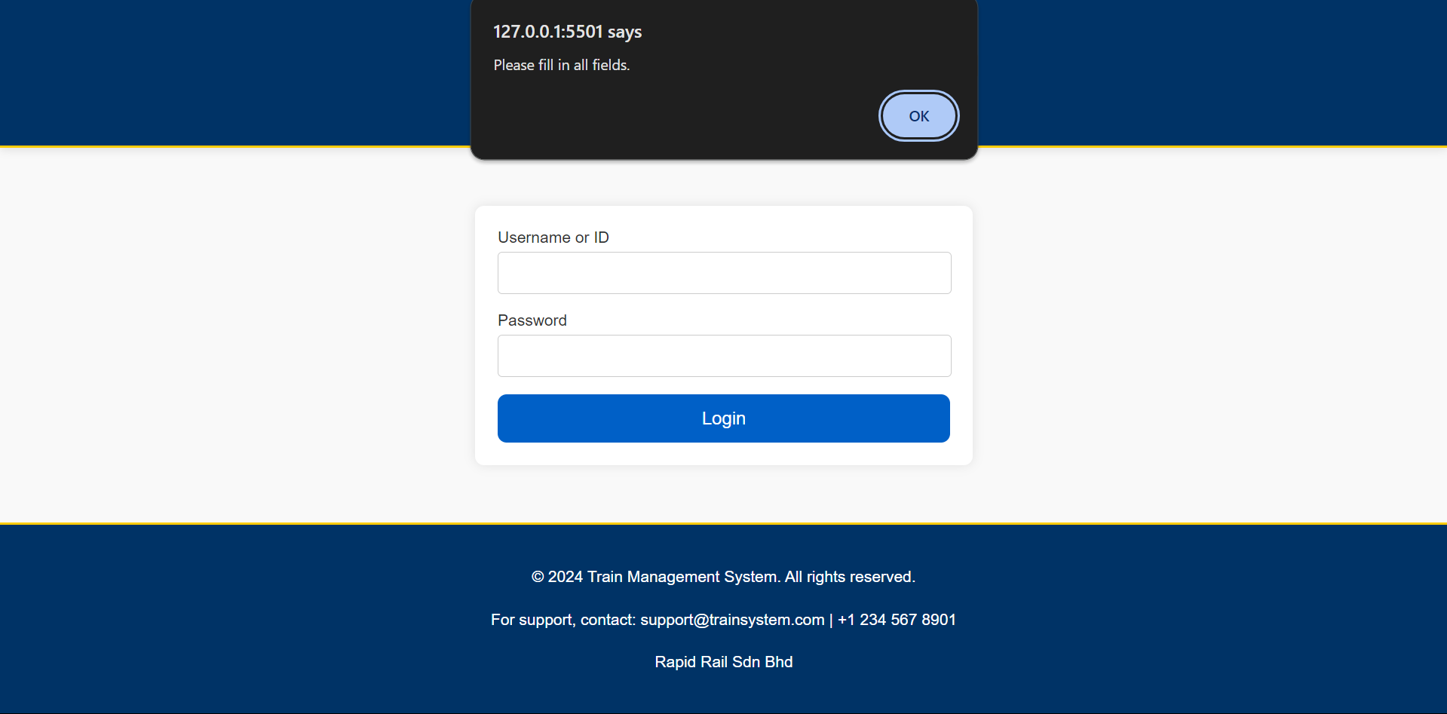

- Menu page : There is a navigation panel on the left hand side that consists of three buttons: View & Search Employees, Update Employee, and Logout. The "View & Search Employees" button takes users to a page where they can see a list of all employee records and search the employee ID. The "Update Employee" button takes users to a page where they can modify employee information. The "Logout" button logs the user out and returns them to the login page.

- View Employee Record page : Users are presented with a comprehensive table listing all employees. This table includes columns for Employee ID, Name, Role, Department, and Date Hired. Users can view detailed records or search for specific employee ID within this table.

- Update Employee Record page : This section allows users to make changes to an employee's information. It includes a dropdown menu for selecting an employee by ID or name. Once an employee is selected, their current details are displayed. Users can then update these details by filling in the fields for role, department, and date hired. The system ensures that all fields are filled before allowing changes to be saved and provides a notification upon successful update.
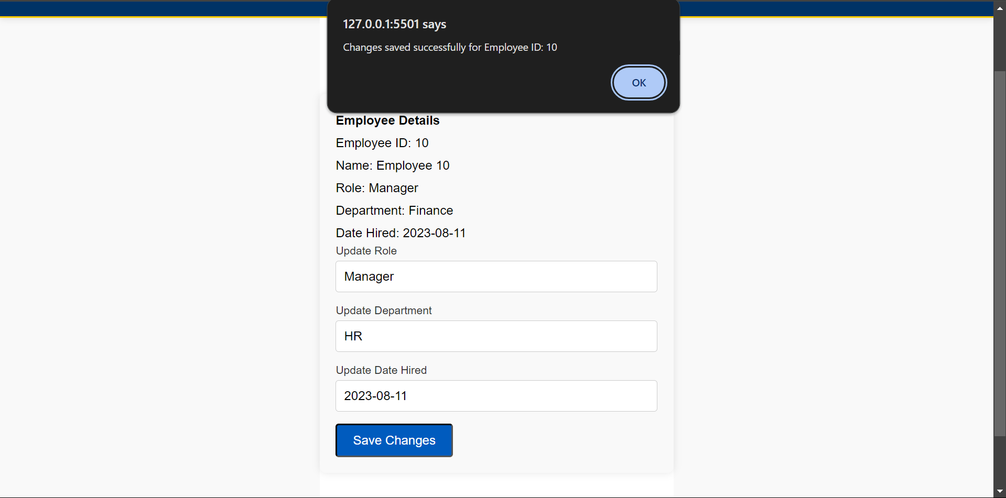
If any required fields are left blank, an error message will be displayed, prompting users to fill in the required fields.
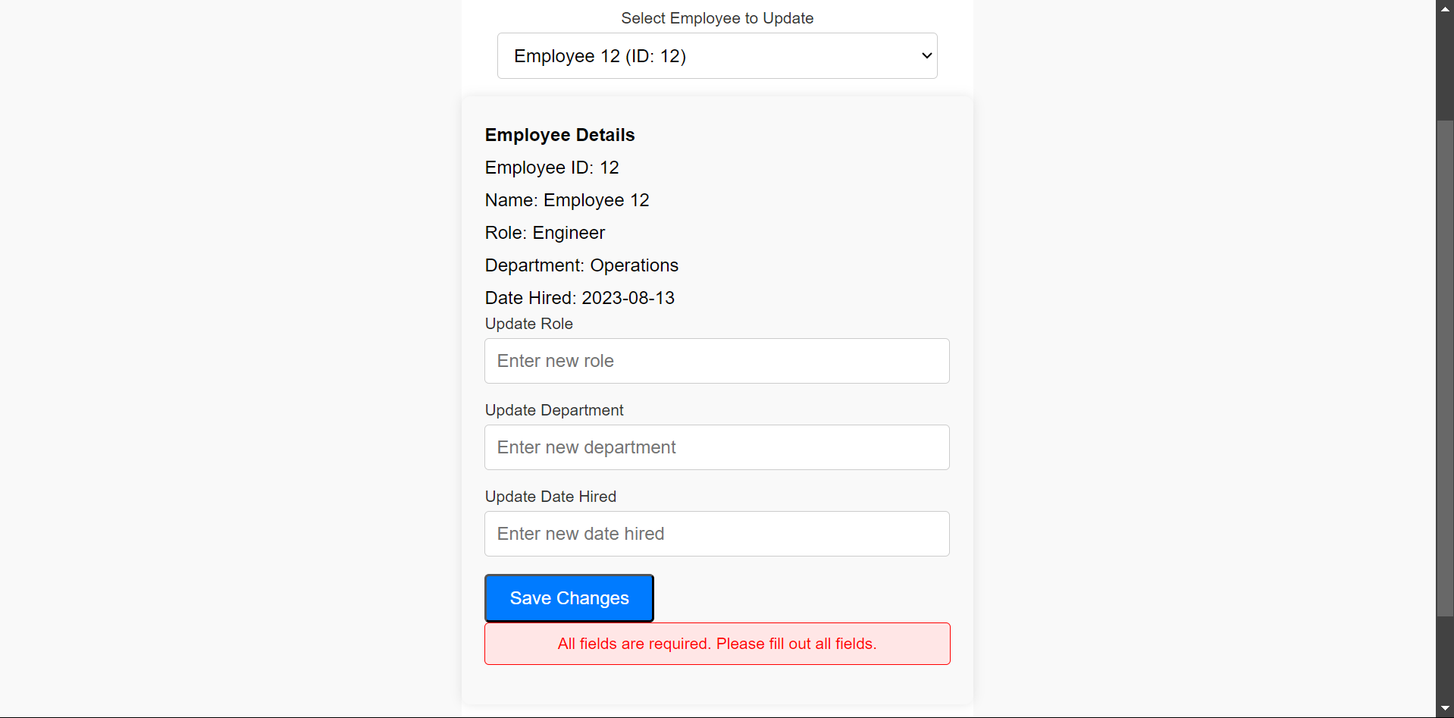

3.2 Quality Attributes User Interface
Usability:

The system's design prioritizes ease of use by ensuring that forms, buttons, and navigation paths are intuitive, allowing users to complete tasks with minimal effort. The interface is simple and does not require extensive instructions, making it accessible to a broad range of users. In terms of learnability, the use of consistent and familiar design patterns enables new users to quickly understand how to navigate the system. Clear labels like “Select Employee Record” and “Respond to Feedback” guide users through tasks, making the interface approachable. For memorability, users who return to the system after a period of non-use can easily recall how to perform tasks thanks to the straightforward layout and consistent design, reducing the need for relearning.

Consistency:

The system maintains visual consistency throughout, with buttons, fonts, colors, and spacing uniform across the application. For example, buttons like “Save Changes” and “Send Notifications” are styled similarly, making them easily recognizable as interactive elements. Functional consistency ensures that similar actions, such as submitting a form or updating information, follow the same sequence across different sections, lowering the learning curve for users. Additionally, the interface achieves internal and external consistency by adhering to standard UI patterns, like the placement of logout buttons and form submission processes, which align with what users commonly encounter in other systems, making the interface intuitive and familiar.

Accessibility:

The system takes into account readable fonts and contrast, ensuring that text is legible even for users with visual impairments. Sufficient contrast between text and background allows users with low vision or color blindness to read content without difficulty. Moreover, the scalable interface allows users to zoom in or out without distorting the layout, which enhances accessibility for those with low vision who need to adjust the display to their comfort level.

Efficiency:

Efficiency is a key feature of the system, with quick access features like "View and Search Now" and "Update Now" at the home page enabling users to rapidly navigate to frequently used functionalities. The design is also optimized to require minimal clicks and navigational steps to complete tasks, improving user productivity. For instance, employee records or feedback responses can be accessed and managed directly from the main interface in just a few clicks. Additionally, the logical workflow ensures that the sequence of actions follows a natural progression, such as selecting an employee record leading directly to updating information, or viewing a maintenance log facilitating control messages or notifications. This streamlined flow helps users complete tasks efficiently without unnecessary steps.

Error Handling:

The system incorporates robust input validation to prevent users from entering incorrect information in fields such as "Employee Name," "Job Role," or "Contact Details." This reduces the chances of errors and ensures that only valid data is saved. When errors do occur, the system provides clear and helpful error messages that guide users on how to correct the issue, offering explanations such as "Invalid email format, please enter a valid email address." Additionally, undo and confirmation options are present to prevent accidental actions, such as confirmation dialogs before sending critical notifications or escalating issues. Lastly, consistent feedback is provided after each action, so users are immediately informed if their action was successful or if further steps are required to resolve an issue. For instance, after clicking “Save Changes,” the system informs users whether the data was successfully saved or if an error occurred.

3.3 Functional Requirements
A functional requirement is a specific behavior or function that a system must perform to meet the needs and objectives of its users. It defines what the system should do. Functional requirements are detailed descriptions of the tasks, operations, or activities the system must carry out. Functional requirements are needed to clearly define what a system should do, ensuring that developers, testers, and stakeholders have a shared understanding of the expected functionality.

3.3.1 Facilities and Service Module
- The system should regularly check the train's performance, including controlling speed and braking.

- The system should monitor software for communication and data processing issues.

- The system must notify relevant personnel of upcoming maintenance tasks and schedule changes.

- The system must receive emergency signals from trains, such as derailments or component failures.

- The system must assign technicians to handle emergencies and track the status of the train until the problem is resolved.

- The system should support arranging maintenance schedules and train schedules.

- The system should schedule maintenance during non-peak hours to avoid affecting customer experience and normal train operation.

- The system should collect user feedback related to train operations and facilities.

- The system should analyze user feedback to identify common issues and areas for improvement.

- The system should track the effectiveness of implemented solutions and adjust strategies as necessary.

3.3.2 Marketing Module
- The system should allow the staff to create, schedule, and manage marketing campaigns with defined objectives and target audiences.

- The system should be able to provide tools for collecting, analyzing, and generating reports from market research data.

- The system should enable staff to create, edit, and publish promotional materials such as brochures and digital content.

- The system shall integrate with advertising platforms to manage ad placements, budgets, and performance metrics.

- The system should be able to support automated email campaign scheduling, list management, and performance tracking.

- The system shall be able to support classification of customers based on various criteria to target specific groups with personalized offers.

- The system should analyze market trends and provide actionable insights for new services or improvements.

- The systems should facilitate the updating and distribution of promotional materials to reflect the latest service updates and offers.

- The system should track and report on the performance of marketing campaigns, including metrics like ROI and engagement rates.

- The system should be able to collect and integrate customer feedback from multiple sources to inform marketing strategies and service improvements.

3.3.3 Customer Service Module
- The system should allow all staff to log and manage passenger complaints, categorizing them by type (train services, facilities, safety concerns).

- The system should maintain a comprehensive audit trail of all actions taken on each complaint, including timestamps, responsible personnel, and communication logs.

- The system should support automated follow-up reminders for unresolved issues, ensuring staff are prompted to follow up until the issue is resolved.

- The system should enable staff to send and receive emails related to complaints and track the communication history for each complaint.

- The system should allow staff to maintain detailed records of passenger interactions, complaints, and resolutions.

- The system should generate daily reports in excel format summarizing key activities, issues handled, and customer feedback for management review.

- The system should enable staff to create and manage special offers, discounts, and loyalty programs.

- The system should track passenger engagement with these offers and programs, providing insights for future promotions.

- The system should provide tools for staff to collect and analyze customer feedback, including surveys and direct responses.

- The system should generate monthly reports in excel format on feedback trends to inform service improvements and strategic planning.

3.3.4 IT Module
- The system should have an automated system for reporting and tracking train issues, which allow the IT department to log problems directly into a centralized system.

- The system shall have an automated notification via email, SMS, or an internal messaging system to keep the departments informed about the status of their issues.

- The system should generate monthly reports based on maintenance or issues resolved by the IT staff.

- The system shall have a streamlined workflow for problem resolution, minimizing the steps required to diagnose and fix issues and prioritize issues based on their impact on train operations and overall productivity.

- The system should have advanced monitoring tools to proactively identify and address potential issues before they escalate into significant problems.

- The system shall have an IT support portal where users can report issues, check the status of their tickets, and access the knowledge base.

- The system should implement tools for managing IT staff schedules and workloads to avoid overburdening the team

- The system shall enable IT staff to provide updates (maintenance/troubleshooting) through the tracking system, reducing the need for multiple follow-up calls or emails.

- The system should allow IT staff to quickly document and categorize issues and solutions for future reference.

- The system shall regularly review performance metrics to identify areas for improvement and ensure timely resolution of issues.

3.3.5 HR Department Module
- The system should allow HR staff to maintain comprehensive records of all train operation employees, including personal information, job roles, qualifications, and certifications.

- The system should enable HR staff to delete employee records when they are fired.

- The system should allow HR staff to plan and organize training programs for train operators and staff.

- The system should track employee training progress, including attendance and completion status.

- The system should enable HR staff to create and manage employee schedules, considering factors like shift preferences, availability, and operational requirements.

- The system should handle employee requests for shift changes and overtime, providing a workflow for approval and recording of these changes.

- The system should ensure that shift changes and overtime requests are logged and tracked for accurate payroll processing.

- The system should track employee attendance, including clock-in and clock-out times, late arrivals, early departures, and absences.

- The system should generate monthly attendance reports in excel format for HR staff to review and address any issues.

- The system should check prerequisites for leave requests, such as sufficient leave balance, adequate staffing levels during the requested period, and any pending approvals.

3.4 Use Case Model
A use case is a detailed description of how a user interacts with a system to achieve a specific goal, typically capturing the functional requirements of the system. It outlines the steps involved in the interaction, including the actions of both the user and the system, along with the conditions under which the interaction takes place. Use cases are employed in software development to ensure that all potential user interactions are considered during the design process, helping to align the system’s functionality with user needs and improving the overall user experience.

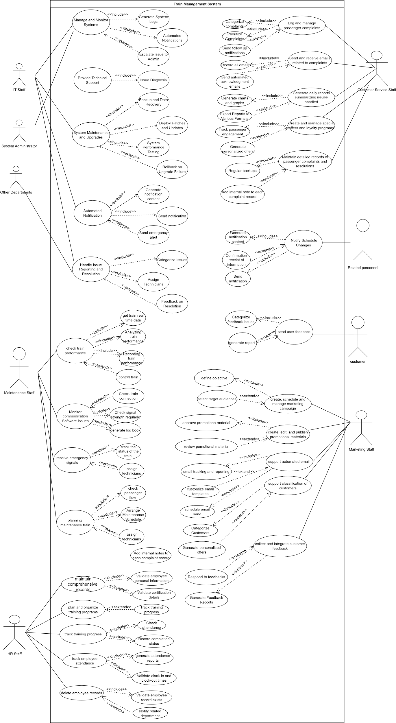
Diagram 3.4.1 (Overall System Use Case Model)

Source: https://app.diagrams.net/?page-id=5dd392Rj4al3jTp8ELpd&scale=auto#G1-_OtvhRcFQlI-1XGXBTcGb9gjiZzD

3.5 Detailed Use Case

3.5.1 Facilities and Service Module
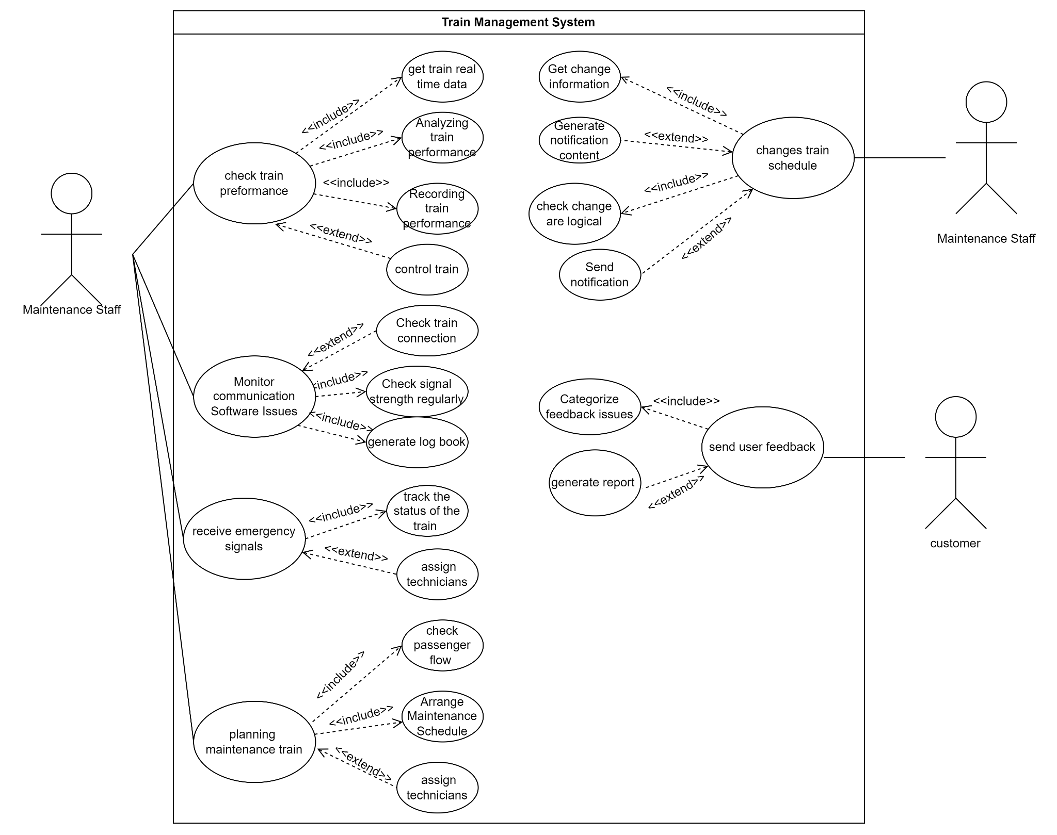
Diagram 3.5.1 (Facilities and Service Module Use Case Model)

3.5.1.1 Use Case Description For Facilities and Service Module
Author:
Use Case Name: Changes train schedule
Actors: Maintenance staff
Pre-Conditions: Receive change schedule request
Brief Description
This use case describes the process of changing schedules and notify relevant personnel.
Main Flow Event
Actor Actions | System Response
1.Actor send change schedule request  4.Maintenance staff select schedule  5.Maintenance staff send changed schedule  7.Maintenance staff send people who need to be notified | 2. The system Receive change schedule request  3. The system send all current schedule  6. The system check change are logical  8. The system creates the content for the notification based on the change information.  9. The system dispatches the notification to the related personnel.  10. The system records the confirmation of receipt from the personnel.
Alternative Flow
Step 6:if the change are unlogic, the system will send an error message and request the actor re-enter the change
Step 9:If the system does not receive an acknowledgment, the system will resend the message.
Post-Conditions: Related personnel are informed about the schedule changes.

3.5.2 Marketing Module
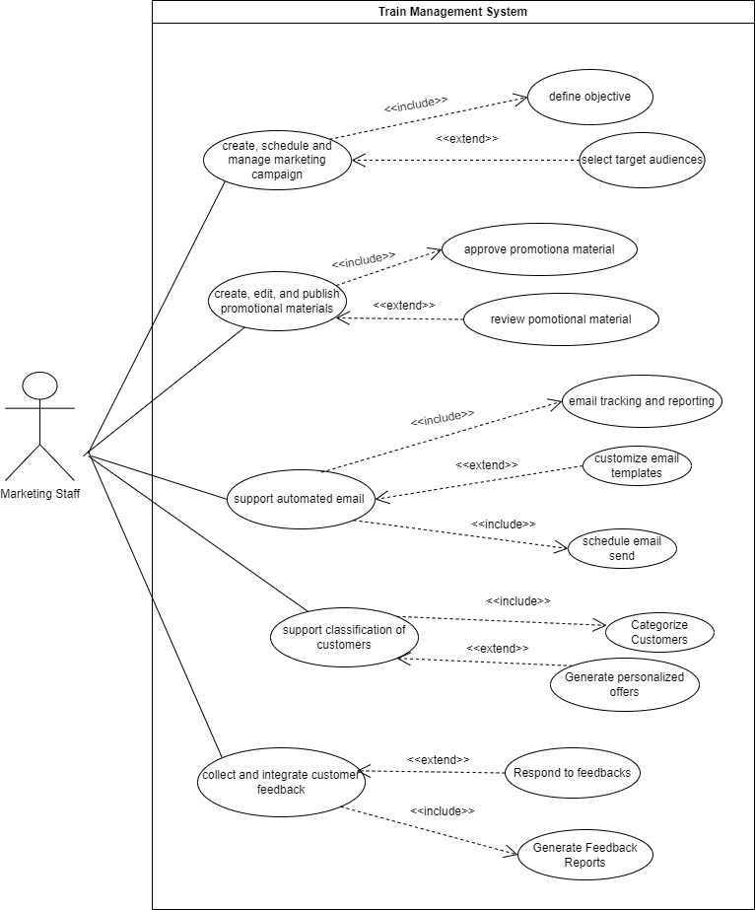
Diagram 3.5.2 (Marketing Module Use Case Model)

3.5.2.1 Use Case Description For Marketing Module
Author:
Use Case Name: Analyze and response to customer feedback
Actors: Marketing Staff
Pre-Conditions: Logged into system
Brief Description:
This use case allows marketing staff to analyze, generate reports and respond to the customer feedback.
Main Flow Event
Actor Actions | System Response
1. Marketing staff select customer feedback.  4. Marketing staff response to the customer feedback. | 2. The system finds the customer feedback record in the database.  3. The system returns the analyzed record.  5. The system saves the response to the database.  6. The system returns the result of the save response.
Alternative Flow
Step 3a. If the record found the report generated, else return an error message to the staff.
Step 6a. If the response is saved, print the response saved message, else return an error message to the staff.
Post-Conditions:
The specific report is generated and a specific response to the customer feedback saved.

3.5.3 Customer Service Module
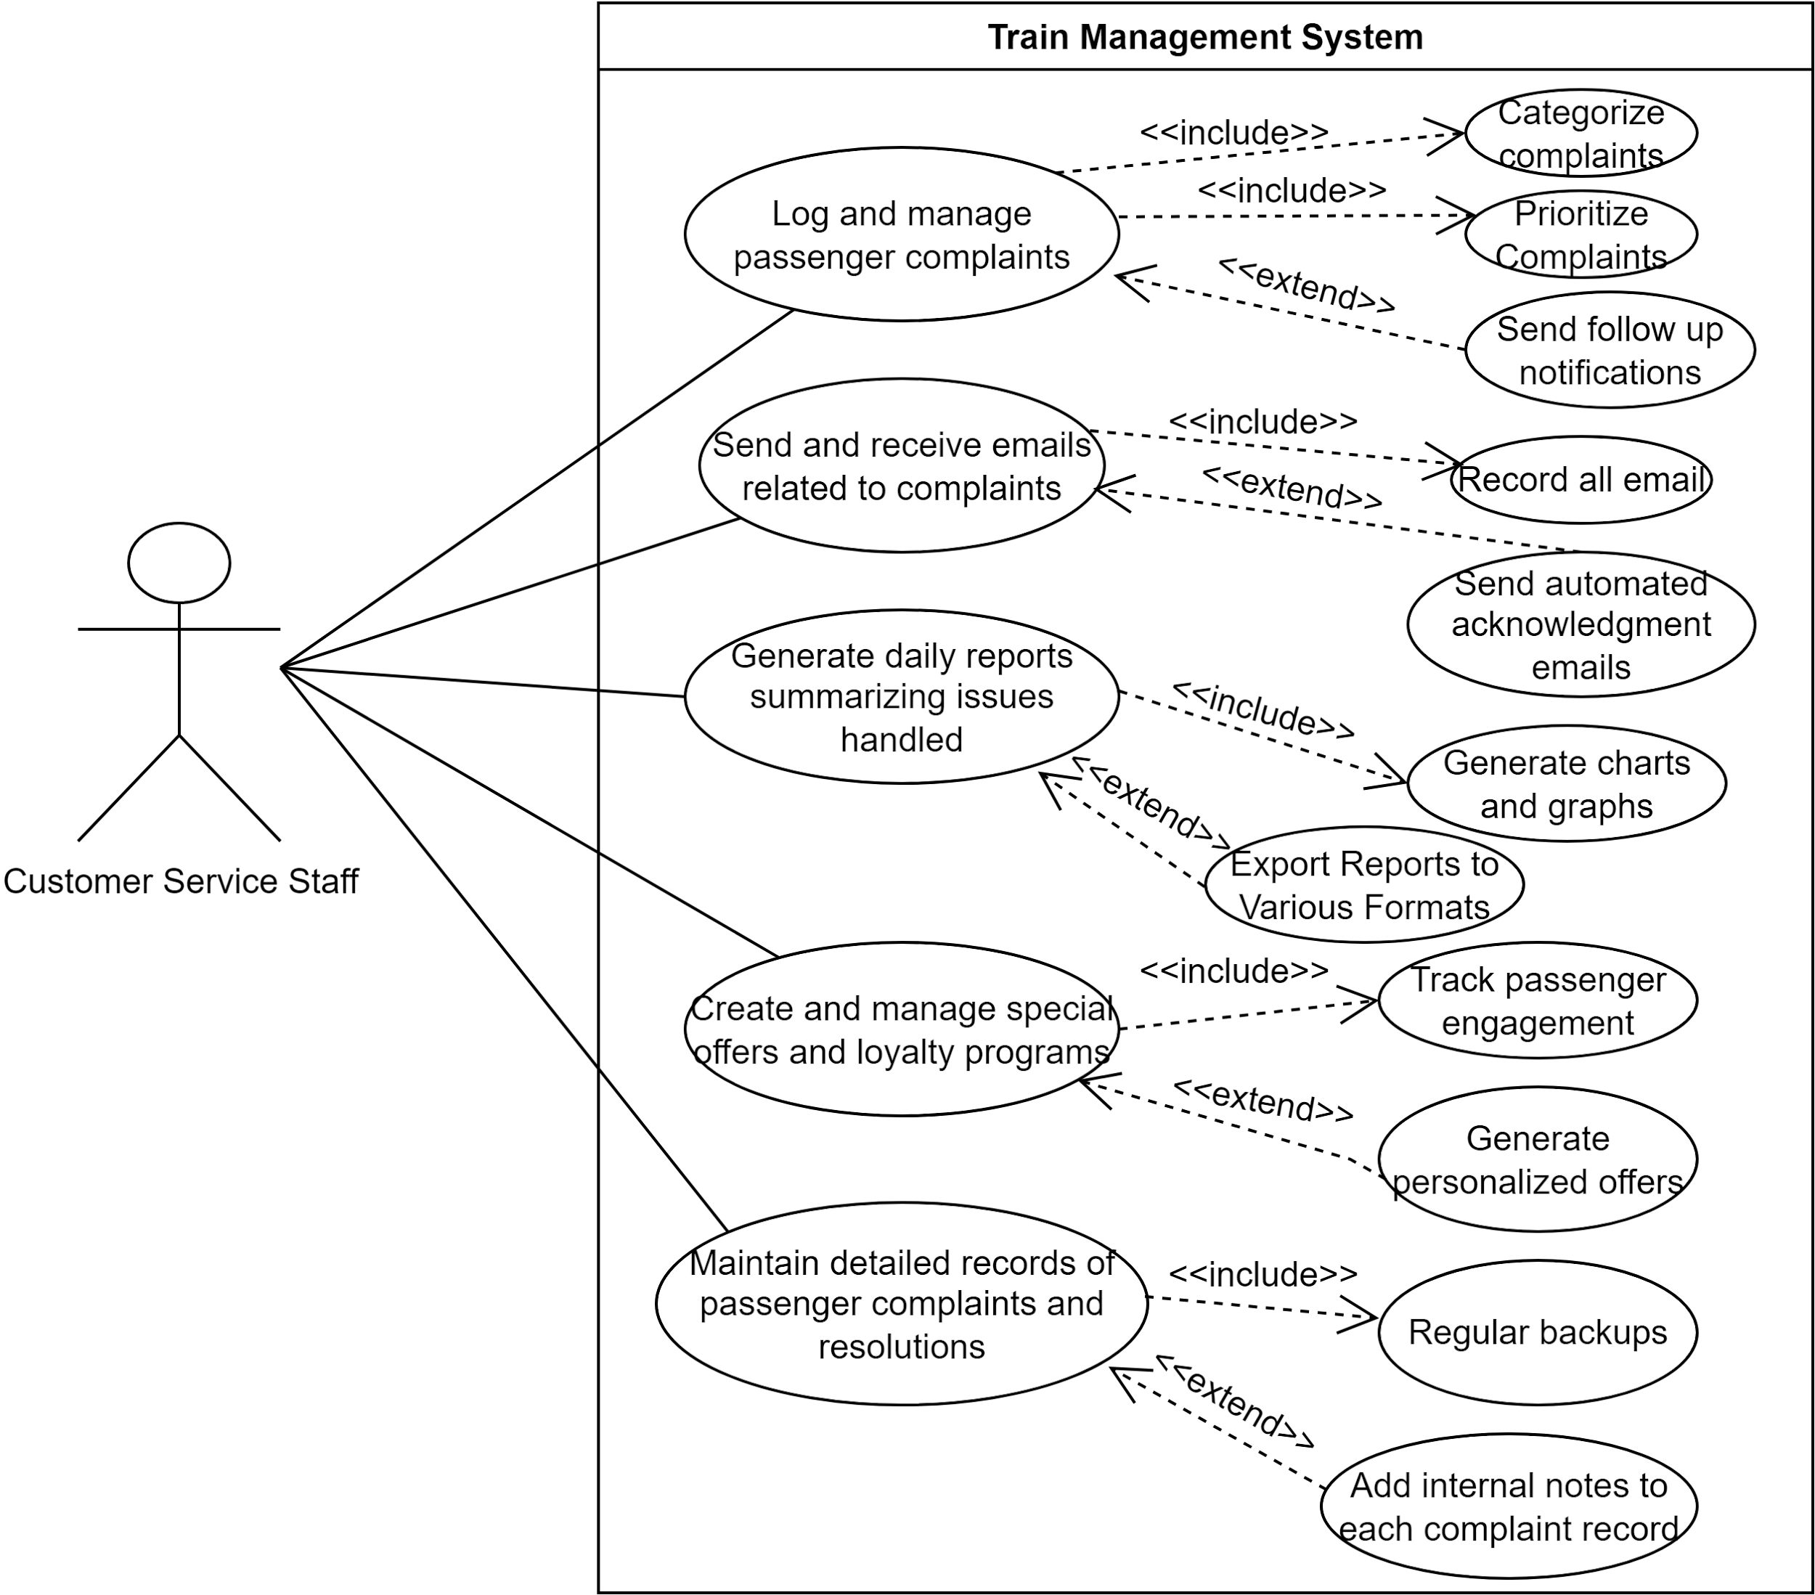
Diagram 3.5.3 (Customer Service Module Use Case Model)

3.5.3.1 Use Case Description For Customer Service Module
Author:
Use Case Name: Log and Manage Passenger Complaints
Actors: Customer Service Staff
Pre-Conditions: Logged in to the system
Brief Description:
This use case describes the process of logging and managing passenger complaints.
Main Flow Event
Actor Actions | System Response
1.The staff navigates to the complaints section.  4.The staff logs a new complaint with details.  6. The staff manage complaint with updated status | 2.The system displays the complaints interface.  3.The system prioritizes, categorizes and displays the complaint.  5.The system records the complaint and generates a complaint ID.  7.The system sends notifications to the relevant parties and updates status in the database.
Alternative Flow:
Step 4a: If the complaint form is not filled completely, the system will prompt an error message saying that all fields are required to be filled.
Post-Conditions:
The complaint is logged, categorized, prioritized, and follow-up notifications are sent.

3.5.4 IT Module
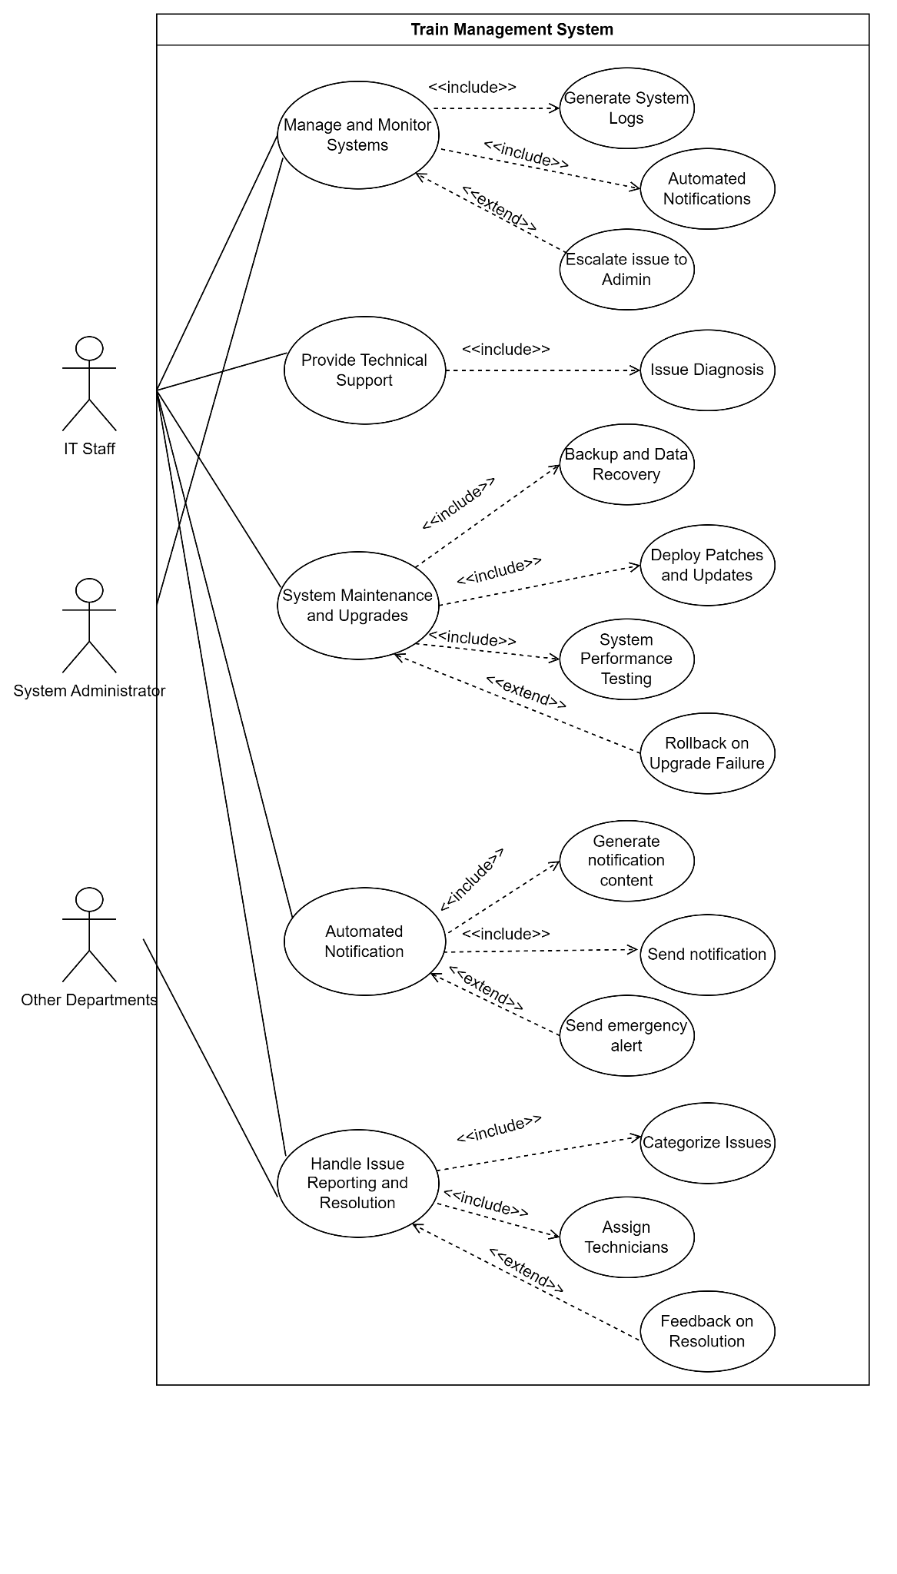
Diagram 3.5.4 (IT Module Use Case Model)

3.5.4.1 Use Case Description For IT Module
Author:
Use Case Name: Manage and Monitor Systems
Actors: IT Staff and System Administrator

Pre-Conditions: The Train Management System is operational.
Brief Description:
This use case describes how IT Staff and System Administrators manage and monitor the systems within the Train Management System.
Main Flow Event
Actor Actions | System Response
1.The IT Staff or System Administrator initiates the system management process.  3.The IT Staff monitors the system status regularly.  5.The IT Staff generates system logs for auditing and troubleshooting.  7.The system detects an issue and sends an automated notification.  9.The IT Staff escalates the issue to the System Administrator if it cannot be resolved at their level. | 2.The system displays current status and performance metrics.  4.The system continuously updates the status and performance metrics.  6.The system generates and stores logs as requested.  8.Automated notifications are sent to predefined recipients.  10.The system provides options for escalation to higher-level administrators.
Alternative Flow
Step 4a: If the system detects a critical issue, it bypasses regular notifications and sends an emergency alert directly to the System Administrator.
Post-Conditions:
The system logs are updated.Notifications are sent out as needed.Issues are escalated and tracked until resolution.

3.5.5 HR Module
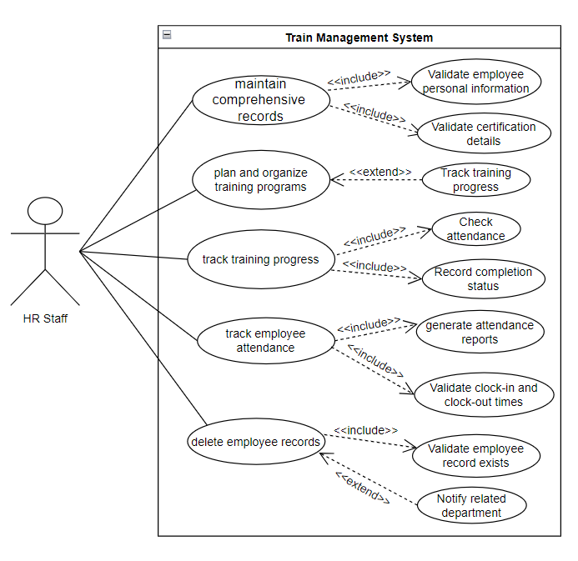
Diagram 3.5.5 (HR Module Use Case Model)

3.5.5.1 Use Case Description For HR Module
Author:
Use Case Name: Maintain comprehensive records
Actors: HR staff
Pre-Conditions: HR Staff must be logged into the system.
Brief Description
This use case allows HR staff to maintain comprehensive records of all employees.
Main Flow Event
Actor Actions | System Response
1. HR Staff selects the "Maintain Employee Records" option from the system menu.  3. HR Staff keys in the employee ID.  5. HR Staff updates the necessary fields. | 2. The system displays a prompt to enter the employee ID.  4. The system displays the employee's record.  6. The system saves the changes.  7. The system validates the employee details.  8. The system logs the changes made by HR Staff.  9. The system displays a confirmation message.
Alternative Flow
Step 3a: If the employee ID is not found, the system displays an "Employee not found" message.
Step 6a: If the data entered is invalid, the system displays an error message indicating the invalid fields.
Post-Conditions:
HR Staff receives a confirmation message that the employee record has been successfully updated.

4 Other Non-functional Requirements
This section will detail the non-functional requirements that the Train Management System must meet, including performance, safety, security, and other quality attributes. These requirements ensure that the system not only performs its intended functions but does so in a reliable, efficient, and secure manner.

4.1 Performance Requirements
Performance requirements define the expected speed, responsiveness, and reliability of a system under various conditions, ensuring that it meets the demands of its users and functions effectively in real-world scenarios. In the context of a Train Management System, these requirements are crucial because they ensure that the system can provide real-time updates, manage high volumes of data, and respond quickly to critical situations, such as scheduling changes or safety alerts. Meeting these performance standards is essential to maintaining the efficiency, safety, and reliability of train operations, minimizing delays, preventing accidents, and providing accurate information to passengers. Without clear performance requirements, the system might fail to operate efficiently under peak loads or during emergencies, leading to disruptions and potentially putting lives at risk.

- The TMS must provide real-time location updates of all trains within the network, with a maximum delay of 2 seconds between the actual position and the reported position. This is crucial for ensuring accurate tracking and coordination of train movements, preventing collisions, and maintaining schedule integrity.

- The TMS should be capable of generating and dispatching train routes within 5 seconds of receiving a scheduling command. This rapid response is necessary to ensure timely adjustments to train schedules, especially during peak hours or in response to unexpected disruptions.

- The TMS must maintain an uptime of 99.9%, ensuring that the system is available at all times except for scheduled maintenance. This high availability is essential to avoid service interruptions and ensure continuous monitoring and control of train operations.

- The TMS system must trigger and display critical safety alerts (e.g., potential collisions, system failures) within 1 second of detecting an issue. Immediate alerting allows for prompt action to mitigate risks and ensure the safety of passengers and train staff.

- The TMS must process and analyze diagnostic data from trains within 3 seconds of data receipt to detect and report any potential issues. Quick processing ensures that maintenance teams can respond swiftly to prevent malfunctions or delays.

- The TMS must update passenger information systems (e.g., platform displays, mobile apps) within 2 seconds of any changes to train schedules or statuses. Timely updates are necessary to provide passengers with accurate and up-to-date information.

- The TMS must be capable of scaling to manage up to 500 trains simultaneously without degradation in performance. This scalability is essential to accommodate future network expansions and increased traffic volumes without compromising system efficiency.

4.2 Safety and Security Requirements
Safety and Security Requirements in a Train Management System are critical to ensuring the protection of both passengers and infrastructure. These requirements encompass the secure transmission of data, robust user authentication, access control, incident response protocols, and compliance with industry regulations. They are essential to prevent unauthorized access, ensure the integrity and reliability of train operations, and protect sensitive information from breaches. By implementing these safety and security measures, the system minimizes the risks of accidents, operational failures, and security threats, thereby safeguarding human lives and maintaining public trust in the railway system.

- Data Encryption: All communications between the Train Management System (TMS) and the trains, control centers, and mobile devices must be encrypted using strong encryption protocols (e.g., SSL/TLS) to prevent unauthorized access and data breaches during transmission.

- User Authentication: The system must enforce secure user authentication mechanisms, requiring operators, maintenance personnel, and other authorized users to log in with unique credentials. Multi-factor authentication (MFA) should be implemented, especially for users accessing the system remotely.

- Access Control: Role-based access control (RBAC) must be implemented to restrict access to system functionalities based on user roles. For example, only authorized maintenance staff should have access to train diagnostics, and only dispatchers should have access to route planning functions.

- Safety Protocols: The system must include safety protocols that prevent unauthorized or accidental operation of trains. This includes implementing emergency stop functions, automated checks before route initiation, and restrictions on manual overrides unless in verified emergency situations.

- Mobile Connection Security: For mobile devices used by train operators or maintenance staff, secure connections must be ensured, especially over public or unsecured networks. The system should support secure VPN connections and alert users to any potential security risks when connecting to the TMS remotely.

- Audit Trail: A comprehensive audit trail must be maintained, recording all system interactions, including train movements, control commands, user logins, and changes to schedules or routes. This audit log must be secured and regularly reviewed to detect and prevent unauthorized activities.

- Incident Response: The TMS must have predefined protocols for incident detection and response, including automatic alerts in the event of unauthorized access attempts, system failures, or potential safety hazards. These protocols should include automatic locking of control functions in case of detected breaches or malfunctions.

- Data Backup and Recovery: Regular backups of all critical TMS data, including schedules, logs, and operational parameters, must be conducted. A robust disaster recovery plan must be in place to ensure that the TMS can be restored quickly in case of data loss, corruption, or system failure.

- Compliance with Regulations: The TMS must comply with relevant railway safety and security standards and regulations, such as the International Railway Industry Standard (IRIS) and ISO 27001 for information security management. Compliance with these standards ensures that the system meets industry-specific safety and security requirements.

- Emergency Communication Protocols: The system should include secure, reliable communication protocols for emergency situations, allowing for rapid, secure communication between train operators, control centers, and emergency response teams to coordinate effective responses to incidents

4.3 Non-functional Requirements
A non-functional requirement specifies the criteria that judge the operation of a system, rather than specific behaviors or functionalities. These requirements define system attributes such as performance, security, usability, reliability, and scalability, ensuring that the system not only functions correctly but also meets certain standards in quality. Non-functional requirements are essential because they address how well the system performs, ensuring that it is robust, efficient, and user-friendly, which ultimately contributes to the overall user experience and system success.

4.3.1 Facilities and Service Module
- The system must perform real-time performance monitoring and control with latency under 100 milliseconds to ensure optimal train operations.

- The system should be able to detect and report issues in software communication and data processing with 99.9% accuracy.

- The system should deliver instantaneous notifications to personnel through an intuitive interface, ensuring they are well-informed of maintenance tasks and schedule changes.

- The system must be 99.999% available and capable of receiving emergency signals within 1 second from trains, ensuring immediate response to critical situations.

- The system should support dynamic assignment of technicians and tracking of train status, scalable to handle up to 10 simultaneous emergencies without performance degradation.

- The system must allow easy configuration and modification of maintenance schedules and train schedules, providing a user-friendly interface for managing and updating schedules in under 2 minutes.

- The system must optimize maintenance scheduling to minimize impact on customer experience and normal operations, ensuring peak performance even during rush hours.

- The system should provide an intuitive and accessible interface for users to submit feedback on train operations and facilities, ensuring ease of use and high user engagement.

- The system must efficiently analyze up to 1 million pieces of user feedback to identify trends and issues, with the capability to scale analysis processes as feedback volume increases.

- The system must reliably track and evaluate the effectiveness of solutions and strategies, with mechanisms in place to adjust and optimize within 24 hours as needed to ensure continuous improvement.

4.3.2 Marketing Module
- The system should provide a user-friendly interface with response times under 200 milliseconds to ensure efficient campaign management.

- The system should ensure 99.9% data accuracy and provide sub-second real-time processing capabilities for effective market analysis.

- The system should protect content from unauthorized access and be available at all times with 99.999% uptime, ensuring no interruptions.

- The system should work smoothly with different advertising platforms and update ad information every 5 seconds.

- The system shall be able to handle 1 million emails per hour reliably and ensure compliance with GDPR, and other privacy regulations.

- The system should be able to handle 10+ TB of customer data and quickly sort and target specific groups using advanced machine learning algorithms.

- The system shall provide real-time updates with less than 1 second latency and predictive analytics to keep up with rapidly changing market trends.

- The system should keep all channels updated every 10 seconds and ensure data stays accurate during updates.

- The system must offer 99.999% availability and high performance to generate and deliver detailed performance reports in under 5 minutes.

- The system should provide reliable and secure feedback collection mechanisms with 99.9% uptime and <0.1% data loss to ensure minimal downtime and high data accuracy.

4.3.3 Customer Service Module
- The system should be user-friendly and intuitive to allow all staff to log and manage passenger complaints, categorizing them by type (train services, facilities, safety concerns) in under 1 minute.

- The system should reliably record all actions with 100% accurate timestamps and personnel information.

- The system should support automated follow-up reminders for unresolved issues, ensuring staff are prompted to follow up until the issue is resolved efficiently, with a maximum latency of 1 second.

- The system should be compatible with various email platforms and ensure seamless integration, making it easy to use and access for all staff.

- The system should be easy to update and maintain, keeping records of passenger interactions, complaints, and resolutions with 99.9% accuracy over time.

- The system should generate daily reports in Excel format summarizing key activities, issues handled, and customer feedback for management review in under 2 seconds.

- The system should handle a growing number of special offers, discounts, and loyalty programs as the customer base increases, scaling up without performance loss.

- The system should track passenger engagement with these offers and programs, providing 99.9% accurate insights for future promotions efficiently.

- The system should provide tools for staff to collect and analyze customer feedback, including surveys and direct responses, that are user-friendly and accessible 24/7.

- The system should generate monthly reports in Excel format on feedback trends to inform service improvements and strategic planning in under 2 seconds with 99.9% accuracy.

4.3.4 IT Module
- The system should have an intuitive and easy automated system for reporting and tracking train issues, allowing the IT department to log problems directly into a centralized system within 30 seconds.

- The system shall have an automated notification via email, SMS, or an internal messaging system to keep the departments informed about the status of their issues, with a maximum 10ms delay.

- The system should generate monthly reports based on maintenance or issues resolved by the IT staff with 99.9% accuracy and consistency.

- The system should handle an increasing number of issues efficiently as operations grow, scaling to manage up to 1000 simultaneous issues without significant slowdowns.

- The system should have advanced monitoring tools to proactively identify and address potential issues with 95% accuracy before they escalate into significant problems.

- The system shall have an IT support portal that is accessible at all times (24/7), where users can report issues, check the status of their tickets, and access the knowledge base with 99.999% uptime.

- The system should implement tools that are easy to update and maintain for managing IT staff schedules and workloads, ensuring the team is never overburdened and operating at optimal capacity.

- The system shall enable IT staff to provide updates (maintenance/troubleshooting) quickly and efficiently through the tracking system, reducing the need for multiple follow-up calls or emails by 50%.

- The system should facilitate easy documentation and categorization of issues and solutions, with the documentation process being straightforward to update and maintain over time, requiring less than 5 minutes per update.

- The system should effectively track and review performance metrics, consistently identify areas for improvement, and support timely resolution of issues within 24 hours.

4.3.5 HR Module
- The system should allow HR staff to easily and accurately maintain comprehensive records of all train operation employees, including personal information, job roles, qualifications, and certifications, with 100% accuracy.

- The system should enable HR staff to delete employee records when they are fired, ensuring secure and authorized deletion of records, with multi-factor authentication and audit trails.

- The system should be able to handle an increasing number of training programs as the workforce grows, scaling to manage up to 500 training programs simultaneously.

- The system should efficiently, accurately, and consistently track employee training progress, including attendance and completion status, with real-time updates and 99.9% accuracy.

- The system should enable HR staff to create and manage employee schedules, considering factors like shift preferences, availability, and operational requirements, where the scheduling feature should be intuitive and usable within 5 minutes per schedule.

- The system should efficiently handle employee requests for shift changes and overtime, providing a workflow for approval within 24 hours and recording these changes with 99.9% accuracy.

- The system should ensure that shift changes and overtime requests are logged and tracked accurately and consistently for 100% accurate payroll processing.

- The system should efficiently, accurately, and consistently track employee attendance, including clock-in and clock-out times, late arrivals, early departures, and absences, with real-time monitoring and less than 1% error rate.

- The system should generate monthly attendance reports in Excel format for HR staff to review and address any issues in under 2 seconds, with 99.9% accuracy.

- The system should quickly and accurately check prerequisites for leave requests, providing feedback within 5 seconds.

4.4 Overall System Quality Attributes
Functionality
- Feature Completeness: The system should provide all required functionalities such as train monitoring, issue reporting, maintenance scheduling, customer service, and marketing campaign management.

- Accuracy: Data such as train performance and attendance records must be accurate to avoid operational disruptions and ensure safety compliance.

- Security: The system must ensure the protection of sensitive data such as employee information, customer complaints, and real-time train diagnostics with encryption and strict access controls.
Usability
- Ease of Use: The system interface should be intuitive for various departments (Facilities, Marketing, IT, etc.), allowing users to perform tasks with minimal training.

- User Interface Design: A well-designed interface for logging issues, accessing reports, and managing operations will improve productivity and reduce errors.

- Accessibility: The system should be accessible to all users, including those with disabilities, by incorporating features like screen readers and scalable interfaces.
Reliability
- Availability: The system should have high availability, ensuring minimal downtime (99.999% uptime) to maintain continuous operations, especially during peak hours.

- Fault Tolerance: The system should be resilient against hardware or software failures, with backup mechanisms in place to recover quickly and avoid service disruptions.

- Data Integrity: All recorded data (e.g., complaints, maintenance records) must be stored and backed up securely to prevent loss or corruption.
Performance
- Response Time: Critical functions like emergency alerts and train performance monitoring should respond in real-time, with minimal latency (under 100 milliseconds).

- Scalability: The system should scale efficiently as the number of trains, users, and customer interactions increases, ensuring consistent performance even under heavy load.

- Resource Efficiency: The system should optimize resource usage (CPU, memory, bandwidth) to ensure smooth operation without overloading infrastructure.
Supportability
- Maintainability: The system should have a modular architecture to allow easy updates, debugging, and future enhancements without significant downtime.

- Documentation and Training: Comprehensive documentation should be provided for users and IT staff to ensure smooth onboarding and troubleshooting.

- Monitoring and Diagnostics: The system should provide tools for real-time monitoring and diagnostics to quickly identify and resolve any issues that arise.

5 Other Requirements
This section outlines the additional requirements the Train Management System must meet, including hardware, software, and architecture needs. It addresses how discrepancies, like scheduling issues, will be managed and the process for implementing changes. The chapter also covers the system’s architecture, providing diagrams that illustrate how different components interact to ensure the system functions smoothly and efficiently.

5.1 Hardware and Software Requirements
Hardware requirements refer to the physical devices and equipment needed to support the system's operation. In the context of the Train Management System (TMS), this might include servers with high processing power to handle real-time data processing, adequate memory (RAM) for efficient multitasking, and large storage capacities for storing system logs, schedules, and maintenance records. Additionally, networking hardware like routers and switches would be required to ensure reliable and secure communication between trains, control centers, and other system components. Other physical devices, such as workstations for staff, mobile devices for field personnel, and backup power systems, may also be necessary to maintain continuous operations, especially in case of equipment failure or power outages.

Software requirements include the programs and platforms needed to develop, operate, and maintain the system. This could involve specific operating systems like Linux or Windows to run the TMS, a database management system like MySQL or PostgreSQL to store and manage train schedules and user data, and programming languages such as Java or Python for system development. In addition, the TMS might require specialized software for monitoring train performance, managing customer service interactions, or generating reports. Software security tools such as encryption protocols and access control systems would also be essential to protect sensitive data and ensure compliance with regulatory requirements. These software components work together with the hardware to provide a smooth, secure, and efficient train management system.

5.1.1 Hardware Requirements
The TMS will require 5 to 10 high-performance servers, depending on the scale of the system and the number of train lines it supports. These servers will handle critical tasks such as real-time data processing, train schedule management, and storage of operational logs. Multiple servers ensure load balancing and redundancy, preventing system downtime in the event of a server failure.

A robust network infrastructure is essential for seamless communication between different system components. The TMS will need approximately 10 routers and switches to manage internal data traffic across control centers and field devices. Additionally, 10-20 firewalls and network security devices will be required to safeguard against external threats and ensure secure communication.

For staff in operations, maintenance, customer service, and administrative roles, around 50 to 100 workstations will be needed. Each workstation should include desktop computers or laptops with sufficient processing power to handle TMS applications, alongside high-resolution monitors. The exact number of workstations depends on the number of employees and the scale of the operations.

Maintenance teams, field personnel, and train operators will require approximately 50 to 100 mobile devices such as rugged tablets or smartphones. These devices will allow personnel to access real-time information remotely, input updates on the go, and respond quickly to maintenance or emergency situations.

To store large amounts of data, the TMS will need 2 to 5 high-capacity storage systems, depending on the scale of the data being generated. These systems must support redundant storage, with options like RAID (Redundant Array of Independent Disks) to prevent data loss. Cloud-based storage could be used as an additional layer for backup and scalability.

To ensure uninterrupted power during outages, 5 to 10 UPS (Uninterruptible Power Supply) systems will be required. These systems will provide temporary power to critical infrastructure such as servers, storage systems, and networking devices, allowing continued operations or an orderly shutdown.

For security purposes, the system will need 10-20 hardware firewalls and intrusion detection systems (IDS) to monitor and secure the network from unauthorized access and cyber threats. Additionally, 2-5 biometric access systems may be installed in server rooms or critical areas to prevent physical tampering with hardware.

To support daily operations, 10-15 peripheral devices such as printers, scanners, and backup drives will be required. These devices will assist in generating reports, digitizing records, and storing data backups, playing a supplementary role in the overall system infrastructure.

5.1.2 Software Requirements
For the Operating System, Linux (Ubuntu Server) is an ideal choice for the Train Management System (TMS), particularly for server operations. Ubuntu is known for its stability, security, and open-source nature, making it cost-effective for large-scale operations like the TMS. It provides excellent performance under high-load conditions and has strong community support, which ensures regular updates and patches. Its compatibility with various hardware systems and cloud platforms makes it versatile and scalable, allowing the system to grow without the need for significant infrastructure changes. Ubuntu’s security features, such as built-in firewall configurations and secure boot options, ensure that the TMS can operate in a secure environment, protecting sensitive operational data from external threats.
For the Database Management System (DBMS), PostgreSQL is a great choice. Known for its reliability, extensibility, and support for both relational and non-relational queries, PostgreSQL provides the flexibility needed to handle the complex data structures of the TMS. It can efficiently manage large datasets, such as train schedules, maintenance logs, and customer feedback, while maintaining ACID (Atomicity, Consistency, Isolation, Durability) compliance, ensuring data integrity even under heavy load. Additionally, PostgreSQL supports advanced data types and full-text search, which can enhance reporting and analytics capabilities within the system. Its robust security features, such as SSL connections and role-based access control, make it well-suited for managing the sensitive information the TMS will process.
In terms of programming languages, Java is the optimal choice for developing the TMS’s core system. Java is renowned for its cross-platform capabilities, allowing the TMS to run on various operating systems without modification. Its scalability and performance in large enterprise systems make it suitable for handling real-time operations, such as train tracking and schedule management. Java also has extensive libraries and frameworks that streamline the development process, improving productivity and reducing development time. Furthermore, Java’s strong object-oriented programming features enhance maintainability, ensuring that the system can be easily updated or extended to meet future requirements.
Using Spring as the framework for Java. Spring offers a comprehensive ecosystem for building scalable, secure, and high-performing enterprise applications. Its features like dependency injection, aspect-oriented programming, and integrated security through Spring Security make development efficient and maintainable.
Spring Boot, in particular, will simplify setting up the TMS by reducing the need for boilerplate code and configuration, enabling faster development cycles. It integrates seamlessly with technologies like PostgreSQL for the database, NGINX for the web server, and AWS for cloud services, ensuring your system is highly adaptable and easily deployable across various environments. Additionally, Spring’s built-in support for RESTful services makes it ideal for managing API-driven data exchanges, crucial for a real-time system like TMS.

For the web server, NGINX stands out as the best choice for the TMS. NGINX is well-known for its high performance, particularly in handling a large number of concurrent connections. This makes it ideal for managing the web-based user interface of the TMS, which will be accessed by numerous staff members, including operators, maintenance teams, and administrators. NGINX’s load-balancing capabilities ensure that even under high traffic conditions, the system remains responsive. Its lightweight architecture also reduces resource consumption, allowing more computing power to be allocated to critical tasks like data processing. Additionally, NGINX supports SSL/TLS encryption, ensuring secure communications between the TMS web interface and its users.
For cloud services, Amazon Web Services (AWS) is an excellent option due to its comprehensive range of services and global infrastructure. AWS offers scalable cloud storage solutions, which are essential for handling the vast amounts of data generated by the TMS. Its robust disaster recovery options ensure that the system can quickly recover from failures, minimizing downtime. AWS also provides flexible computing resources, allowing the TMS to scale efficiently based on demand, especially during peak hours. Moreover, AWS's security services, such as identity and access management (IAM) and encryption options, provide the necessary tools to protect sensitive data and comply with industry regulations.
In terms of data analytics tools, Power BI is a suitable choice for the TMS. Power BI offers powerful data visualization and reporting capabilities, allowing the system to generate real-time dashboards that help staff monitor train performance, customer feedback, and maintenance operations. Its integration with various data sources, including PostgreSQL, enables seamless data analysis. Power BI’s ease of use and intuitive interface make it accessible to users without a technical background, ensuring that different departments can derive valuable insights from the system’s data. Additionally, Power BI’s ability to create interactive reports helps in making data-driven decisions quickly and effectively.
For network security software, Sophos XG Firewall is an ideal solution. Sophos provides advanced threat protection with features like deep packet inspection, intrusion prevention systems (IPS), and SSL inspection, ensuring the TMS network is secure from external attacks. Its user-friendly interface simplifies network management, while real-time monitoring and automated reporting help administrators stay on top of any potential security threats. Sophos XG Firewall also supports role-based access control, ensuring that only authorized personnel can access critical areas of the system. This level of security is essential for a system as sensitive as the TMS, where the integrity of operational and passenger data must be maintained.
For backup and recovery software, Veeam Backup & Replication is an excellent choice for the TMS. Veeam provides reliable and fast backup solutions for both virtual and physical environments, ensuring that all critical data within the TMS is regularly backed up and easily recoverable in case of failures. It offers features like incremental backups, deduplication, and compression, which save storage space and reduce backup times. Additionally, Veeam’s automated recovery testing ensures that backups are always ready for restoration, minimizing downtime in case of system crashes. This is critical for a system like the TMS, where data loss could disrupt operations and negatively affect train services.
For UI frameworks, Angular is a great choice for building the TMS’s user interfaces. Angular provides a robust framework for building dynamic and interactive web interfaces. Its two-way data binding, dependency injection, and modular architecture make it an excellent choice for large-scale systems like TMS. Angular’s ability to efficiently handle data-driven applications ensures that the user interface remains responsive even with heavy real-time data loads, such as those encountered in train operations, maintenance, and customer service. Furthermore, Angular’s built-in tools and libraries enhance productivity by allowing developers to create reusable components, streamline workflows, and ensure consistency across the entire system.
For version control and collaboration, GitHub is the preferred platform for managing the TMS’s source code and development processes. GitHub provides a centralized repository for tracking changes, collaborating with team members, and managing different versions of the codebase. Its integration with continuous integration/continuous deployment (CI/CD) pipelines allows for automated testing and deployment, ensuring that updates to the system can be rolled out smoothly and with minimal disruption. GitHub also provides tools for issue tracking and project management, making it easier for teams to stay organized and ensure that development milestones are met efficiently.

5.2 Requirement Management
The system is supposed to track and manage train schedules, but there are discrepancies between the scheduled times and the actual train times. This results in confusion among staff who rely on accurate timing for various operational tasks, such as coordinating train arrivals and departures, managing staff shifts, and handling customer inquiries. After analysis of historical data and system logs reveals patterns of discrepancies. It is observed that timing errors occur at specific intervals or under certain conditions.

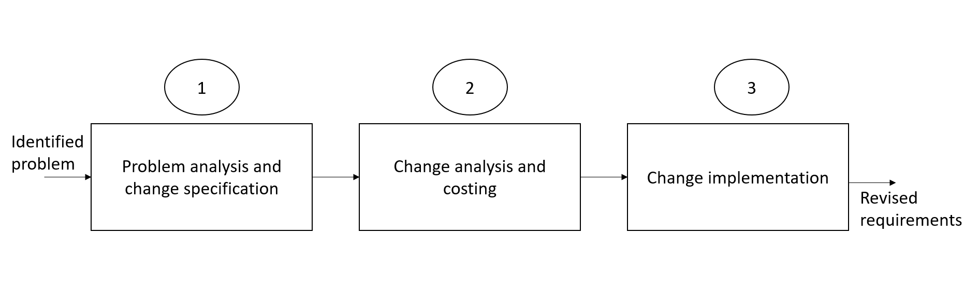
Diagram 5.2 (Change Management Process – Summary Diagram)

5.2.1 Problem analysis and change specification
The primary problem is the frequent discrepancies between scheduled train times and actual train times. This issue creates significant confusion among staff who depend on precise timing for their operational responsibilities, including coordinating train arrivals and departures, managing staff shifts, and responding to customer inquiries.

The discrepancies are caused by bugs within the scheduling module of the system, which causes errors in timing calculations and reporting. This situation highlights a critical flaw in the system's requirements, as the current functionality does not meet the operational needs of staff or support efficient management of train schedules.

To address these problems, a detailed problem analysis should be conducted to understand the root causes of the timing errors. This analysis would involve reviewing the system’s scheduling algorithms, examining the integration of timing data, and evaluating how discrepancies are currently being reported and handled. Based on this analysis, change specifications would be proposed to rectify the identified bugs, enhance the accuracy of the scheduling module, and ensure that the system aligns with the operational needs of the staff. These changes may include refining the scheduling algorithms, implementing additional validation checks, and improving the system’s error reporting mechanisms to prevent future discrepancies and support better operational decision-making.

5.2.2 Change analysis and costing
The changes primarily affect several critical requirements, including the accuracy of train scheduling, error handling, and user notifications. Specifically, the scheduling module, which is central to the problem, requires corrections to address the identified bugs. Additionally, the database may need adjustments to ensure accurate data integrity, and modifications to the user interface might be necessary to reflect accurate timings and error notifications. Integration points with external systems may also require updates to accommodate the revised scheduling data.

In terms of cost estimation, the overall expense involves both time and financial resources. The analysis and design phase could take several weeks, depending on the complexity of the bugs and the depth of the problem analysis. Development efforts to fix the bugs and update system components may span additional weeks to months, influenced by the size and expertise of the development team. Testing the system thoroughly, including unit, integration, and user acceptance testing, is crucial and could require a significant time investment. Financially, the development and testing phases involve costs related to developer hours, testing resources, and potentially additional training for staff if the changes impact user interactions.

5.2.3 Change implementation
Once the changes to the train management system have been implemented, the next step involves updating the requirements documentation to reflect these modifications accurately. A set of amendments or a new version of the requirements document is produced to capture the changes made to the system. This updated documentation should include detailed descriptions of the corrected scheduling algorithms, updated error handling procedures, and any modifications to the user interface or external integrations.

To ensure the quality and accuracy of the updated requirements document, it must go through rigorous validation and quality checking procedures. This typically involves reviewing the changes with key stakeholders, including system users, developers, and quality assurance teams, to confirm that all requirements are correctly addressed and that no new issues have been introduced. Additionally, the document should be verified against the initial problem analysis and the proposed solutions to ensure consistency and completeness. Any feedback from these reviews should be incorporated to finalize

5.3 Architecture Requirement
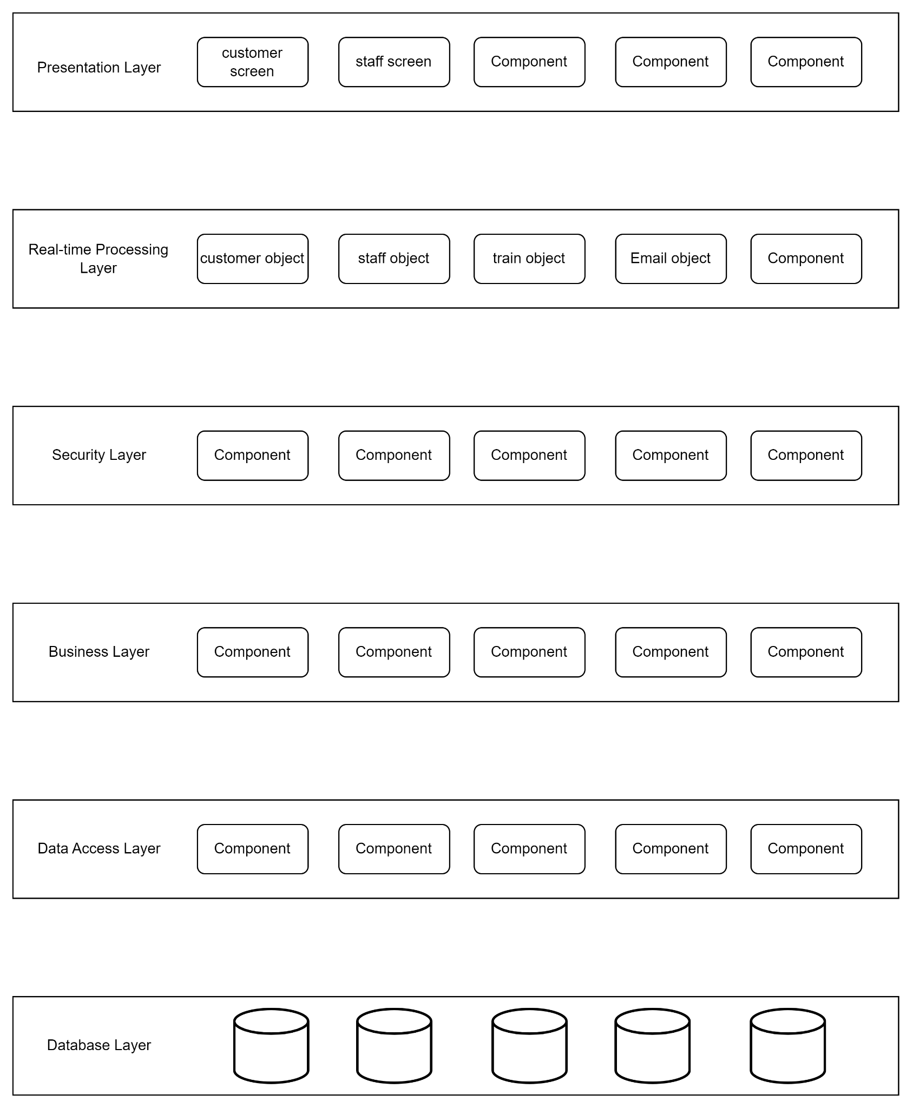
Diagram 5.3 (Layered Architecture Diagram)
At the presentation layer, Angular serves as the front-end framework, providing an interactive and responsive user interface that allows train operators, customer service agents, and maintenance staff to engage with the system easily. Angular’s component-based structure and two-way data binding fit perfectly within this architecture, allowing it to communicate efficiently with the business logic layer. For the core logic of the system, Java was selected for its ability to handle complex decision-making processes and real-time operations such as train scheduling, maintenance tasks, and customer feedback management. Java’s scalability and robustness align well with the layered architecture, ensuring that the system can grow as the demand increases without affecting other layers.
The data access layer relies on PostgreSQL, a powerful relational database management system, to manage structured data such as train schedules, maintenance logs, and employee records. PostgreSQL’s performance and support for complex queries ensure that the system can handle real-time data processing and retrieval efficiently. This data is stored in the database layer, also using PostgreSQL, ensuring data integrity and easy access. The separation of the data access and database layers helps maintain modularity and allows for independent scaling and optimization.
For system security, Sophos XG Firewall protects the TMS by providing advanced network security and intrusion prevention, securing data transmission between layers. This security layer is integrated across the architecture, ensuring safe communications and protecting sensitive information. In terms of system resilience, Veeam Backup & Replication was chosen to manage backups and recovery for all layers, ensuring that critical data is backed up regularly and can be restored quickly in the event of a failure. Finally, Apache Kafka was selected to handle real-time data processing in the real-time processing layer, allowing the TMS to manage large-scale data streams and respond to events, such as train performance issues, instantly.
To enhance the business logic layer of the Train Management System (TMS) using Spring, several powerful add-ons can be incorporated to optimize performance, scalability, and security. One essential extension is Spring Data JPA, which simplifies data access and database operations by abstracting the persistence layer. Its seamless integration with PostgreSQL ensures efficient management of structured data such as train schedules and maintenance logs, enabling the system to handle complex queries effortlessly. For security, Spring Security can be used to add robust authentication and authorization mechanisms, including role-based access control, which integrates well with the existing network security provided by Sophos XG Firewall. Spring Batch further complements the system by enabling efficient processing of large data volumes, making it ideal for handling periodic maintenance tasks and train schedule updates.
When it comes to scalability and microservices architecture, Spring Cloud offers excellent tools for building distributed systems, allowing the TMS to communicate efficiently with cloud platforms like AWS and manage system load effectively during peak hours. Additionally, Spring Kafka plays a crucial role in managing real-time data streams, ensuring that the TMS can process events such as train performance updates and customer feedback instantly, allowing for prompt responses to operational issues. To maintain clean and organized code, Spring AOP (Aspect-Oriented Programming) helps manage cross-cutting concerns like logging and transaction management without cluttering the core business logic. Finally, Spring Actuator provides essential monitoring and metrics tools, enabling administrators to track the system’s health and performance in real-time, ensuring the TMS remains responsive and reliable. These Spring extensions not only optimize the system’s core operations but also ensure that the business logic layer remains secure, scalable, and efficient as the system grows.
Benefits:
The overall benefits of choosing a layered architecture for the Train Management System (TMS) are significant in terms of modularity, scalability, maintainability, and security. First, modularity is a key advantage, as each layer focuses on specific responsibilities (e.g., user interface, business logic, data management), allowing developers to update or modify one layer without impacting others. This separation of concerns makes the system easier to manage and reduces the risk of errors during system updates or feature enhancements.
Scalability is another important benefit. Each layer can scale independently based on system needs. For instance, if there is a higher load on the presentation layer due to an increase in users, additional servers or resources can be allocated without affecting the business logic or data layers. This makes the system more efficient and adaptable to future growth, such as the addition of more trains, users, or functionalities.
The architecture also offers enhanced security by allowing security measures to be applied consistently across the system, particularly in the security layer. The use of Sophos XG Firewall ensures that all data transmitted between layers is protected from unauthorized access or external threats. With security implemented at multiple points, the system becomes more robust and resilient to attacks.
Maintainability is significantly improved in a layered architecture. The clear separation of layers allows for easier troubleshooting and maintenance. If a problem arises, such as a bug in the business logic layer or a data inconsistency in the database layer, it can be isolated and fixed without affecting the entire system. This reduces downtime and speeds up the development process for new features.
Finally, real-time processing is supported efficiently through the real-time processing layer using Apache Kafka. This ensures that critical data, such as train performance metrics or maintenance alerts, are handled in real-time, allowing the system to respond quickly to operational changes or emergencies. By having this capability within its own layer, the system ensures high performance without overloading other layers.

5.4 State Diagram

5.4.1 Facilities and Service Module
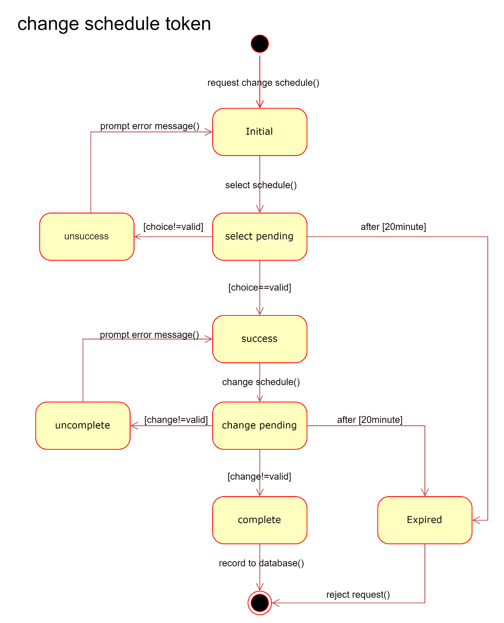 Diagram 5.4.1 (Facilities and Service Module State Diagram)

5.4.2 Marketing Module

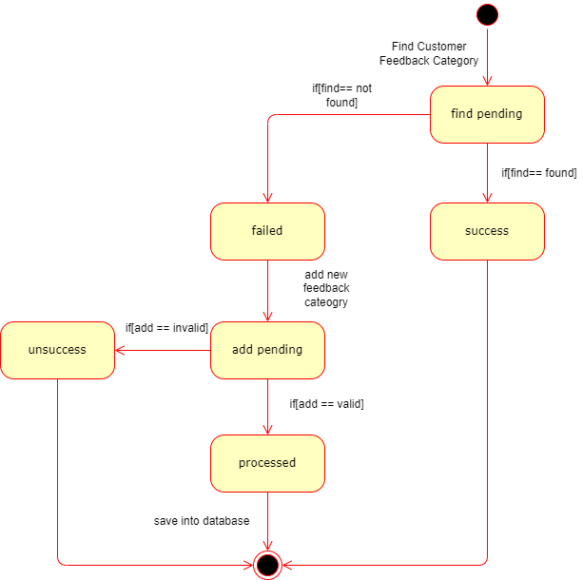
Diagram 5.4.2 (Marketing Module State Diagram)

5.4.3 Customer Service Module

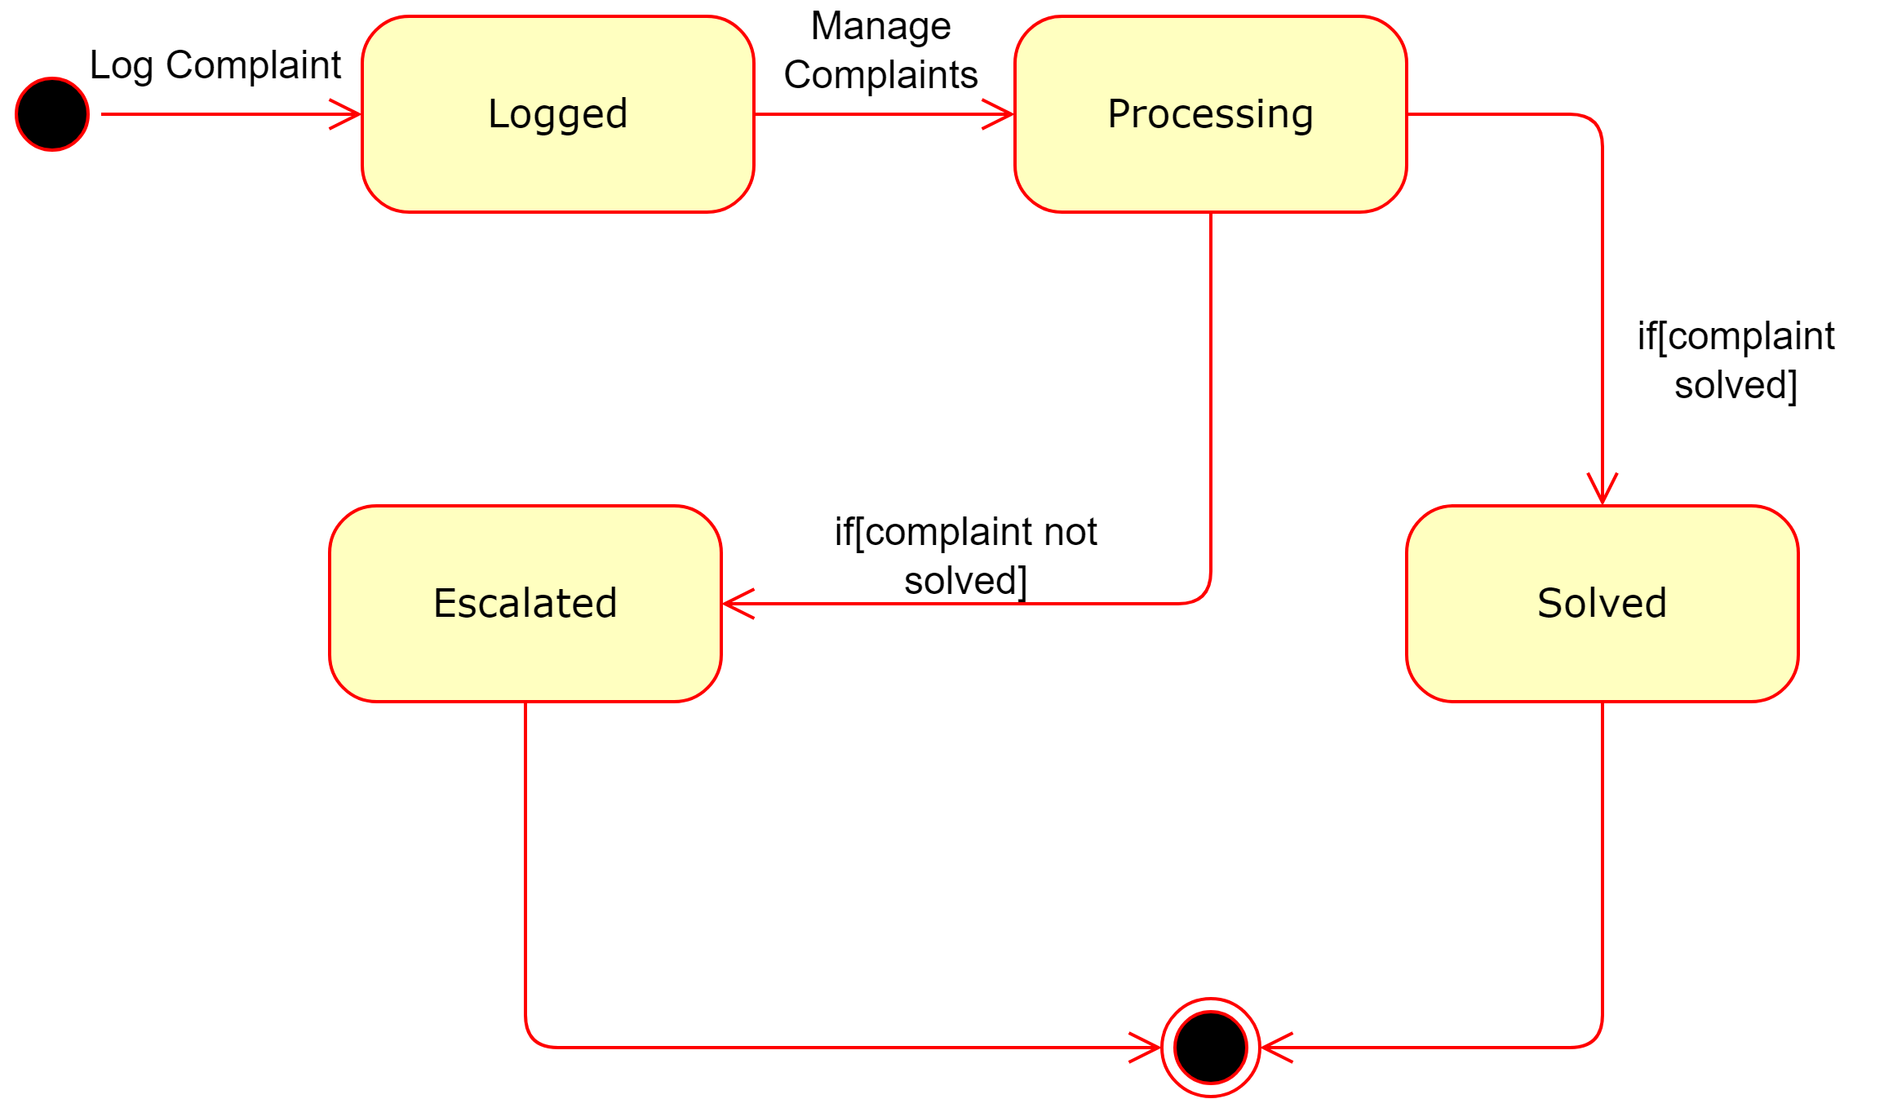
Diagram 5.4.3 (Customer Service Module State Diagram)

5.4.4 IT Module

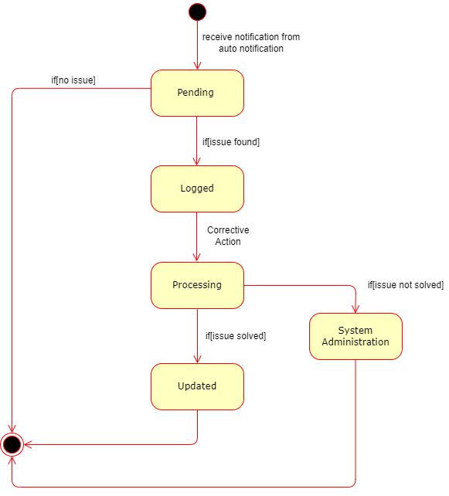
Diagram 5.4.4 (IT Module State Diagram)

5.4.5 HR Module
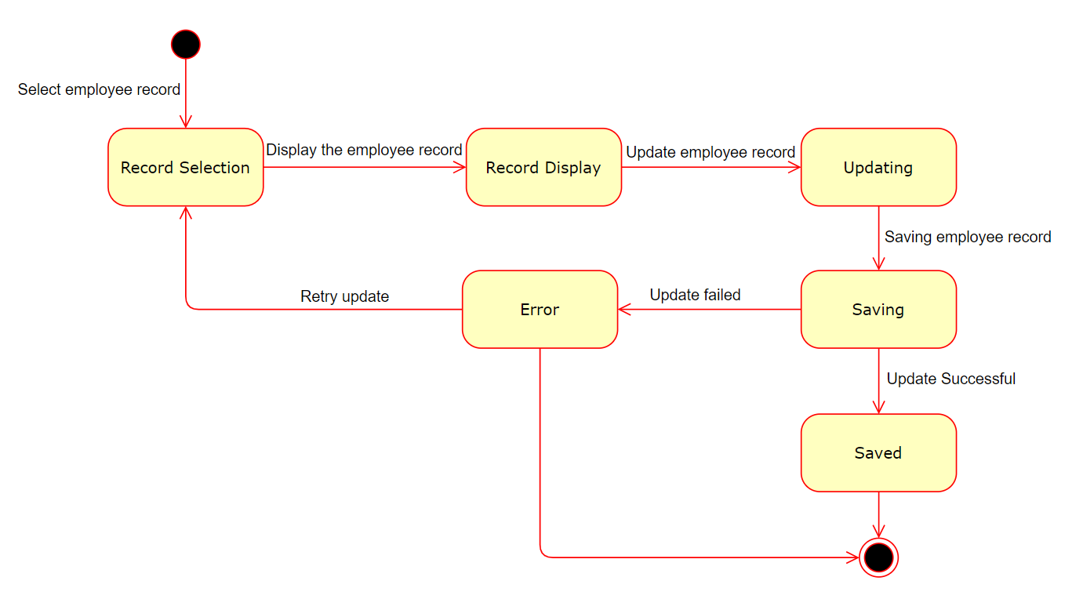
Diagram 5.4.5 (HR Module State Diagram)

5.5 Sequence Diagram

5.5.1 Facilities and Service Module
The Schedule module receives change requests from maintenance staff and loops through the database to retrieve all schedule data, which is then sent to the maintenance staff. Upon receiving a selected schedule, the module performs a validity check: if the schedule is valid, the details are sent; if invalid, an error message is returned and the staff is prompted to reselect the schedule. When a changed schedule is received, the module compares it with the existing schedule and checks its validity. If the changed schedule is valid, it is updated in the database, and a success message is sent to the staff; if invalid, an error message is issued, and the staff is prompted to rechange the schedule. The Notify module retrieves available accounts from the database and sends this information to the staff. Upon receiving a selected account from the staff, the module performs a validity check: if valid, a success message is sent; if invalid, an unsuccessful message is issued, and the staff is prompted to reselect. The Notify module also handles confirmation receipts, looping until a confirmation receipt is received. Once received, the confirmation receipt is recorded in the database.
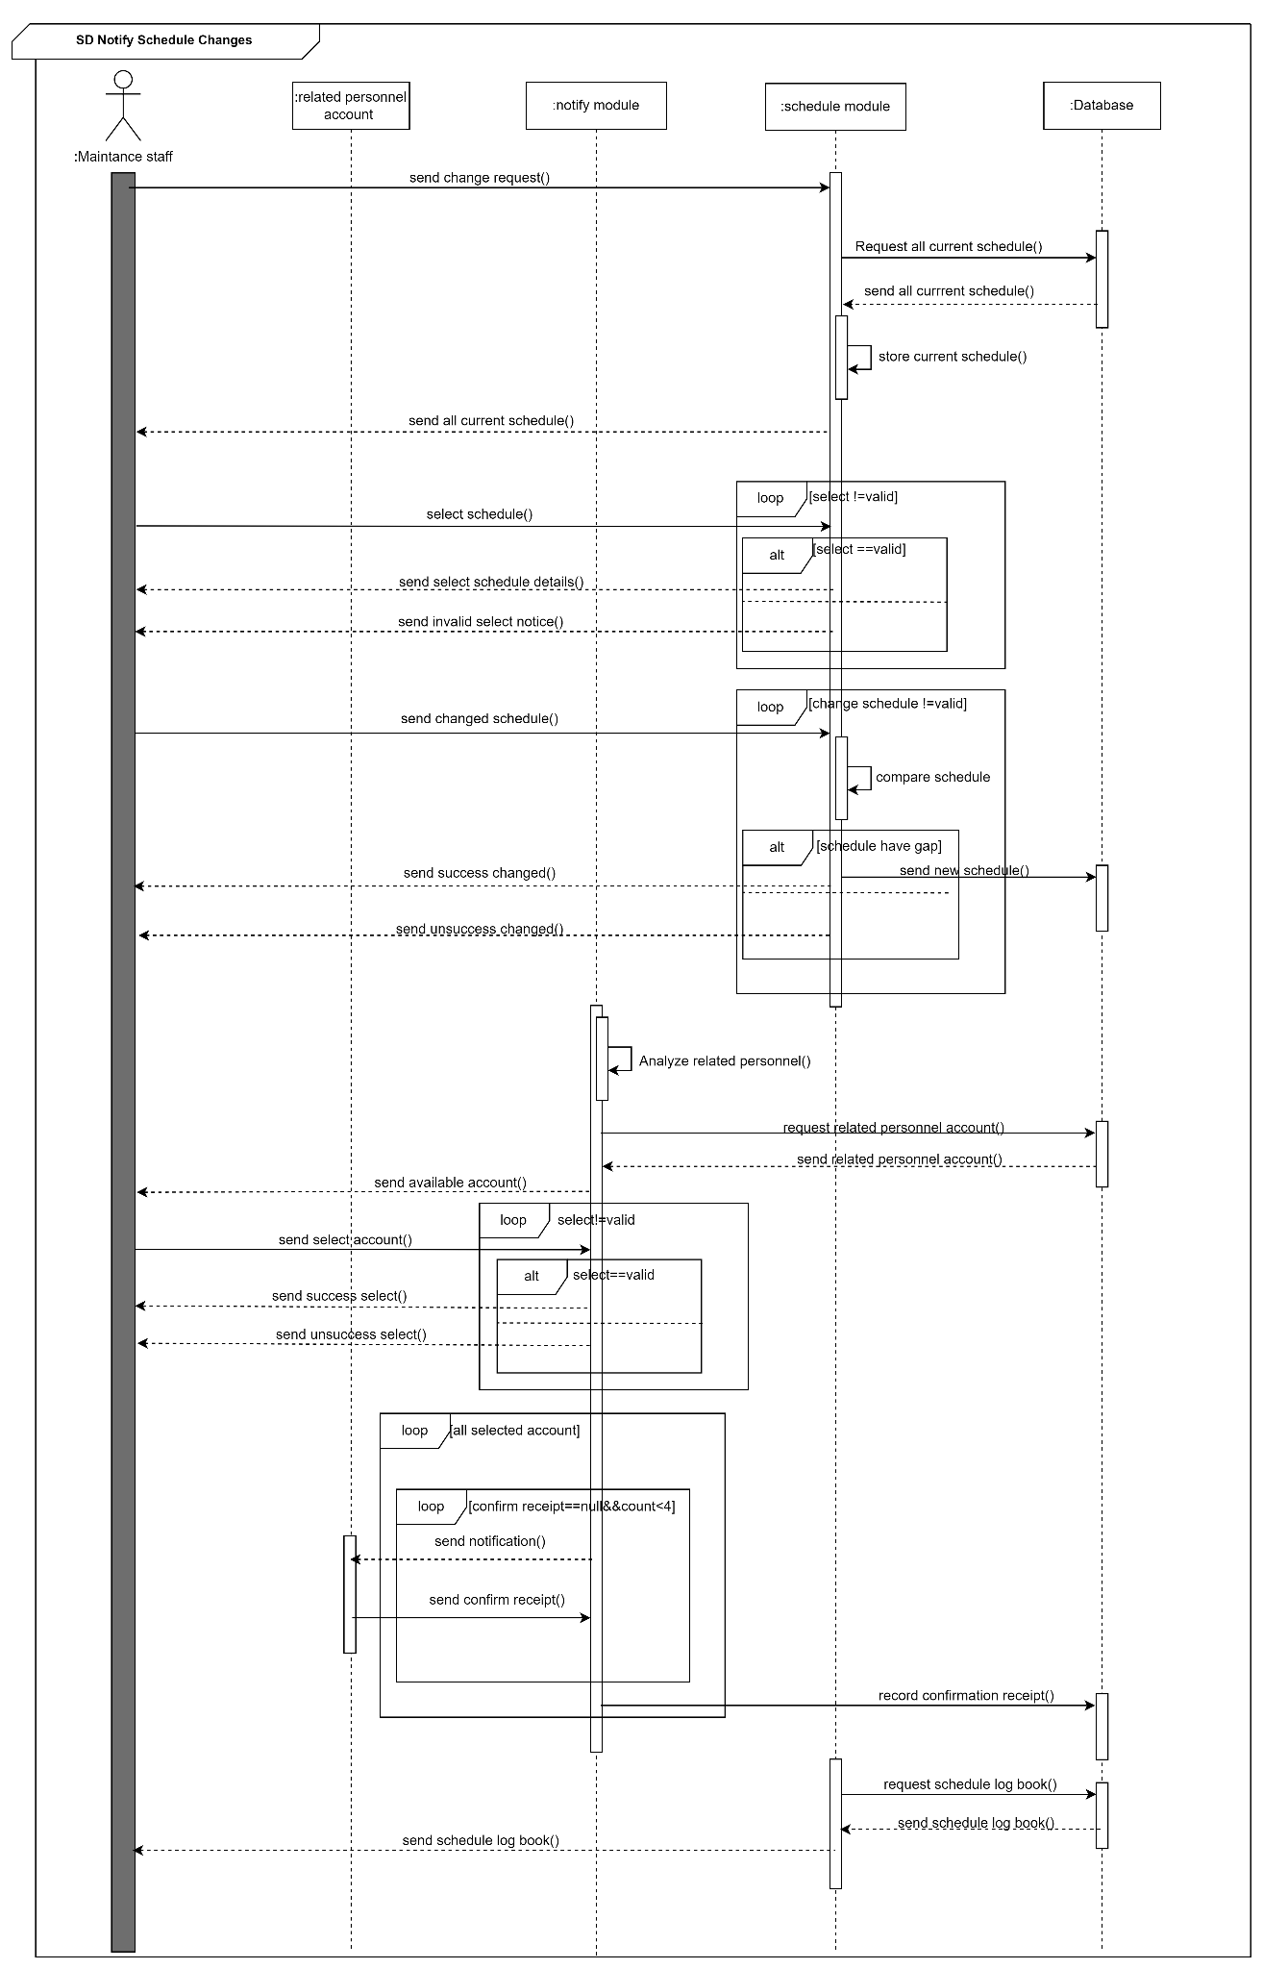
Diagram 5.5.1 (Facilities and Service Module Sequence Diagram)

5.5.2 Marketing Module
Staff send id and password for logging into the Module, get and return the id and password from the database else if error, loop for try 3 times to validate the login credentials and return the validation result to the Module. If the login is successful proceeds to the next steps, else prompts for re-entry of credentials. Staff selects the customer feedback to analyze, checks whether the customer feedback record exists in the Database. If the record is found, the module returns the result and the Marketing Staff generates a customer feedback report, else print an error message. Staff responds to the customer feedback, if successfully saved in the database response saved message to the staff, else print error message.
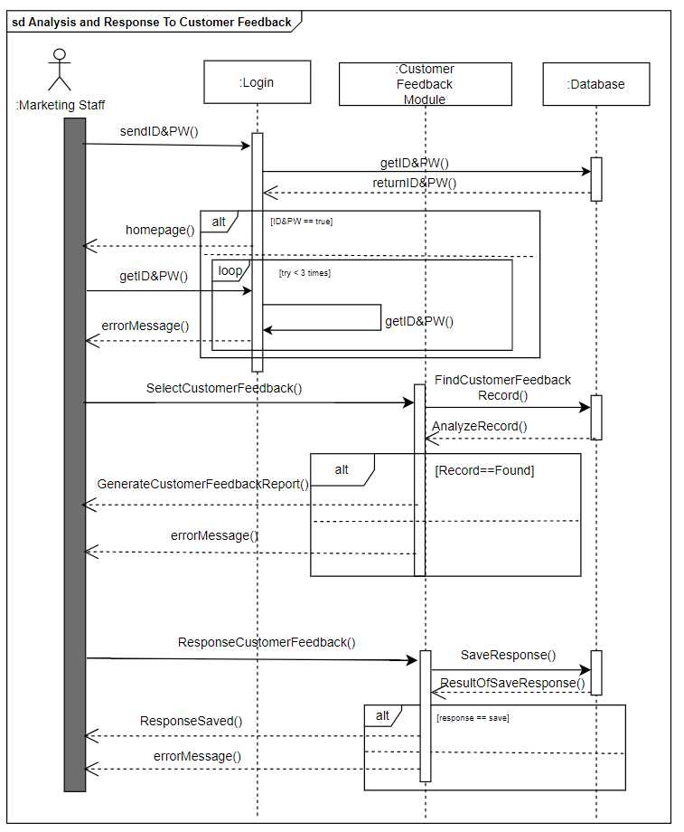
Diagram 5.5.2 (Marketing Module Sequence Diagram)

5.5.3 Customer Service Module
The system starts with the login and verification process, during which the user’s ID and password are obtained through a looping mechanism. Once authenticated, the system navigates to the complaint session where new complaints can be logged and recorded in the database. The system then loops through the database to categorize and prioritize the complaints, displaying all categorized and prioritized complaints for review.
Staff members manage the complaints: if a complaint is resolved, the status is updated in the database and a notification is sent to the relevant customer. If the complaint cannot be resolved, it is escalated, the status is updated in the database, and a notification is sent to the relevant customer.

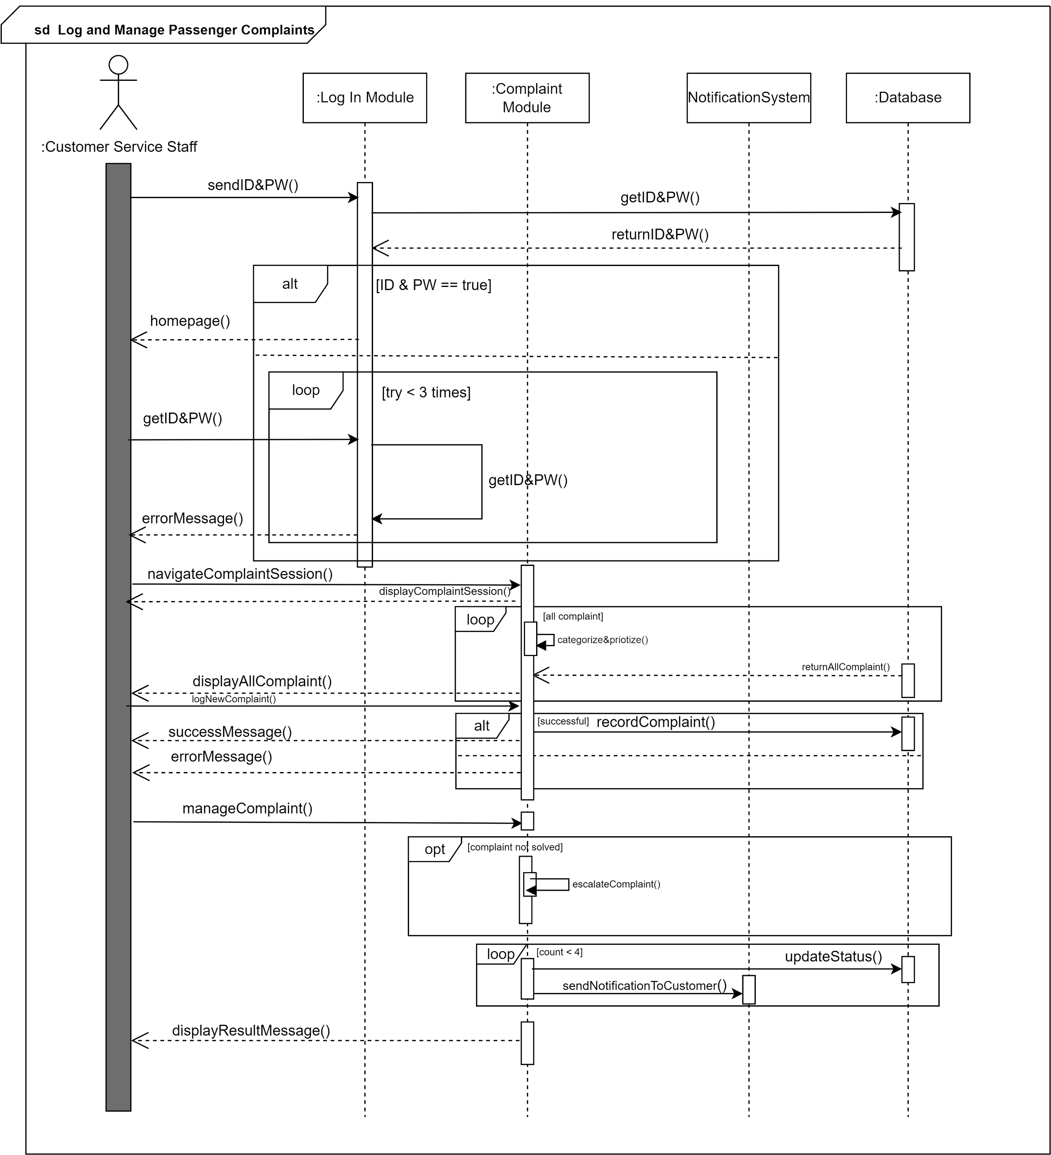
Diagram 5.5.3 (Customer Service Module Sequence Diagram)

5.5.4 IT Module
The login process includes verification steps, and the system continually tracks for potential issues. When an issue is found, it is logged, displayed, and corrective actions are initiated. If the issue is resolved, the status is updated, and actions are recorded. In cases where issues remain unresolved, technical support is requested.

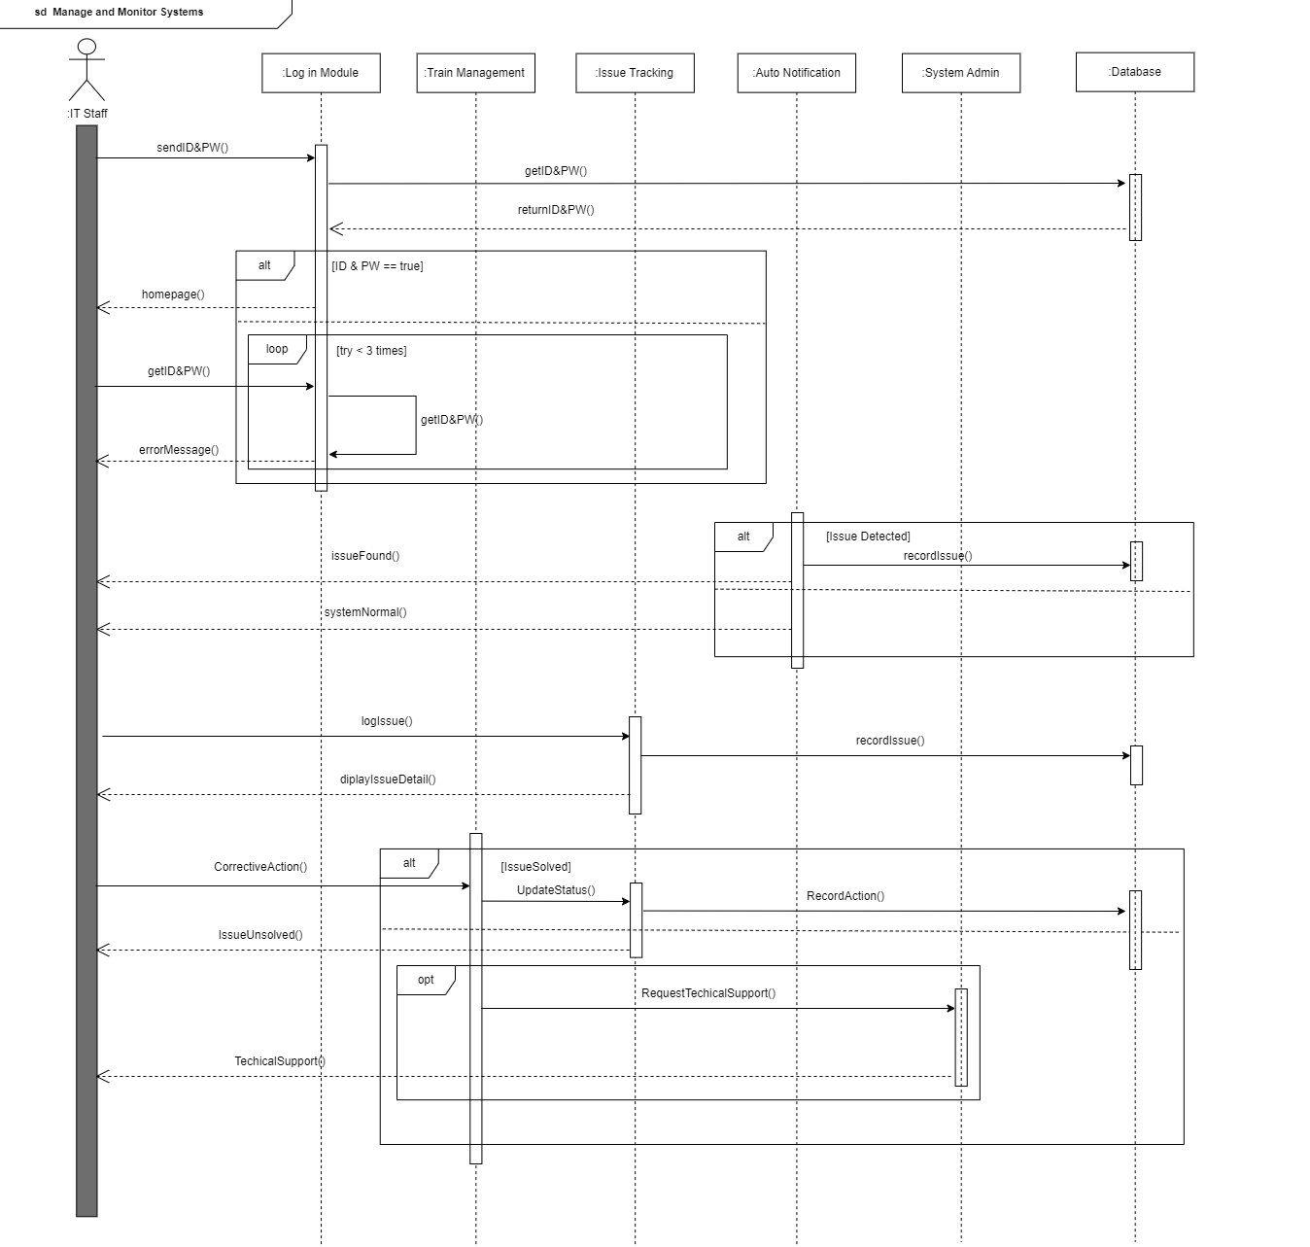
Diagram 5.5.4 (IT Module Sequence Diagram)

5.5.5 HR Module
The HR staff logs into the system through the Login Module, where they input their ID and password. The Login Module communicates with the Database to verify the credentials. If the credentials are correct, the system grants access; if not, the user is given up to three times to re-enter the correct information. After successful login, the HR staff is directed to the homepage. The HR staff searches for an employee's record by interacting with the Search Record Module, which requests the necessary information from the Database. If the record is found, it is returned to the HR staff; otherwise, an error message is displayed. The HR staff update the employee record through the Update Record Module. After the updates are made, the changes are saved to the Database, and a confirmation message is displayed to the HR staff, indicating the successful update of the employee's record.

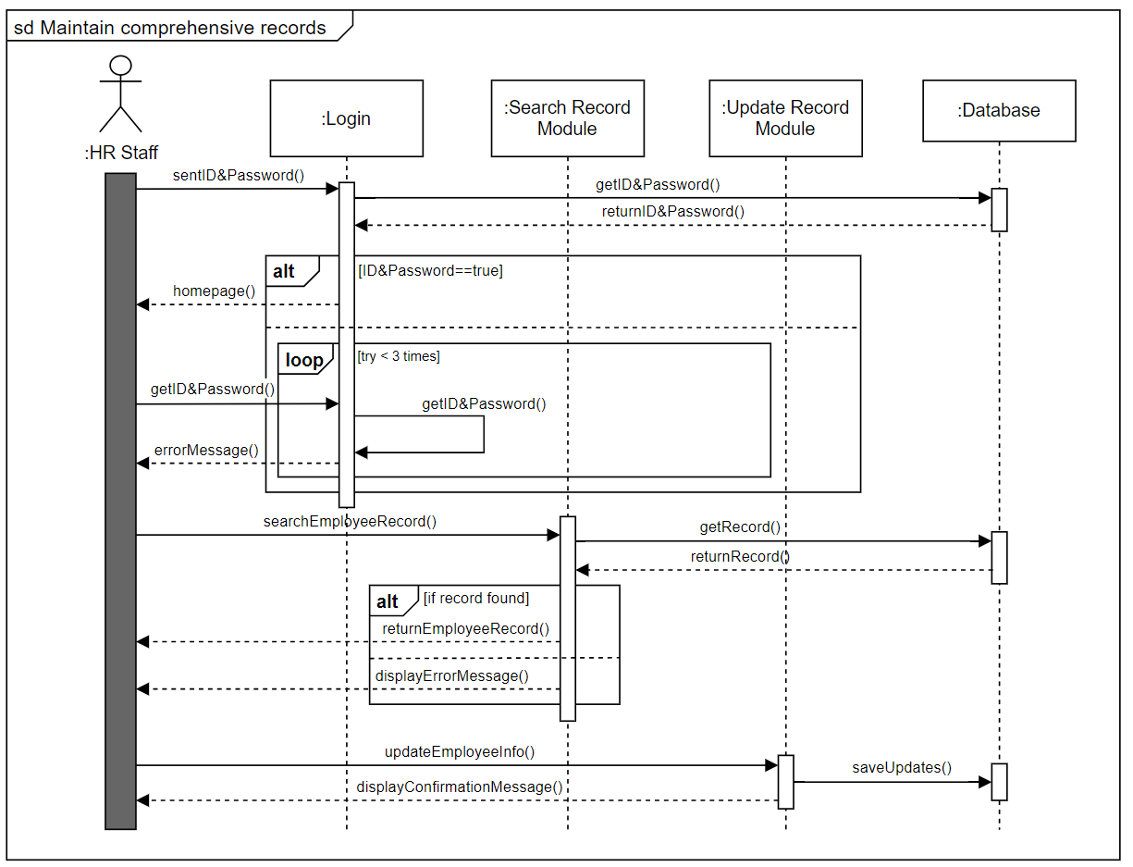
Diagram 5.5.5 (HR Module Sequence Diagram)

5.6 Communication Diagram
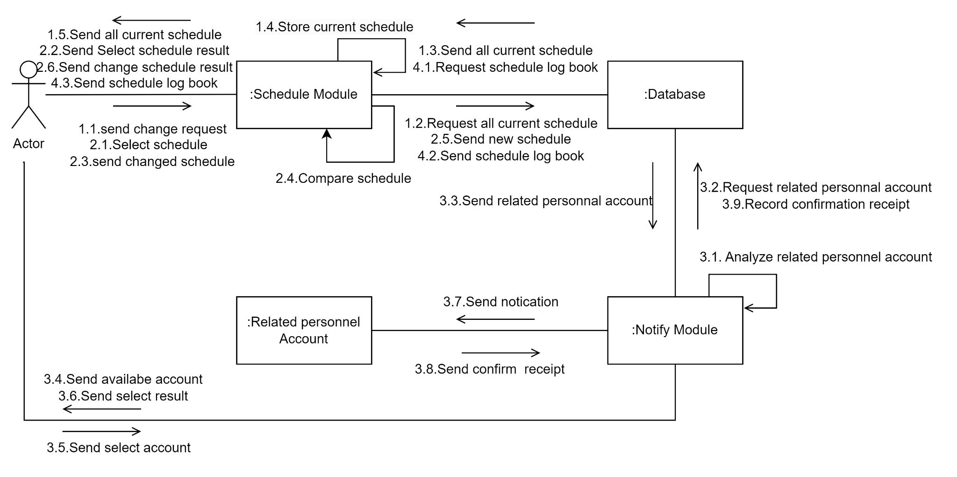
Diagram 5.6 (Facilities and Service Module Communication Diagram)

5.7 Activity Diagram
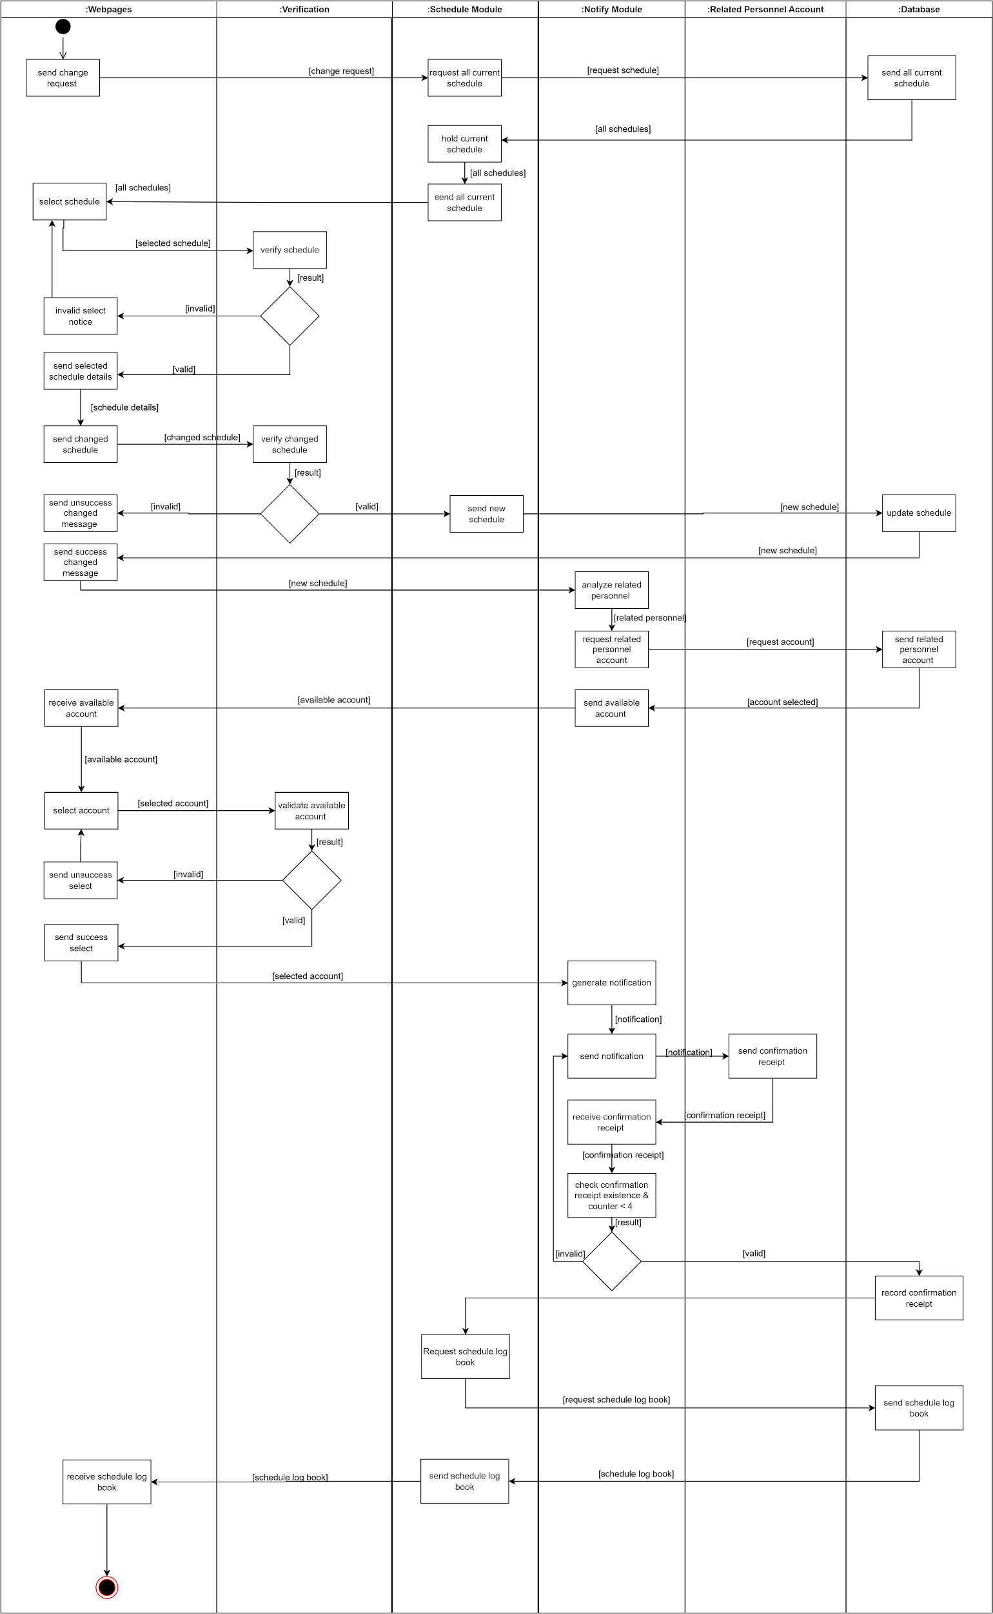
Diagram 5.7 (Facilities and Service Module Activity Diagram)

Appendix
This section outlines the use of interviews as a key stakeholder-driven elicitation technique for gathering system requirements in the train management system. It includes background on Rapid Rail’s operations and presents tailored interview questions for various departments, emphasizing the importance of stakeholder engagement to ensure system alignment with organizational needs. Additionally, it analyzes the roles and influence of key stakeholders in shaping the system’s development.

Background Studies

Rapid Rail manages and operates an extensive network of LRT (Light Rail Transit) and MRT (Mass Rapid Transit) lines in Kuala Lumpur and the Klang Valley. This includes the Kelana Jaya Line, Ampang Line, Sri Petaling Line, KL Monorail, and the MRT Kajang Line. In 2023, it expanded its operations to include the management of the MRT Putrajaya Line.

The company was officially established following a corporate restructuring in 2013, building on its initial operations that began in 2002. At that time, Prasarana took over the management and assets of the Star-LRT and Putra-LRT lines, which were subsequently renamed the Ampang Line and Kelana Jaya Line, respectively. The acquisition of the KL Monorail followed in 2007.

Rapid Rail has implemented various initiatives to encourage public transport usage, resulting in a steady increase in ridership. As of September 2022, the network serves over 260,000 commuters daily, reflecting its integral role in Kuala Lumpur's transport infrastructure.

Interview
An interview in stakeholder-driven elicitation techniques is a structured or semi-structured conversation between the project team (often business analysts or system developers) and stakeholders. The purpose of the interview is to gather information, clarify requirements, and gain a deeper understanding of the stakeholders’ needs, expectations, and concerns regarding the system or project being developed.
This technique is highly effective in the early stages of a project when it is crucial to collect detailed input from key stakeholders. It allows for direct communication and provides the opportunity to explore both explicit requirements and implicit expectations, such as user preferences or operational constraints.
Interviews are valuable because they allow stakeholders to express their thoughts in detail, ask questions, and raise potential concerns. The project team benefits from real-time feedback and can clarify any ambiguities directly with the stakeholder, ensuring a more complete and accurate understanding of the system requirements.

Interview Questions

Facilities and Service Department
- Can you describe a specific system you have used to monitor train performance, including speed and braking control? What were its strengths and weaknesses?
- Can you give an example of a communication or data processing issue you encountered in a train management system? How did you resolve it?
- Tell me about a time when you received an emergency signal from a train. How did you assign technicians and track the resolution of the problem?
- How do you prioritize maintenance tasks when faced with multiple urgent issues? Can you provide an example?
- Describe the protocol you follow for assigning technicians during train emergencies. How do you ensure that the problem is resolved efficiently?
- Can you discuss a situation where you had to manage a major train component failure? How did you handle the pressure and ensure a quick resolution?
- Describe a time when you had to coordinate a large-scale maintenance operation. How did you manage the logistics and communication?
- What methods have you used to collect user feedback related to train operations and facilities? How did you ensure the feedback was actionable?
- Can you give an example of how you analyzed user feedback to identify a common issue and implemented a solution? What was the result?
- Describe an experience where you worked with other departments to change a train schedule? What problems did you face, and how did you handle them?

Marketing Department
- What are the key features you need for creating and managing marketing campaigns with defined objectives and target audiences?
- What tools do you currently use for collecting and analyzing market research data?
- How do you currently create, edit, and publish promotional materials such as brochures and digital content?
- What are your requirements for managing ad placements, budgets, and performance metrics?
- How do you currently schedule and manage email campaigns?
- What features would help you better target specific groups with personalized offers?
- What specific insights are you looking for from the new system to inform your strategies?
- What distribution methods do you use, and what improvements do you expect from the new system?
- How frequently do you need reports, and what specific details are you looking for in these reports?
- What features would help you better use this feedback to inform your marketing strategies and service improvements?

Customer Service Department
- How do you currently log and manage passenger complaints, and what categories do you use (e.g., train services, facilities, safety concerns), What features would help you improve the categorization and management of passenger complaints?
- What are your requirements for maintaining an audit trail of actions taken on each complaint, including timestamps, responsible personnel, and communication logs?
- What would you like to see in an automated follow-up reminder system to ensure issues are promptly addressed?
- How do you handle email communication related to complaints, and how do you track communication history?
- What features would help you keep more detailed and organized records?
- What key activities, issues, and customer feedback do you need to be summarized in daily reports for management review?
- How do you create and manage special offers, discounts, and loyalty programs? What features would help you streamline and enhance the management of these programs?
- What insights are you looking for to improve future promotions?
- What tools would help you better gather and analyze this feedback?
- How do you currently generate reports on feedback trends, and what information do you find most valuable? What improvements do you expect from the new system to inform service improvements and strategic planning?

IT Department
- What features would you like to see in an automated system for logging problems directly into a centralized system?
- How do you prefer to receive notifications about the status of reported issues (e.g., email, SMS, internal messaging)?
- What key information should be included in monthly reports based on maintenance or issues resolved by the IT staff?
- What features would help streamline the workflow for problem resolution and prioritize issues based on their impact?
- How do you currently identify and address potential issues before they become significant problems?
- How do users currently report issues, check the status of their tickets, and access the knowledge base? What features would make an IT support portal more effective for users?
- How do you currently manage IT staff schedules and workloads to avoid overburdening the team? What tools would help improve the management of staff schedules and workloads?
- What improvements do you expect from a tracking system to reduce the need for multiple follow-up calls or emails?
- How do IT staff currently document and categorize issues and solutions for future reference?What features would help IT staff quickly document and categorize issues more effectively?
- What performance metrics are most important to you, and how would you like to ensure timely resolution of issues?

HR Department
- Can you describe your experience with maintaining comprehensive employee records, including personal information, job roles, and qualifications? What systems have you used for this purpose?
- How do you handle shift changes and overtime requests while ensuring adequate staffing levels? What systems or processes do you use to manage these changes efficiently?
- How do you ensure that employee records are compliant with legal and regulatory requirements, particularly in the context of train operations?
- Describe a time when you had to audit employee records for compliance. What was your approach, and what were the results?
- How have you planned and organized training programs for employees to ensure compliance with safety regulations and operational procedures? Can you provide an example of a successful program you managed?
- How do you track employee training progress and certifications to ensure workforce readiness? What tools or systems have you used for this purpose?
- What strategies do you use to ensure that all train operators and staff are up-to-date with their required training and certifications? How do you handle situations where employees fall behind on their training?
- How do you create and manage employee schedules, taking into account shift preferences, availability, and operational requirements? Can you describe a time when you had to manage complex scheduling needs?
- How do you handle shift changes and overtime requests while ensuring adequate staffing levels? What systems or processes do you use to manage these changes efficiently?
- Can you discuss a time when you had to resolve scheduling conflicts or issues with staffing levels? What steps did you take to address the problem?

Stakeholder analysis
A stakeholder is any individual with an interest in the success or failure of a system. Stakeholders play a crucial role as they are authorized to make decisions, collaborate with team members, and possess valuable knowledge that contributes to the system's development. They can range from users who interact directly with the system to customers or clients who commission the system’s construction. The cooperation of stakeholders is vital for successful requirement elicitation, as they bring essential perspectives and insights.

Identifying stakeholders is important because it allows them to be involved in the project’s efforts early on. Their participation fosters the generation of new ideas from different viewpoints, which can significantly impact the project’s direction. Involving stakeholders early also increases trust between the project team and the stakeholders, thereby enhancing the probability of the project’s success. Moreover, their inclusion in planning and execution helps secure their support throughout the process.

To identify stakeholders, several factors should be considered: their position within the organization, their role in decision-making, and their ability to reach agreements. Other key considerations include the type of knowledge they contribute, their level of domain expertise, their exposure to the system’s perceived problems, as well as their personal interests and any potential conflicts. Finally, their influence on the system's acceptance should also be assessed.
In the Facilities and Service Department, the Maintenance Manager holds a critical position. They have the authority to make key decisions regarding maintenance plans, priorities, and budget allocations for facilities and equipment. Working closely with other departments, such as customer service, they ensure that maintenance activities are well-coordinated with the overall operational plan. For instance, when a train line requires maintenance, the customer service department needs to be informed to notify customers about the service interruption.
Maintenance managers possess a deep understanding of the technical aspects and maintenance requirements of facilities and equipment. This expertise enables them to provide valuable insights and suggestions during system design and implementation. They can effectively communicate the maintenance needs and ensure these are integrated into the system's design.
Additionally, maintenance managers play an important role in identifying potential problems and offering preventive measures during the requirements phase. Their familiarity with the current system allows them to foresee issues and propose improvements. Their involvement also ensures that the system undergoes all necessary maintenance and safety checks before it is officially launched.
Moreover, maintenance managers can develop and implement new maintenance protocols and procedures, contributing to the overall improvement of the team's skill set and ensuring the long-term operational efficiency of the facilities and equipment.
In the Marketing Department, the Marketing Manager plays a pivotal role in shaping the company's marketing direction. They are responsible for developing and implementing comprehensive marketing strategies that align with the company's overall goals and objectives. One of their key duties is allocating the marketing budget across various channels and campaigns to ensure resources are used optimally for maximum impact.
The Marketing Manager is also responsible for planning and executing marketing campaigns. This involves setting clear goals, identifying the right target audience, and selecting the most effective methods, such as social media, advertisements, or other promotional channels. Furthermore, they decide on the type of content to create and distribute—whether it be blogs, social media posts, or videos—in order to engage and attract the target audience effectively.
An important part of the role is commissioning and interpreting market research. By understanding customer needs, preferences, and behaviors, the manager can identify new market opportunities and recognize potential threats. This information is essential for shaping marketing strategies and campaigns.
Additionally, the Marketing Manager leads and manages the marketing team, overseeing tasks such as recruitment, training, and performance management. They ensure that the marketing team is aligned with the company’s promotional goals, particularly in promoting train services. Lastly, the Marketing Manager ensures that all campaigns and promotions are executed on time and according to the planned schedule, ensuring smooth operations and consistency in marketing efforts.
In the Customer Service Department, the Customer Service Manager plays a crucial role in overseeing the overall functioning of the customer service team. Their leadership ensures that daily operations run smoothly and efficiently, while they also have the authority to make key decisions regarding process improvements, resource allocation, and the adoption of new technologies.
With deep knowledge of current customer service processes, common challenges, and team performance, the Customer Service Manager is well-equipped to identify areas that need improvement. Their extensive experience in customer service management gives them an understanding of industry best practices, standards, and effective problem-solving techniques.
One of the issues the manager may face is operational inefficiencies, such as delays in responding to customer inquiries due to outdated, paper-based systems. As someone committed to improving team efficiency, the manager is motivated to meet service standards and reduce response times to ensure that customers receive timely and accurate responses.
However, despite the drive for improvement, the manager may show some resistance to adopting new systems due to familiarity with the current processes. They could be concerned about how their team will adapt to new workflows and whether additional training or support will be required. Balancing these concerns with the goal of enhancing customer service operations is a key aspect of their role.
In the IT Department, the IT Department Manager holds a critical position, responsible for making decisions regarding the IT infrastructure, software, and hardware necessary for the train management system. They play a key role in coordinating with other departments to ensure that IT solutions meet operational needs and align with the company's overall goals.
With extensive technical knowledge of system architecture, network infrastructure, and software applications, the IT Department Manager is well-equipped to manage the technological aspects of the train management system. They are also able to clearly define IT-related requirements, such as performance expectations, security measures, and scalability needs to ensure the system operates efficiently.
The IT Department Manager's expertise allows them to identify potential IT-related challenges early on, such as cybersecurity risks or integration issues between various components of the system. Their proactive involvement in the requirements phase helps in mitigating these risks before they become significant problems.
Furthermore, the IT Department Manager is a key figure in system acceptance testing, ensuring that all IT components meet the specified technical and security requirements. They are also responsible for developing and overseeing new IT protocols and procedures to enhance both the efficiency and security of the train management system, ensuring long-term reliability and safety.
In the HR Department, the HR Manager plays a pivotal role in managing HR policies and processes, ensuring they align with the organization’s goals and foster a productive, compliant work environment. The HR Manager is responsible for making key decisions regarding HR policies, resource allocation, and the implementation of new technologies that support HR functions.
With extensive knowledge in HR management, the HR Manager is well-versed in labor laws, employee benefits, performance management, and best practices for hiring and training. Their expertise allows them to navigate complex HR challenges, such as employee grievances, performance issues, and compliance with regulatory requirements.
The HR Manager is often focused on improving the efficiency of HR processes, enhancing the overall employee experience, ensuring legal compliance, and supporting the organization’s growth. However, they may face conflicts, such as balancing the company’s objectives with employee needs, managing workplace disputes, and overcoming resistance to new processes or training initiatives.
Their influence is significant in the acceptance and successful implementation of HR systems and policies. By playing a key role in securing buy-in from both employees and management, the HR Manager ensures that these systems are integrated effectively within the organization and contribute to a healthy, efficient work environment.

